# **Lab-1**

# **Introduction to PIC microcontroller and its registers**

**Objective**

In this lab students will learn

* About the internal registers of PIC microcontroller
* Some of the instructions of PIC microcontroller

**Theory**

PIC is a Peripheral Interface Microcontroller which was developed in the year 1993 by the General Instruments Microcontrollers. It is controlled by software and programmed in such a way that it performs different tasks and controls a generation line. PIC microcontrollers are used in different new applications such as smartphones, audio accessories, and advanced medical devices. There are many PICs available in the market ranging from PIC16F84 to PIC16C84. These types of PICs are affordable flash PICs. Microchip has recently introduced flash chips with different types, such as 16F628, 16F877, and 18F452. The 16F877 costs twice the price of the old 16F84, but it is eight times more than the code size, with more RAM and much more I/O pins, a UART, A/D converter and a lot more features.

**Lab Exercise**

What is the meaning of letter ‘F’ and ‘C’ in PIC series number?

**________________________________________________________________________________________________________________________________________________________________________________________________________________________________________________________________________________________________________________________**

What is the difference between file and work register?

**________________________________________________________________________________________________________________________________________________________________________________________________________________________________________________________________________________________________________________________**

**________________________________________________________________________________________________________________________________________________________________________________________________________________________________________________________________________________________________________________________**

What is the difference between GPRs and SFRs?

**________________________________________________________________________________________________________________________________________________________________________________________________________________________________________________________________________________________________________________________________________________________________________________________________________________________________________________________________________________________________________________________________________________________________________________________________________________________________________________**

State the contents of file register RAM locations after the following program?



How to decide if the destination is a file register or WREG register?

**________________________________________________________________________________________________________________________________________________________________________________________________________________________________________________________________________________________________________________________________________________________________________________________________________________________________________________________________________________________________________________________________________________________________________________________________________________________________________________**

What will be the contents of WREG register after the execution of the following instruction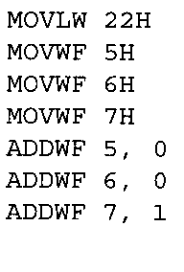**____________________________________________________________________________________________________________________________________________________________________________________________________________________________________________________________________________________________________________________________________________________________________________________________________________________________________________________________________________________**

State the contents of file register RAM locations 12H and WREG after the following program



**______________________________________________________________________________________________________________________________________________________________________________________________________________________________________________________________________________________________________________________________________________________________________________________________________**

Write a simple program to toggle the SFR of PORTC continuously.

**______________________________________________________________________________________________________________________________________________________________________________________________________________________________________________________________________________________________________________________________________________________________________________________________________**

What is the difference between MOVF MOVWF instructions?

**______________________________________________________________________________________________________________________________________________________________________________________________________________________________________________________________________________________________________________________________________________________________________________________________________**

Show the status of the C,DC, and Z flags after the addition of 9CH and 22H

**______________________________________________________________________________________________________________________________________________________________________________________________________________________________________________________________________________________________________________________________________________________________________________________________________**

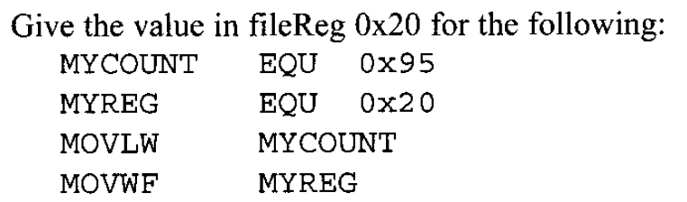

**______________________________________________________________________________________________________________________________________________________________________________________________________________________________________________________________________________________________________________________________________________________________________________________________________**

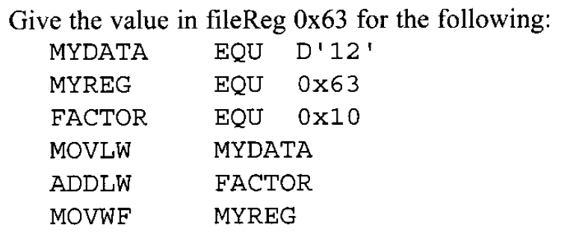

**______________________________________________________________________________________________________________________________________________________________________________________________________________________________________________________________________________________________________________________________________________________________________________________________________**

Conclusion

**______________________________________________________________________________________________________________________________________________________________________________________________________________________________________________________________________________________________________________________________________________________________________________________________________**