Lab-3

Implementation of Unconditional jumps in PIC microcontroller using assembly language programming
Objective:
In this lab students will learn
- How to implement stack in assembly language?
- How delay routines are implemented in PIC microcontroller.
Theory
In the previous lab you have studied how the conditional statements are used for transferring the control of a program anywhere you want. There are also unconditional jumps available for introducing delays in your program. They are CALL and RCALL. CALL instruction is a 4 byte instruction while RCALL is a 2 byte instruction. So it depends how much ROM is available in the PIC series you are using.
Each call routine ends on a return statement so that the assembler can start execution from where the control was transferred. The stack is used for storing the address of the next instruction from where the call was made.
Lab Exercise
Analyze the stack for the call instruction in the following program
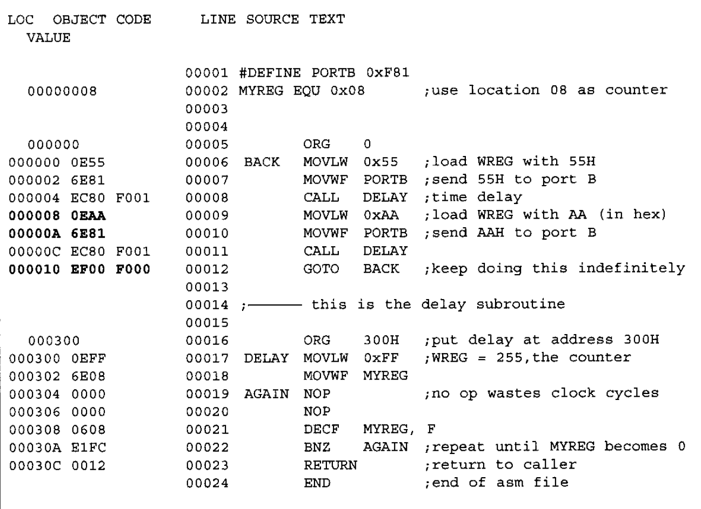
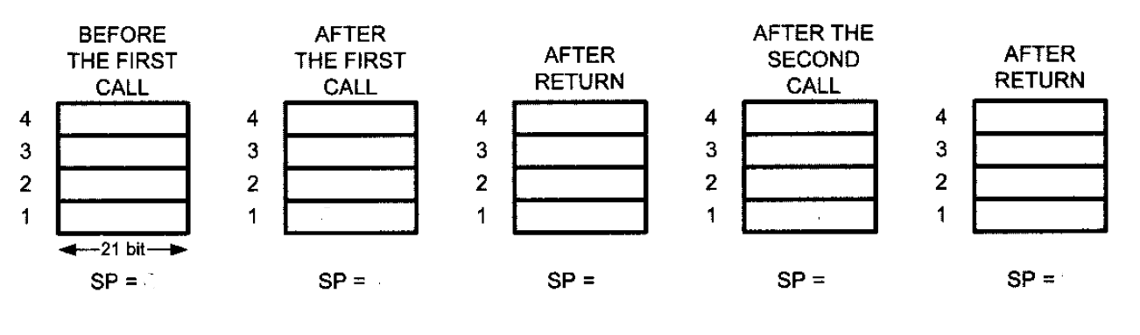
Write a program to count up from 05 to FFh and send the count to SFR of PORTB. Put a delay in between each routine while issuing data. Also mention the contents of stack.
________________________________________________________________________________________________________________________________________________________________________________________________________________________________________________________________________________________________________________________ ________________________________________________________________________________________________________________________________________________________________________________________________________________________________________________________________________________________________________________________ ________________________________________________________________________________________________________________________________________________________________________________________________________________________________________________________________________________________________________________________
Find the size of the delay of the code snippet below if the crystal frequency is 4MHz.
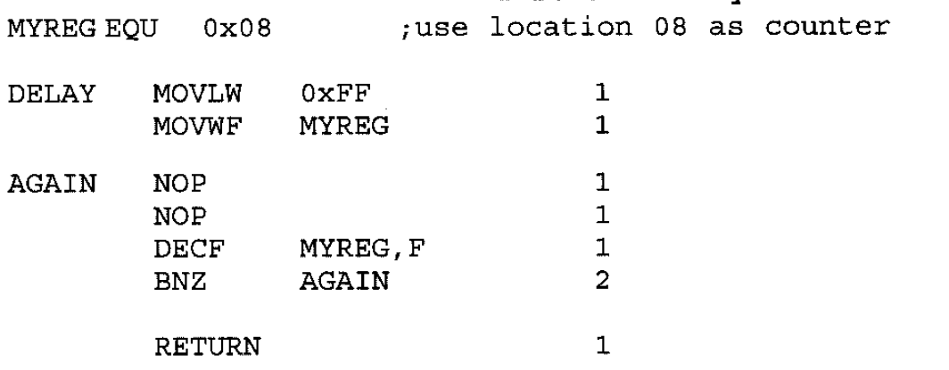
____________________________________________________________________________________________________________________________________________________________ ________________________________________________________________________________________________________________________________________________________________________________________________________________________________________________________________________________________________________________________ ____________________________________________________________________________________________________________________________________________________________

Find the size of the delay of the code snippet below if the crystal frequency is 20MHz.
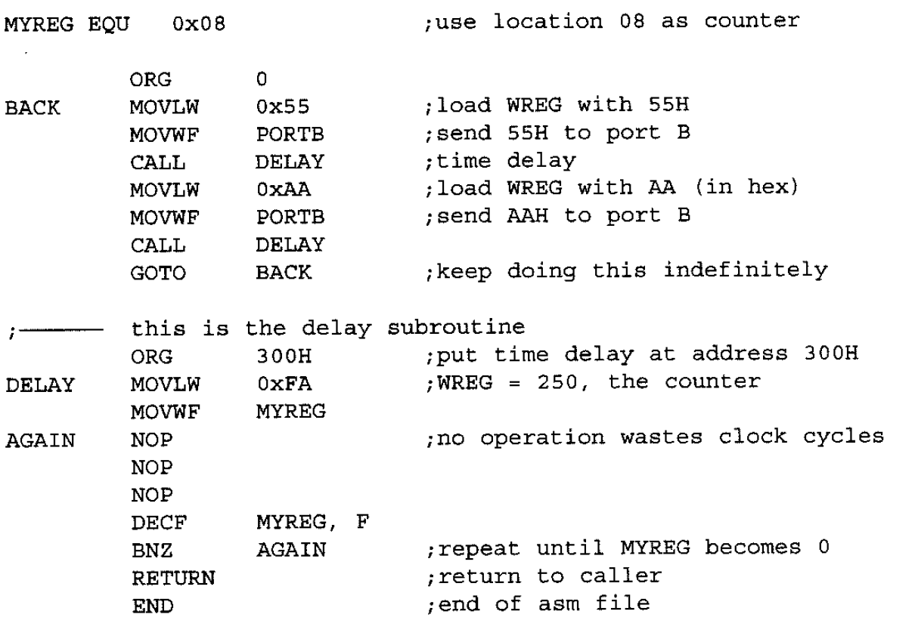
____________________________________________________________________________________________________________________________________________________________ ________________________________________________________________________________________________________________________________________________________________________________________________________________________________________________________________________________________________________________________ ____________________________________________________________________________________________________________________________________________________________
Find the size of the delay of the code snippet below if the crystal frequency is 16MHz.
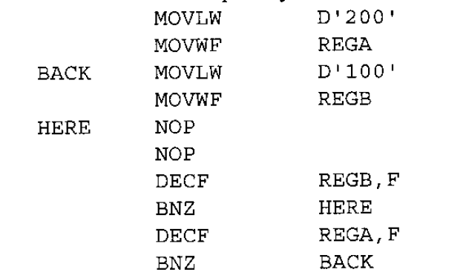

Find the number of times the following loop is performed?

  

