Lab-6
PIC Timer Programming microcontroller using assembly language
Objective:
In this lab students will learn
- How many timers are there in PIC18f4550
- How timers are used for introducing delays.
Theory
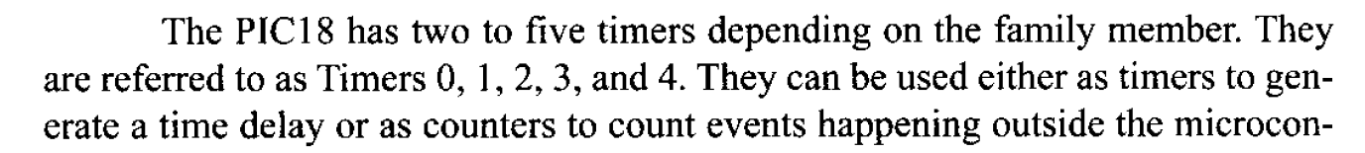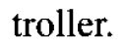
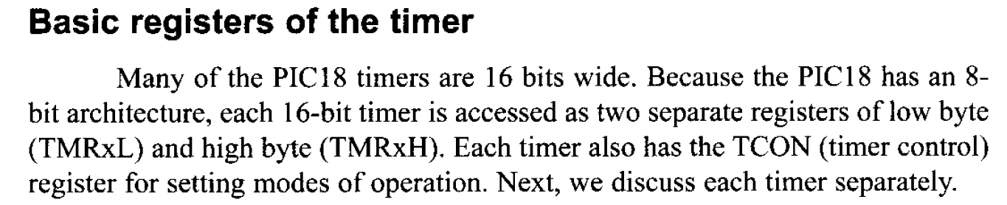
Timer0 register and programming
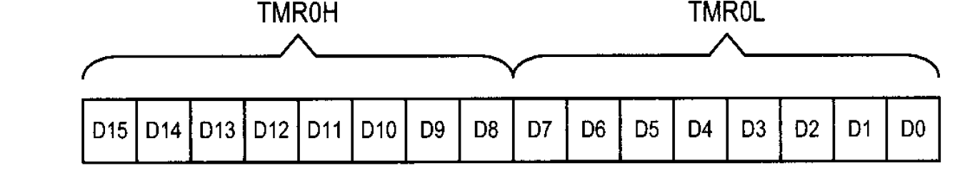
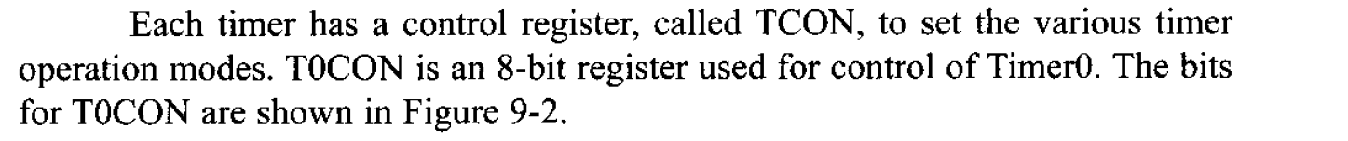
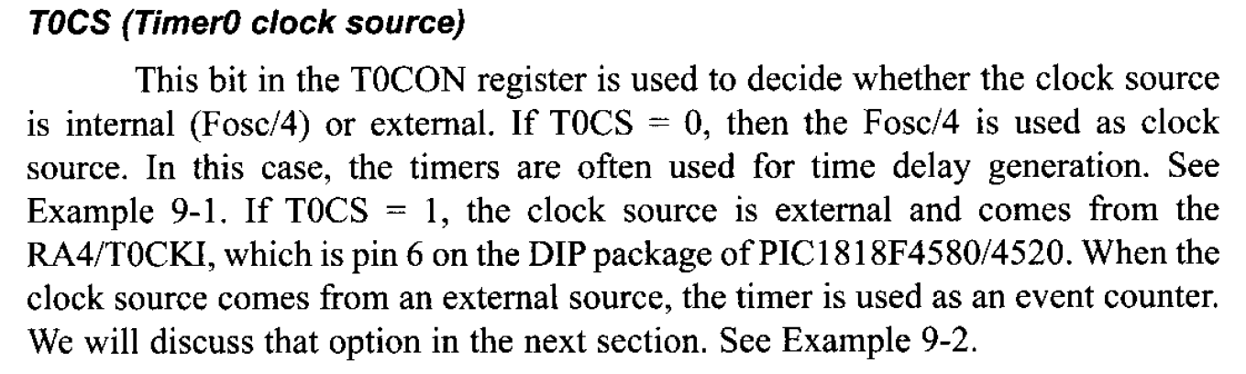
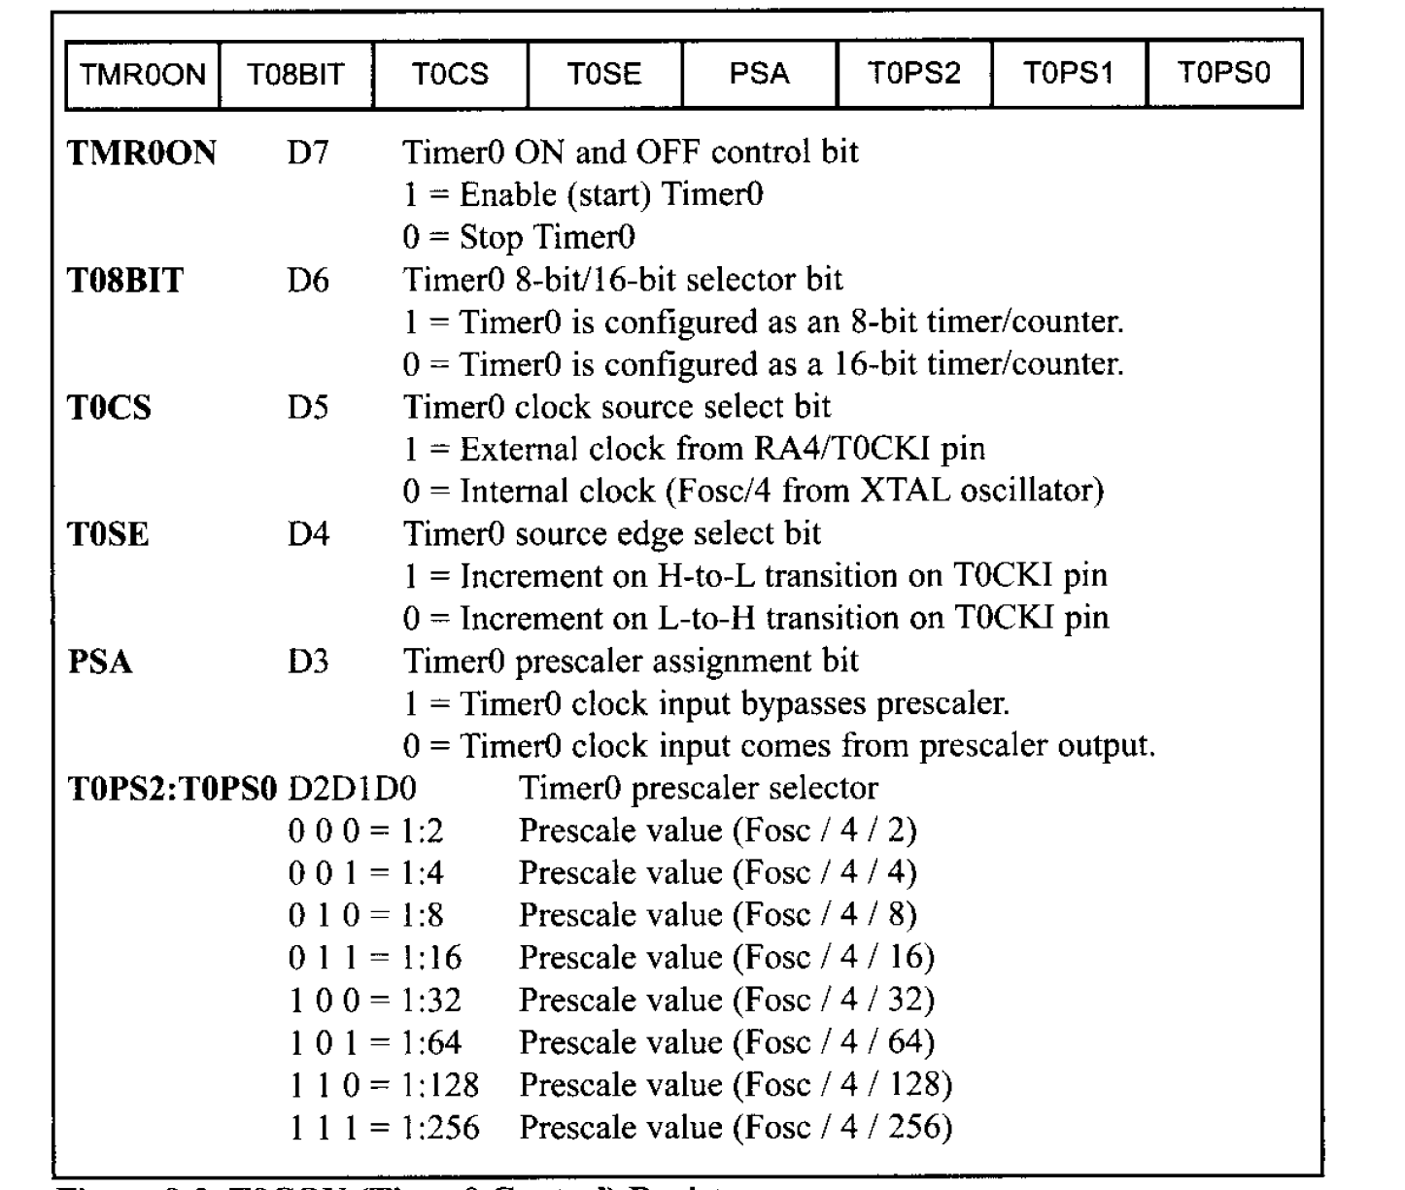
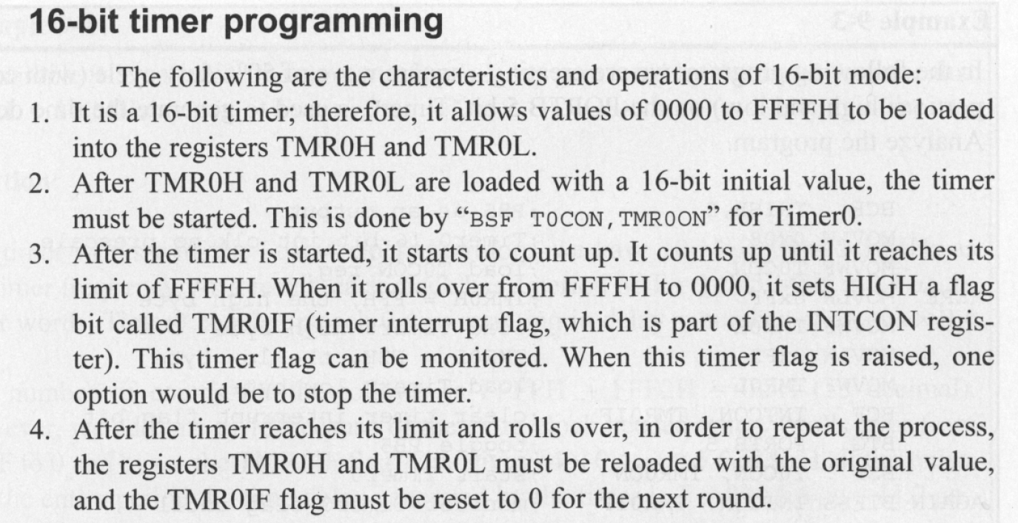

Lab Exercise
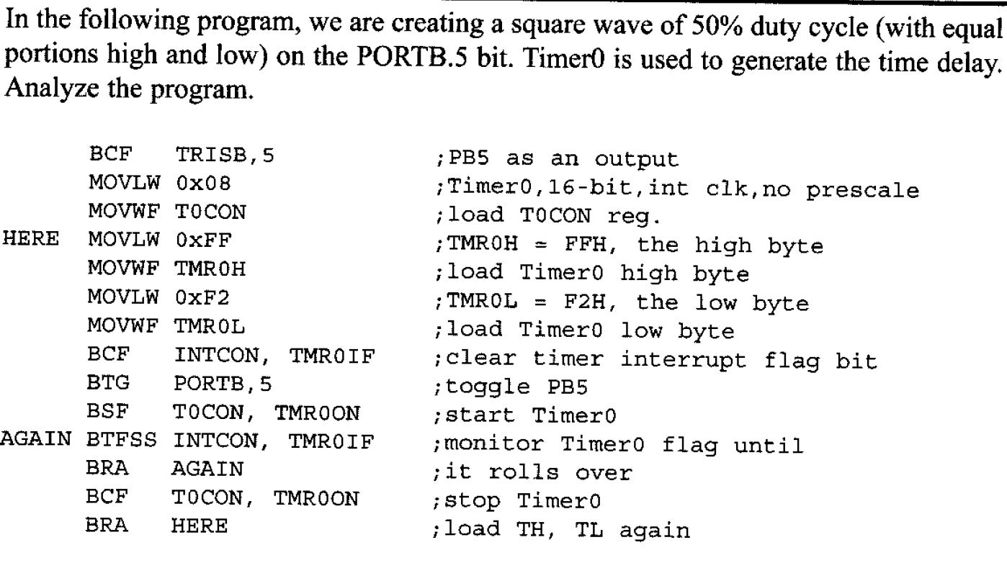
Also calculate the delay introduced.
________________________________________________________________________________________________________________________________________________________________________________________________________________________________________________________________________________________________________________________________________________________________________________________________________________________________________________________________________________________________________________________________________________________________________________________________________________________________________________________________________________________________________________________________________________________________________________________________________________________________________________________________________________________________________________________________________________________________________________________________________________________________________________________________________________________________________________________________________________________________________________________________________________________________________________________________________________________________
Write down the steps for programming the timer in 16 bit mode.
____________________________________________________________________________________________________________________________________________________________________________________________________________________________________________________________________________________________________________________________________________________________________________________________________________________________________________________________________________________________________________________________________________________________________________________________________________________________________________________________________________________________________________________________________________________________________________________________________________________________________________________________________________________________________________________________________________________________________________________________________________________________________________________________________________________________________________________________________________________________________________________________________________________________________________________________________________________________________________________________________________________________________________________________________________________________________________________________________________________________________________________________________________________________________________________________________________________________________________________________________________________________________________________________________________________________________________________________________________________________________________________________________________________________________________________________________________________________________________________________________________________________________________________________________________________________________________
Calculate the frequency of square waveform generated at pin PORTB.5
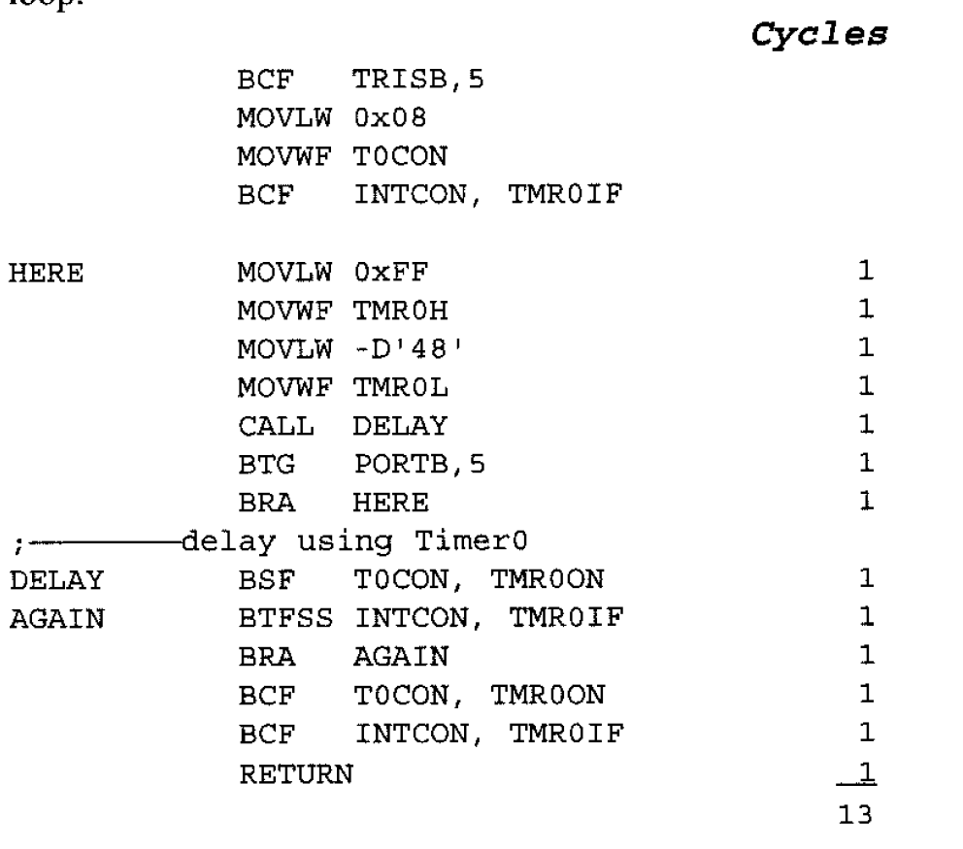

____________________________________________________________________________________________________________________________________________________________________________________________________________________________________________________________________________________________________________________________________________________________________________________________________________________________________________________________________________________
Write a program to generate a square waveform with a period of 20msec on pin PORTB.3
____________________________________________________________________________________________________________________________________________________________________________________________________________________________________________________________________________________________________________________________________________________________________________________________________________________________________________________________________________________________________________________________________________________________________________________________________________________________________________________________________________________________________________________________________________________________________________________________________________________________________________________________________________________________________________________________________________________________________________________________________________________________________________________________________________________________________________________________________________________________________________________________________________________________________________________________________________________________________________________________________________________________________________________________________________________________________________________________
Generate a square waveform of 3KHz frequency on pin PORTB.3
________________________________________________________________________________________________________________________________________________________________________________________________________________________________________________________________________________________________________________________________________________________________________________________________________________________________________________________________________________________________________________________________________________________________________________________________________________________________________________________________________________________________________________________________________________________________________________________________________________________________________________________________________________________________________________________________________________________________________
Compare the 8-bit and 16-bit timer mode of PIC microcontroller
________________________________________________________________________________________________________________________________________________________________________________________________________________________________________________________________________________________________________________________________________________________________________________________________________________________________________________________________________________________________________________________________________________________________________________________________________________________________________________________________________________________________________________________________________________________________________________________________________________________________________________________________________________________________________________________________________________________________________
What is the minimum frequency that you can generate using 16-bit timer mode?
________________________________________________________________________________________________________________________________________________________________________________________________________________________________________________________________________________________________________________________________________________________________________________________________________________________________________________________________________________________________________________________________________________________________________________________________________________________________________________________________________________________________________________________________________________________________________________________________________________________________________________________________________________________________________________________________________________________________________

