Remote Monitoring and Control of Environmental Variables via GSM
____________________________________________________

Submitted By
Warda Mustafa (104)
Sadia Abdul Samad (113)
Sana Jaweed (117)
Maryam Masood (129)

ABSTRACT
Aim of this project is to make it possible for a remote user to remain in touch with what is happening at his home/office. To achieve this goal first we have selected two environmental variables to be monitored i.e. temperature and light. The system we have designed selects one of the two environmental variables to be sense continuously. After this temperature or light is monitored using sampling circuits and then if it goes above from a defined value, the user is then informed by SMS through GSM Network. Then from an appropriate response in the form of text message, appliance can be switched ON/OFF.
Table of Contents
Chapter 1: Introduction 1
1 Introduction 2
1.1 Purpose 3
1.2 Project Overview 4
1.3 Features 4
1.4 Scope 5
1.5 Block Diagram 6
Chapter 2: History of GSM 7
2 GSM 8
2.1 GSM Features 9
2.2 Short Message Service (SMS) 9
Chapter 3: Hardware Components 10
3 Components list with specifications 11
3.1 Communicators & Cables 12
3.1.1 Cell Phone (Ericsson T68i) 12
3.1.2 T68i data cable 13
3.1.3 RS232 Serial Port 15
3.2 Sensors 17
3.2.1 Temperature Sensor (LM35) 17
3.2.2 Light Sensor (LDR) 18
3.3 IC’s 21
3.3.1 Microcontroller AT89C51 21
3.3.2 Analog to digital converter (ADC0804) 23
Multiplexer (CD4051) 25
3.3.3 TTL Logic Converter MAX232 27
3.3.4 Relay 29
3.3.5 LCD 16x4 30
3.3.6 Voltage Regulator (7805): 31
Chapter 4: AT Commands 32
4 AT commands: 33
4.1 Types of AT commands 33
4.2 Type of Extended AT Commands: 34
Chapter 5: SMS Using Ericsson T68i 36
5 SMS using Ericsson T68i 37
5.1 Introduction of SMS 37
5.2 Technical details of SMS 37
5.3 The PDU format 38
5.3.1 Receiving a message in the PDU mode 38
5.3.2 Interpreting 8-bit octets as 7-bit messages 41
5.3.3 Coding 7-bit data (septets) into octets 42
5.3.4 Making octets: 43
5.3.5 Sending a message in the PDU mode 47
Chapter 6: Software Requirements 48
6 Software Used 49
6.1 Testing Software 50
6.1.1 HyperTerminal Introduction 50
6.1.2 AT Commands Implementation on HyperTerminal 51
6.1.3 Real Term Introduction 54
6.1.4 AT Commands on Realterm 55
6.2 Software for Designing 56
6.2.1 Keil µVision2 Introduction 56
6.2.2 Programming in Keil µVision2 56
6.2.3 Proteous 7 Professional 57
Chapter 7: Hardware Design & implementation 58
7 Hardware Development 59
7.1 Implementation of Hardware circuit design 60
7.2 Sensing unit 60
7.2.1 Sensing unit Block 60
7.2.2 Sensing circuit design implementation on Proteous 61
7.3 Monitoring Unit: 62
7.3.1 Monitoring unit Block 62
7.3.2 Sensing Circuit Design Implementation 63
7.4 Switching Unit: 64
7.4.1 Switching unit Block 64
7.4.2 Switching Circuit Design Implementation 64
7.4.3 Working: 64
7.5 PCB Design and Layout 65
Chapter 8: Software Development 67
8 Assembly language Program 68
1 Appendix A: Hardware components Specifications Features & details i
1.1 Specifications of T68i: i
1.2 Detailed Pin Description of 8051 ii
1.3 Resolution Detail of ADC0804: v
1.4 MAX232 Application Circuit: vi
1.5 MAX232 Interfacing with Microcontroller: vii
1.6 Technical Specifications of LCD viii
1.7 Block Diagram of 7805: ix
1.8 7805 voltage regulator circuit diagram: ix
APPENDICES
2 APPENDEX B: AT Commands for ERICSSONT68i x
2.1 List of AT Commands for Sony Ericsson x
List Of Refences
Web References xi
Book References xi

LIST OF FIGURES
Figures | Description | Page No.
1.1 | Block Diagram | 6
3.1 | Characteristic curve of LM35 | 17
3.2 | LDR circuit 1 | 19
3.3 | LDR circuit 2 | 20
3.4 | Pin configuration of AT89C51 | 21
3.5 | Pin configuration of ADC0804 | 23
3.6 | Pin configuration of Multiplexer 4051 | 26
3.7 | Pin configuration of MAX232 | 28
3.8 | Relay Connections | 29
3.9 | Connections of 7805 | 31
7.1 | Detailed Block Diagram | 60
7.2 | Sensing Unit Block Diagram | 61
7.3 | Monitoring Unit Block Diagram | 63
7.4 | Sensing Circuit Design | 64
7.5 | Communication Block Diagram | 64
7.6 | Switching Unit | 65
7.7 | Switching Circuit Design | 65

LIST OF ABBREVIATIONS
GSM | Global System for Mobile Communication
SMS | Short Message Service
AT | Attention
TDMA | Time Division Multiple Access
FDMA | Frequency Division Multiple Access
LED | Light Emitting Diode
CD | Carrier Detect
RXD | Receive Data
TXD | Transmit Data
DTR | Data Terminal Ready
GND | System Ground
DSR | Data Set Ready
RTS | Request to Send
CTS | Clear to Send
RI | Ring Indicator
PSEN | Program Store Enable
ALE | Address Latch Enable
BSS | Base stations
ISDN | Integrated Service Digital Network
GPRS | General Packet Radio Switching
SIM | Subscriber Identity Module
Tx | Transmit
Rx | Receive
DTE | Data Terminal Equipment
DCE | Data Communication Equipment
GND | Ground
LDR | Light Dependent Resistor
LED | Light Emitting Diode
A/D | Analogue to digital
RAM | Random Access Memory
CPU | Central Processing unit
RST | Reset
XTAL | Crystal
TTL | Transistor Transistor Logic
CMOS | Complimentary Metal Oxide Semiconductor
NC | Normally Close
NO | Normally Open
PC | Personal Computer
UDH | User Data Header
RS232 | Recommended Standard 232
PDU | Protocol Description Unit

Chapter 1: Introduction

Introduction

In this project a remote place is selected to be monitored and controlled. Then some environmental variables (e.g. Temperature & light) are monitored continuously and information of that remote place is sent to the user via SMS using GSM network. When the user replies in a specific format using SMS, the information is processed and proper actions are taken. For example if temperature increases to a specified limit, by switching the air conditioner ‘ON’ the temperature is decreased or if temperature goes below a specific level the temperature will be increased by switching a heater ‘ON’. All actions are performed with the consent of the user. Similarly, if light intensity of that place goes below some certain threshold, the user is informed and lights are switched ‘ON’, if appropriate reply is received. All of the above communication between user and the remote area is done using GSM technology.

Purpose

Purpose of this project is to make it possible for a remote user to remain in touch with what is happening at his home/office. To achieve this goal first of all temperature/light intensity of remote place is monitored using sampling circuits and then information of high temperature or light is sent to the user, who replies to switch appliances on/off. For this purpose another circuit is designed.
Text messages can be received with the occurrence of an event automatically to GSM mobile (cell) phones. Command messages can be transmitted and switched the output-switch on/off remote equipment .SMS messages at occurrence of the certain events can be received- operation of entrance sensors. SMS messages can be sent for management of the various equipments (the conditioner, the heating equipment).
Our project can be used in warehouses where the refrigerators and freezers contain stock that has a significant value. By using our remote control module attached to the thermostat, the refrigeration company responsible for maintenance can be notified as soon as the temperature rises above a certain point. Once it is notified a technician can be dispatched to rectify the problem.

Project Overview
Our project “Remote Monitoring & Control of Environmental Variables via GSM” uses AT commands to inform remote user. When the user replies in a specific format using SMS, the information is processed and proper actions are taken.
- It solves the problem of manual monitoring
- Remote access is possible
- Device can also be controlled
The basic system comprises of 4 elements:
- The remote unit itself together with the remote equipment to be monitored and controlled
- The GSM network message carrier service
- A mobile phone capable of GSM text messaging (SMS)
- The user(s)
Communication is by means of simple text messages in a special format that allows a high degree of security whilst allowing a flexible naming system for monitored and controlled functions.

Features
- Simple user interface i.e. uses standard text messages
- Low Power Consumption
- Almost unlimited range using GSM network
- 1 mobile phone can monitor and control many remote units
- Reduced man power
- Automatically sends alarm messages when go above threshold value
- Interrogate on demand functions

Scope

Global System for Mobile communication (GSM) has been one of the best trustable wireless communication system that can be accessed and used very easily. It is cost effective either if we consider the price of its transceiver module (a simple cellular phone) or the subscription fees. With the trend of huge growing usage of GSM during the past decade, network services are extended beyond speech communication to so many other custom specified applications, machine automation and machine-to-machine communication. This communication is implemented by using an AT command interfaced to a mobile phone. The user sends GSM data in the form of SMS (short message service) message to switch level above to below of any variable under consideration, like light, temperature etc.
The GSM network provides full duplex link to support the user requirement. The user can access the application remotely through SMS service where his message read and decoded by the micro controller attached to the mobile set through a suitable interface, usually data cable is used but also either Blue tooth or infrared links can be used.

Block Diagram

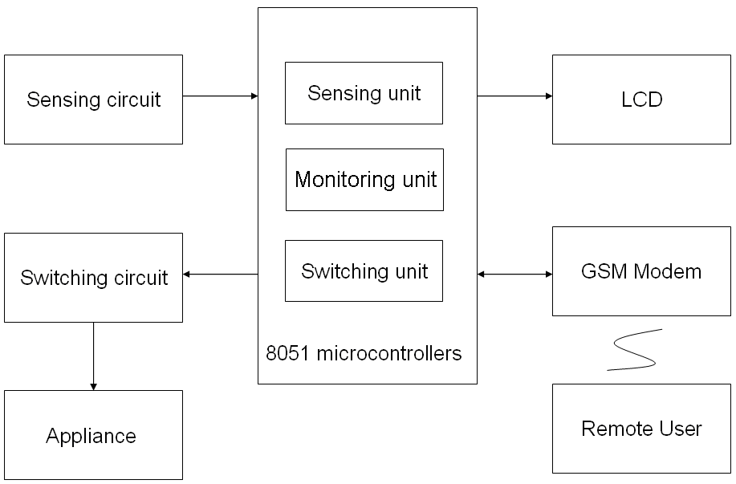

Fig 1.1

Chapter 2: History of GSM

GSM

GSM is the most popular standard for mobile telephony systems in the world. Its ubiquity enables international roaming arrangements between mobile phone operators, providing subscribers the use of their phones in many parts of the world.
- GSM stands for Global System for Mobile Communication and is an open, digital cellular technology used for transmitting mobile voice and data services.
- The GSM standard is the most widely accepted standard and is implemented globally.
- The GSM makes use of narrowband Time Division Multiple Access (TDMA) technique for transmitting signals.
- The GSM was developed using digital technology. It has an ability to carry 64 kbps to 120 Mbps of data rates.
- The GSM provides basic to advanced voice and data services including Roaming service. Roaming is the ability to use your GSM phone number in another GSM network.
A GSM digitizes and compresses data, then sends it down through a channel with two other streams of user data, each in its own time slot. It operates at either the 900 MHz or 1,800 MHz frequency band.
GSM carrier frequencies
GSM networks operate in a number of different carrier frequency ranges (separated into GSM frequency ranges for 2G and UMTS frequency bands for 3G), with most 2G GSM networks operating in the 900 MHz or 1800 MHz bands.

GSM Features

GSM covers making phone calls, sending SMS text messages, and access to Internet via GPRS. A SIM (Subscriber Identity Module) card is given along the contract with an operator, and the customer inserts the card in the phone to authorize it for use other than emergency dialing.
One of the most useful and popular feature of GSM that we are using is SMS.

Short Message Service (SMS)
Short Message Service (SMS) is the text communication service component of phone, web or mobile communication systems, using standardized communications protocols that allow the exchange of short text messages between fixed line or mobile phone devices. SMS text messaging is the most widely used data application in the world.

Chapter 3: Hardware Components

Components list with specifications

- Communicators & Cables
  - Cell Phone Ericsson T68i
  - Data Cable For Ericsson T68i
  - Serial Port DB-9

- Sensors
  - Temperature Sensor LM35
  - Light Sensor LDR

- IC’s
  - Micro Controller 8051
  - Analog to Digital Convertor ADC0804
  - MUX 4051
  - TTL Logic Converter MAX232

- Relay 5V,12 Ampere, support 220V

- LCD 16X4

- Voltage Regulator 7805

- Battery 9 volts

- Resistors
  - Variable resistor 10k
  - Resistors 1k,470ohm,

- LED Color: Red(for Power indication)

- Diode 1N4007

- Capacitors 104,33pF

- Crystal Oscillator 11.0592 MHz

Communicators & Cables

Cell Phone (Ericsson T68i)

The Ericsson T68i is a compact mobile phone manufactured by the Ericsson company in 1999. It was the lightest and slimmest phone at the time, with a weight of only 81 grams unlike cell phones of the time (1999-2001) it had a fixed, stubby external antenna.

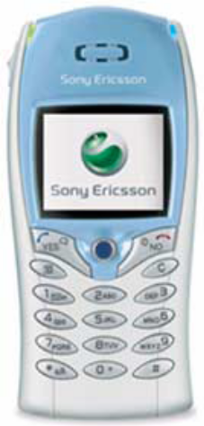

Ericsson T68i supports AT commands, so we use this cell phone to receive data from serial port and also to transmit it.

T68i data cable
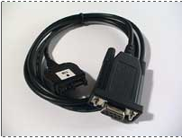
The T68i and data cable is used by a great number of people to unlock and flash (service cable) and to transfer files and phonebooks (data cable) on [Sony] Ericsson phones.

The data cable utilizing four wires for GND, +5 (for cable circuit), Rx (Receive data) and Tx (Transmit data), three of which needs to be altered.

Ends of the data cable

The two ends of data cable are
  - Phone connector
  - Serial connector
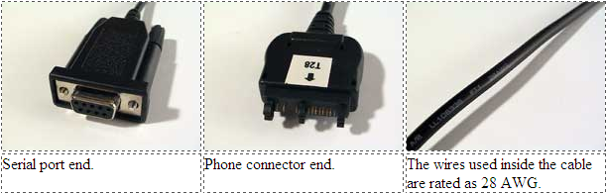
Phone Connector
The phone connector can easily be opened just by pressing the two tabs on the back end together and the front tabs apart and it easily flip open, here is the view of phone connector side of T68i data cable.
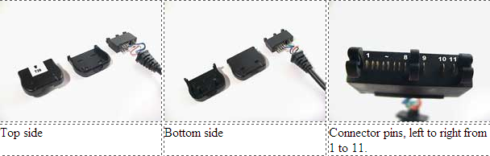
Serial Connector
All the conversion is done on this side, the connector is glued togeter with it, there is a RS 232 circuit embedded in a small chip and connected to the serial connector. Here is a view of serial connector side of T68i data cable
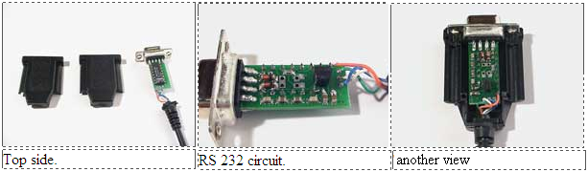

Data cable Wiring
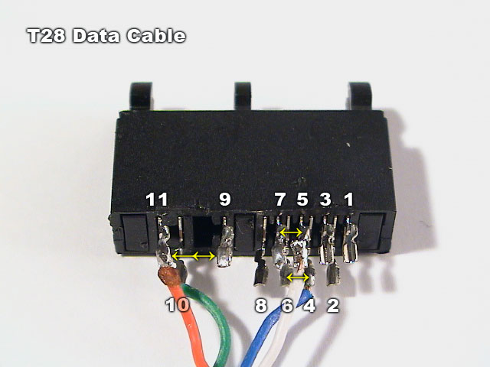
Here is a wiring overview of data cable
4. Data to Phone (Rx)
5. Data from Phone (Tx)
9. Test & Flash. NOT CONNECTED!
10. Ground
11. +5v for cable circuit

RS232 Serial Port

RS or Recommended Standard-232 is a standard for computer data communications introduced in 1960. Today, the majority of all personal computers have the capability of utilizing this form of data communications.
Officially, RS-232 is defined as the
“Interface between data terminal equipment and data communications equipment using serial binary data exchange.”
This definition defines data terminal equipment (DTE) as the computer, while data communications equipment (DCE) is the modem. A modem cable has pin-to-pin connections, and is designed to connect a DTE device to a DCE device. It specified signal voltages, signal timing, signal function, a protocol for information exchange, and mechanical connectors.

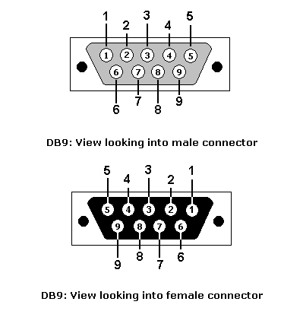 Standards of RS232:

The RS-232 standard supports two types of connectors,
- The 25 pin DB-25 connector
- The 9 pin DB-9 connector

DB-9 connector:
In our project, DB9 connector standard of RS232 is used.
These diagrams show the male and female pin numbering for DB9 sub-miniature connectors. Generally Pin 1 is marked on the front of the connector right next to the pin. Some manufacturers mark each pin number on the plastic housing at the rear of the connector. The male connector has the sticking out.

Pin Configuration of DB-9 Connector:

DB-9 Pin | IDC internal  pin name* | Name | Dir | Description
1 | 1 | CD |  | Carrier Detect
2 | 3 | RXD |  | Receive Data
3 | 5 | TXD |  | Transmit Data
4 | 7 | DTR |  | Data Terminal Ready
5 | 9 | GND |  | System Ground
6 | 2 | DSR |  | Data Set Ready
7 | 4 | RTS |  | Request to Send
8 | 6 | CTS |  | Clear to Send
9 | 8 | RI |  | Ring Indicator

Sensors

Temperature Sensor (LM35)

Introduction
The LM35 is an integrated circuit sensor that can be used to measure temperature with an electrical output proportional to the temperature (in ºC).

Features of LM35

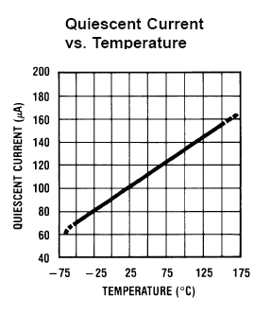
- Calibrated directly in ° Celsius (Centigrade)
- Linear + 10.0 mV/°C scale factor
- 0.5°C accuracy guarantee able (at +25°C)
- Rated for full −55° to +150°C range
- Suitable for remote applications
- Low cost due to wafer-level trimming
- Operates from 4 to 30 volts
- Less than 60 μA current drain
- Low self-heating, 0.08°C in still air
Fig 3.1
- No linearity only ±1⁄4°C typical
- Low impedance output, 0.1 for 1 mA load

Advantages
- It measures temperature more accurately than a using a thermistor.
- The sensor circuitry is sealed and not subject to oxidation, etc.
- The LM35 generates a higher output voltage than thermocouples and may not require that the output voltage be amplified.

Electrical Connections of LM35
- Here is a commonly used circuit. For connections refer to the picture above.
- In this circuit, parameter values commonly used are:
i) V_{c} = 4 to 30v
ii) 5v or 12 V are typical values used.
iii) R_{a} = V_{c} /10⁻⁶
Actually, it can range from 80 KW to 600 KW, but most just use 80 KW.
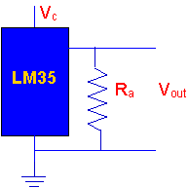

Light Sensor (LDR)

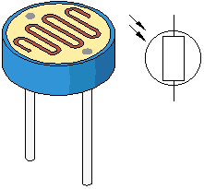
Principle
Light Dependent Resistance [LDR] is a resistance, in which opposing power of current depends on the presence of quantity of light present, i.e. the resistance of LDR increases or decreases, according to quantity of light, which falls on it.
If LDR places in darkness, the resistance of LDR increases and when light falls on it, the resistance of LDR decreases and acts as a conductor. Any LDR in the presence of light and darkness changes its resistance is depends on the different types of LDR.

Advantages
- By using laser, it can be used for security purposes.
- It can be used to stop the wastage of electricity.
- The cost of circuit is low.
- This circuit saves the men's power.

Light Dependent Resistor Circuits
There are two basic circuits using light dependent resistors.
- The first is activated by darkness.
- The second is activated by light.
The two circuits are very similar and just require an LDR, some standard resistors, a variable resistor (potentiometer), and any small signal transistor.
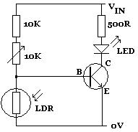
Fig 3.2

In the above circuit diagram, the LED lights up whenever the LDR is in darkness. The 10K variable resistor is used to fine-tune the level of darkness required before the LED lights up. The 10K standard resistor can be changed as required to achieve the desired effect, although any replacement must be at least 1K to protect the transistor from being damaged by excessive current.
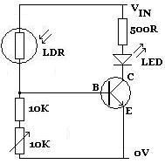
Fig 3.3
By swapping the LDR over with the 10K and 10K variable resistors (as shown above), the circuit will be activated instead by light. Whenever sufficient light falls on the LDR (manually fine-tuned using the 10K variable resistor),the LED will light up.
The Output Voltage is then passed to 8-bit A/D Converter as the input. The output of the A/D converter is passed to the PC through parallel port. The reading is then evaluated in the software and decision is made based on the maximum and minimum threshold of light intensity, whether to switch on or off lights.
As single A/D Converter is used hence input of this converter must be switched between the two sensing circuits, i.e. Temperature sensing circuit and Light sensing circuit.

IC’s

Microcontroller AT89C51

The AT89C51 provides the following standard features:
- 4K bytes of Flash,
- 128 bytes of RAM,
- 32 I/O lines,
- Two 16-bit timer/counters,
- A five vector two-level interrupt architecture,
- Full duplex serial port,
- On-chip oscillator and clock circuitry

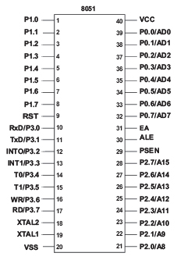
In addition, the AT89C51 is designed with static logic for operation down to zero frequency and supports two software selectable power saving modes. The Idle Mode stops the CPU while allowing the RAM, timer/counters, serial port and interrupt system to continue functioning. The Power-down Mode saves the RAM contents but freezes the oscillator disabling all other chip functions until the next hardware reset.

Pin outs

Fig 3.4

Brief Pin Description

Pin Number | Description
1 - 8 | P1.0 - P1.7 - Port 1
9 | RST - Reset
10 - 17 | P3.0 - P3.7 - Port 3
18 | XTAL2 – Crystal
19 | XTAL1 – Crystal
20 | GND – Ground
21-28 | P2.0 - P2.7 - Port 2
29 | PSEN - Program Store Enable
30 | ALE - Address Latch Enable
31 | EA - External Access Enable
32-39 | P0.7 - P0.1 - Port 0
40 | Vcc - Positive Power Supply

Analog to digital converter (ADC0804)
ADC is an electronic device that converts an input analog voltage (or current) to a digital number proportional to the magnitude of the voltage or current. Differential analog voltage inputs allow increasing the common-mode rejection and offsetting the analog zero input voltage value. In addition, the voltage reference input can be adjusted to allow encoding any smaller analog voltage span to the full 8 bits of resolution.
An analog-to-digital converter (abbreviated ADC, A/D or A to D) is a device that converts a continuous quantity to a discrete digital number. Typically, an ADC is an electronic device that converts an input analog voltage (or current) to a digital number proportional to the magnitude of the voltage or current.

Pin outs
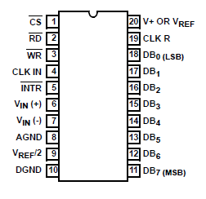
Fig 3.5

Electrical Symbol
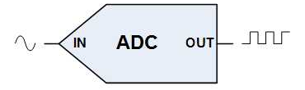

Key Specification

Resolution | 8 bits
Total error | ±¼ LSB, ±½ LSB and ±1 LSB
Conversion time | 100 µs

Features

• 80C48 and 80C80/85 Bus Compatible - No Interfacing Logic Required
• Easy Interface to Most Microprocessors
• Differential Analog Voltage Inputs
• TTL Compatible Inputs and Outputs
• On-Chip Clock Generator
• Analog Voltage Input Range (Single + 5V Supply) 0V to 5V

Multiplexer (CD4051)

The CD4051 is a single 8 channel multiplexer having three binary control inputs, A, B, and C, and an inhibit input. The three binary signals select 1 of 8 channels to be turned on, and connect one of the 8 inputs to the output.

Features

- Logic Level Conversion
- High-Voltage Types (20V Rating)
- CD4051BMS Signal 8-Channel
- Wide Range of Digital and Analog Signal Levels:
  - Digital 3V to 20V
  - Analog to 20Vp-p
- Very Low Quiescent Power Dissipation Under All Digital
- Control Input and Supply Conditions: 0.2μW (typ) at
VDD - VSS = VDD - VEE = 10V
- 5V, 10V and 15V Parametric Ratings
- Break-Before-Making Switching Eliminates Channel Overlap

Pin outs

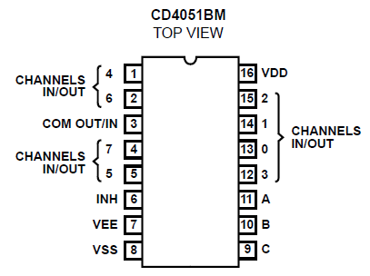
Fig 3.6

TTL Logic Converter MAX232

Usually all the digital ICs works on TTL or CMOS voltage levels, which cannot be used to communicate over RS-232 protocol. So a voltage or level converter is needed which can convert TTL to RS232 and RS232 to TTL voltage levels.
The most commonly used RS-232 level converter is MAX232.
The MAX232 is an integrated circuit that converts signals from an RS-232 serial port to signals suitable for use in TTL compatible digital logic circuits. The MAX232 is a dual driver/receiver and typically converts the RX, TX, CTS and RTS signals.
The drivers provide RS-232 voltage level outputs (approx. ± 7.5 V) from a single + 5 V supply via on-chip charge pumps and external capacitors. This makes it useful for implementing RS-232 in devices that otherwise do not need any voltages outside the 0 V to + 5 V range, as power supply design does not need to be made more complicated just for driving the RS-232 in this case.
The receivers reduce RS-232 inputs (which may be as high as ± 25 V), to standard 5 V TTL levels. These receivers have a typical threshold of 1.3 V, and a typical hysteresis of 0.5 V.
The later MAX232A is backwards compatible with the original MAX232 but may operate at higher baud rates and can use smaller external capacitors – 0.1 μF in place of the 1.0 μF capacitors used with the original device.
- The MAX232 contains two EIA232 (RS232) Transmitters & two Receivers in one package.
- The MAX232 has better noise immunity and zap and latch-up protection.

MAX232 Pin out:

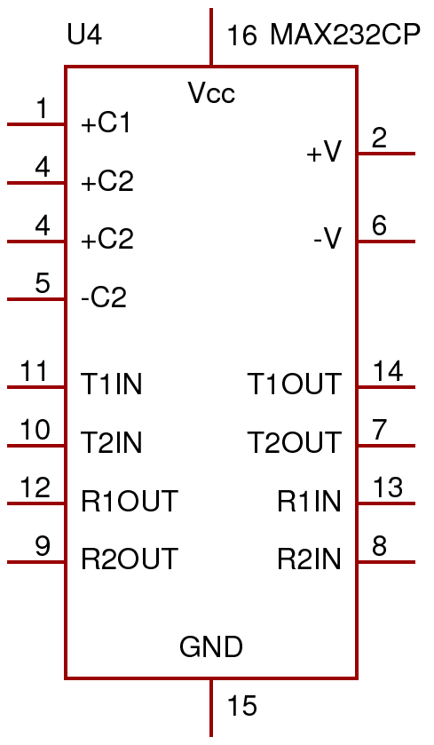

Fig 3.7

Relay

A relay is a simple electromechanical switch made up of an electromagnet and a set of contacts. Relays are used in virtually every type of electronic device to switch voltages and electronic signals.

Relay Construction
- Electromagnet
- Armature that can be attracted by the electromagnet
- Spring
- Set of electrical contacts

Working of Relay

When electricity is applied to the coil of wire it becomes magnetic, hence the term electromagnet. The A, B and C terminal are an SPDT switch controlled by the electromagnet. When electricity is applied to V1 and V2, the electromagnet acts upon the SPDT switch so that the B and C terminals are connected. When the electricity is disconnected, then the A and C terminals are connected. It is important to note that the electromagnet is magnetically linked to the switch but the two are NOT linked electrically.

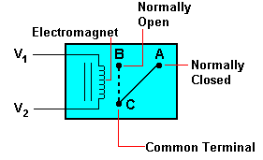
Fig 3.8

LCD 16x4
The LCD we are using is a programmable LCD display, with 4 lines of 16 characters. One default message and up to 49 other messages are programmable using an onboard RS-232 serial port and supplied Windows software.
Any of the 49 remaining pre-programmed messages can be displayed by closing the respective onboard 7x7 matrix terminals.
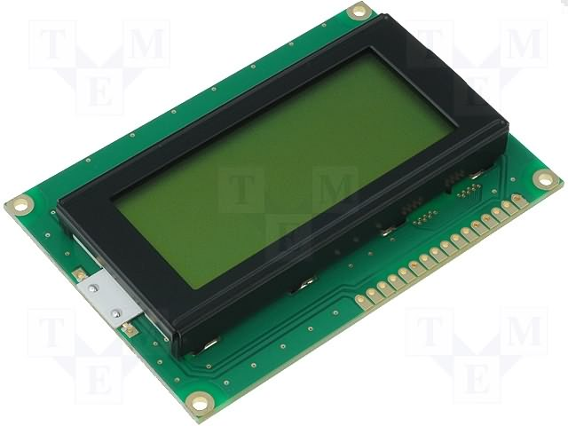

Functions include
- RS-232 serial connector for quick message programming
- External message activation using any 'make' contact e.g. switches, relays, open collector outputs or simply push buttons
- Single or dual line messages
- Character set includes lower and uppercase letters, 0-9, !"#$%&'()*+,-./:;<=>?@[]_{}¥|^`’
- Relay output for controlling external devices.
- Luminescence control
The module includes protection against inverse polarity, indicator LED and screw terminal connections. Simply install the supplied software on a Windows PC equipped with a serial port and software.

Voltage Regulator (7805):

In electronics, a linear regulator is a voltage regulator based on an active device (such as a bipolar junction transistor, field effect transistor or vacuum tube) operating in its "linear region" (in contrast, a switching regulator is based on a transistor forced to act as an on/off switch) or passive devices like zener diodes operated in their breakdown region. The regulating device is made to act like a variable resistor, continuously adjusting a voltage divider network to maintain a constant output voltage. It is very inefficient compared to a switched-mode power supply, since it sheds the difference voltage by dissipating heat.

Pin out of Voltage Regulator:

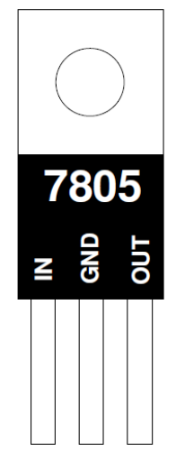
Fig 3.9

Features of 7805:
- Output Current up to 1A
- Output Voltages of 5 volt
- Thermal Overload Protection
- Short Circuit Protection
Chapter 4: AT Commands

AT commands:
AT commands are instructions used to control a modem. AT is the abbreviation of Attention. Every command line starts with "AT" or "at". That's why modem commands are called AT commands. Many of the commands that are used to control wired dial-up modems, such as ATD (Dial), ATA (Answer), ATH (Hook control) and ATO (Return to online data state), are also supported by GSM/GPRS modems and mobile phones. Besides this common AT command set, GSM/GPRS modems and mobile phones support an AT command set that is specific to the GSM technology, which includes SMS-related commands like AT+CMGS (Send SMS message), AT+CMSS (Send SMS message from storage), AT+CMGL (List SMS messages) and AT+CMGR (Read SMS messages).

Types of AT commands
There are two types of AT commands:
- Basic commands
- Extended commands.
Basic commands are AT commands that do not start with "+". For example, D (Dial), A (Answer), H (Hook control) and O (Return to online data state) are basic commands.
Extended commands are AT commands that start with "+". All GSM AT commands are extended commands. For example, +CMGS (Send SMS message), +CMSS (Send SMS message from storage), +CMGL (List SMS messages) and +CMGR (Read SMS messages) are extended commands

Type of Extended AT Commands:

Test Command
AT+<X>=?
The mobile equipment returns the list of parameters and value ranges set with the corresponding Write command or by internal processes
Read Command
AT+<X>?
This command returns the currently set value of the parameter or parameters.
Set Command
AT+<X>=<…>
This command sets the user-definable parameter values.
Execution Command
AT+<X>
The execution command reads non-variable parameters affected by internal processes in the GSM engine.
Some common AT commands:
Command | Description
AT+CMGF | Select SMS message format
AT+CMGF=0 | PDU mode
AT+CMGF=1 | TEXT mode
ATA | answer an incoming call
ATH | disconnect the existing connection
ATDL | redial the last number
AT+CMGL | LIST SMS MESSAGES
AT+CMGS | SEND SMS MESSAGE
AT+CMGR | read the SMS
AT+CMGD | delete the SMS
AT+CMGW | WRITE SMS MESSAGE TO MEMORY
AT+CMSS | SEND SMS MESSAGE FROM STORAGE
AT+CMGC | SEND SMS COMMAND
AT+CNMI | NEW SMS MESSAGE INDICATIONS
AT+CPMS | PREFERRED SMS MESSAGE STORAGE
AT+CRES | RESTORE SMS SETTINGS
AT+CSAS | SAVE SMS SETTINGS
AT+CSCA | SMS SERVICE CENTER ADDRESS
AT+CSCB | SELECT CELL BROADCAST SMS MESSAGES
AT+CSDH | SHOW SMS TEXT MODE PARAMETERS
AT+CSMP | SET SMS TEXT MODE PARAMETERS
AT+CSMS | SELECT MESSAGE SERVICE

Chapter 5: SMS using Ericsson T68i

SMS using Ericsson T68i

Introduction of SMS
Short Message Service (SMS) is a service available on most digital mobile phones (and other mobile devices, e.g. a Pocket PC, or occasionally even desktop computers) that permits the sending of short messages (also known as text messages) between mobile phones, other handheld devices and even landline telephones. Other uses of text messaging can be for ordering ring tones, wallpapers and entering competitions.

Technical details of SMS
Messages are sent via a store-and-forward mechanism to a Short Message Service Centre (SMSC), which will attempt to send the message to the recipient and possibly retry if the user is not reachable at a given moment. Message delivery is best effort, so there are no guarantees that a message will actually be delivered to its recipient and delay or complete loss of a message is not uncommon, particularly when sending between networks. Users may choose to request delivery reports, which can provide positive confirmation that the message has reached the intended recipient.
Transmission of the short messages between SMSC and phone can be done through different protocols such as SS7 within the standard GSM MAP framework or TCP/IP within the same standard.
Larger content (known as long SMS or concatenated SMS) can be sent segmented over multiple messages, in which case each message will start with a user data header (UDH) containing segmentation information. Since UDH is inside the payload, the number of characters per segment is lower: 153 for 7 bit encoding, 134 for 8 bit encoding and 67 for 16 bit encoding. The receiving phone is then responsible for reassembling the message and presenting it to the user as one long message. While the standard theoretically permits up to 255 segments, 6 to 8 segment messages are the practical maximum, and long messages are billed as equivalent to multiple SMS messages.
Some service providers offer the ability to send messages to land line telephones regardless of their capability of receiving text messages by automatically phoning the recipient and reading the message aloud using a speech synthesizer along with the number of the sender.
Today, SMS is also used for machine to machine communication. For instance, there is a LED display machine controlled by SMS, and some vehicle tracking companies like ESITrack use SMS for their data transport or telemetry needs.

The PDU format
There are two ways of sending and receiving SMS messages: by text mode and by PDU (protocol description unit) mode. The text mode (unavailable on some phones) is just an encoding of the bit stream represented by the PDU mode. Alphabets may differ and there are several encoding alternatives when displaying an SMS message. These are all set by the at-command AT+CSCS, when you read the message in a computer application. If you read the message on your phone, the phone will choose a proper encoding. An application capable of reading incoming SMS messages can thus use text mode or PDU mode. If text mode is used, the application is bound to (or limited by) the set of preset encoding options. In some cases, that's just not good enough. If PDU mode is used, any encoding can be implemented.

Receiving a message in the PDU mode
AT command | Meaning
+CNMI | New message indications
+CMGL | List messages
+CMGR | Read messages
+CNMA | New message acknowledgement
The PDU string contains not only the message, but also a lot of meta-information about the sender, his SMS service center, the time stamp etc. It is all in the form of hexa-decimal octets or decimal semi-octets. The following string is an example received on a Ericsson T28 when sending the message containing "1" from any other mobile.
AT+CPMS="ME"
AT+CMGL=0
AT+CMGR=1
AT+CMGD=1
07 | 91294355000001 | 240C912943450248880000607051815273020131

This octet sequence consists of three parts: An initial octet indicating the length of the SMSC information ("07"), the SMSC information itself ("91294355000001"), and the SMS_DELIVER part (specified by ETSI in GSM 03.40).
07 | Length of the SMSC information (in this case 7 octets)
91 | 91 means international format of the phone number
294355000001 | Service center number(in decimal semi-octets). The phone number of this service center is "+923455000010".
24 | First octet of this SMS-DELIVER message.
0C | Address-Length. Length of the sender number (0C hex = 12 dec)
91 | Type-of-address of the sender number
294345024888 | Sender number (+923454208488)
00 | TP-PID. Protocol identifier.
00 | TP-DCS Data coding scheme
60705181527302 | TP-SCTS. Time stamp (semi-octets)
01 | TP-UDL. User data length, length of message. The TP-DCS field indicated 7-bit data, so the length here is the number of septets (1). If the TP-DCS field were set to indicate 8-bit data or Unicode, the length would be the number of octets (9).
31 | 31(HEX)=0011 0001(BIN)= 49(ASCII)  => ‘1’  TP-UD. Message "1" , 8-bit octets representing 7-bit data.

All the octets above are hexa-decimal 8-bit octets, except the Service center number, the sender number and the timestamp; they are decimal semi-octets. The message part in the end of the PDU string consists of hexa-decimal 8-bit octets, but these octets represent 7-bit data (see below).
The semi-octets are decimal, and e.g. the sender number is obtained by performing internal swapping within the semi-octets from "92 34 54 20 48 44" to "29 43 45 02 48 88". The length of the phone number is even. Another example if sender number would be odd then the sender number is obtained by performing internal swapping within the semi-octets from "72 38 88 09 00 F1" to "27 83 88 90 00 1F". The length of the phone number is odd, so a proper octet sequence cannot be formed by this number. This is the reason why the trailing F has been added. The time stamp, when parsed, equals "60705181527302", where the 6 first characters represent date, the following 6 represents time, and the last two represents time-zone related to GMT.
60 70 51 | 06 07 15 | 15th July 2006
81 52 73 | 18 25 37 | 18hrs 25mins 37sec
02 |  | Time Zone 02

Interpreting 8-bit octets as 7-bit messages
This transformation is described in detail in GSM 03.38, and an example of the "high: temp" transformation is shown below. The transformation is based on the 7 bit default alphabet, but an application built on the PDU mode can use any character encoding.
In form of septets:
h 1101000
i 1101001
g 1100111
h 1101000
: 0111010
0100000
t 1110100
e 1100101
m 1101101
p 1110000

Coding 7-bit data (septets) into octets
The message "high: temp" consists of 10 characters, called septets when represented by 7 bits each. These septets need to be transformed into octets for the SMS transfer.
h | i | G | h | :
104 | 101 | 108 | 108 | 111
1101000 | 1101001 | 1100111 | 1101000 | 0111010
  1101000
  110100 | 1
  11001 | 11
  1101 | 000
  011 | 1010
 | t | e | m
104 | 101 | 108 | 108
0100000 | 1110100 | 1100101 | 1101101
  01 | 00000
  1 | 110100
  1100101
  1101101
The first septet (h) is turned into an octet by adding the rightmost bit of the second septet. This bit is inserted to the left which yields 1 + 1101000 = 11101000 ("E8"). The rightmost bit of the second character is then consumed, so the second character (septet) needs two bits (yellow) of the third character to make an 8bit octet. This process goes on and on yielding the following octets:
1
  1101000
  11 | 110100
  000 | 11001
  1010 | 1101
  00000 | 011
E8 | F4 | 19 | AD | 03
  110100 | 01
  1100101 | 1
  0 | 1101101
  00 | 111000
D1 | CB | 6D | 38

Making octets:
11101000
11110100
00011001
10101101
00000011
11010001
11001011
01101101
00111000

1110 1000 E 8
1111 0100 F 4
0001 1001 1 9
1010 1101 A D
0000 0011 0 3
1101 0001 D 1
1100 1011 C B
0110 1101 6 D
0011 1000 3 8
E8F419AD03D1CB6D38 (high: temp)
923314489312
293341849321
Sending "high: temp" TO 923314489312
at+CMGF=0
at+CSMS=0
at+CMGS=23
0011000C912933418493210000AA0AE8F419AD03D1CB6D38

Octet(s) | Description
00 | Length of SMSC information. Here the length is 0, which means that the SMSC stored in the phone should be used. Note: This octet is optional. On some phones this octet should be omitted! (Using the SMSC stored in phone is thus implicit)
11 | First octet of the SMS-SUBMIT message.
00 | TP-Message-Reference. The "00" value here lets the phone set the message reference number itself.
0C | Address-Length. Length of phone number (12)
91 | Type-of-Address. (91 indicates international format of the phone number).
293341849321 | The phone number in semi octets (923314489312). The length of the phone number is even (12). In other case if length would be odd e.g. 11 then a trailing F will be added, as if the phone number were "46708251358F".
00 | TP-PID. Protocol identifier.
00 | TP-DCS. Data coding scheme. This message is coded according to the 7bit default alphabet. Having "04" instead of "00" here, would indicate that the TP-User-Data field of this message should be interpreted as 8bit rather than 7bit (used in e.g. smart messaging, OTA provisioning etc).
AA | TP-Validity-Period. "AA" means 4 days.
0A | TP-User-Data-Length. Length of message. The TP-DCS field indicated 7-bit data, so the length here is the number of septets (10). If the TP-DCS field were set to 8-bit data or Unicode, the length would be the number of octets.
E8F419AD03D1CB6D38 | TP-User-Data. These octets represent the message "high: temp". How to do the transformation from 7bit septets into octets is shown

First octet of the SMS-SUBMIT PDU
The first octet of the SMS-SUBMIT PDU has the following layout:
Bit no | 7 | 6 | 5 | 4 | 3 | 2 | 1 | 0
Name | TP-RP | TP-UDHI | TP-SRR | TP-VPF | TP-VPF | TP-RD | TP-MTI | TP-MTI
where the fields have the following meaning:
Fieldname | Meaning
TP-RP | Reply path. Parameter indicating that reply path exists.
TP-UDHI | User data header indicator. This bit is set to 1 if the User Data field starts with a header
TP-SRR | Status report request. This bit is set to 1 if a status report is requested
TP-VPF | Validity Period Format. Bit4 and Bit3 specify the TP-VP field according to this table:  bit4 bit3  0 0 : TP-VP field not present  1 0 : TP-VP field present. Relative format (one octet)  0 1 : TP-VP field present. Enhanced format (7 octets)  1 1 : TP-VP field present. Absolute format (7 octets)
TP-RD | Reject duplicates. Parameter indicating whether or not the SC shall accept an SMS-SUBMIT for an SM still held in the SC which has the same TP-MR and the same TP-DA as a previously submitted SM from the same OA.
TP-MTI | Message type indicator. Bits no 1 and 0 are set to 0 and 1 respectively to indicate that this PDU is an SMS-SUBMIT
Example
A first octet of "11" (hex) has the following meaning:
Bit no | 7 | 6 | 5 | 4 | 3 | 2 | 1 | 0
Name | TP-RP | TP-UDHI | TP-SRR | TP-VPF | TP-VPF | TP-RD | TP-MTI | TP-MTI
Value | 0 | 0 | 0 | 1 | 0 | 0 | 0 | 1

The Type-of-Address octet
Bit no | 7 | 6 | 5 | 4 | 3 | 2 | 1 | 0
Name | Always set to 1 | Type-of-number |  |  | Numbering Plan Identification
Note that bit no 7 should always be set to 1.
Bits 6, 5 and 4 denote the Type-of-number e.g. 0 0 1 : International number.
Bits 3, 2, 1, 0 denote the Numbering-Plan-Identification e.g. ISDN/telephone numbering plan.

Sending a message in the PDU mode

AT command | Meaning
+CMGS | Send message
+CMSS | Send message from storage
+CMGW | Write message to memory
+CMGD | Delete message
+CMGC | Send command
+CMMS | More messages to send

The following example shows how to send the message "High: temp" in the PDU mode from a Nokia 6110.
AT+CMGF=0 //Set PDU mode
AT+CSMS=0 //Check if modem supports SMS commands
AT+CMGS=23 //Send message, 23 octets (excluding the two initial zeros)
>0011000C912903900493670000AA0AE8F419AD03D1CB6D38
There are 23 octets in this message (46 'characters'). The first octet ("00") doesn't count, it is only an indicator of the length of the SMSC information supplied (0).
Chapter 6: Software Requirements

Software Used

- Testing Software:
  - Hyperterminal
  - RealTerm
- Designing Software:
- Keil µVision2
- Proteus

Testing Software

HyperTerminal Introduction
HyperTerminal is a program that can be used to connect to other computers, Telnet sites, and bulletin board systems (BBSs), online services, and host computers, using your modem, a null modem cable or Ethernet connection.
Though using HyperTerminal with a BBS to access information on remote computers is a practice that has become less common with the availability of the World Wide Web, HyperTerminal is still a useful means of configuring and testing your modem or examining your connection with other sites.
HyperTerminal records the messages passed to and from the computer or service on the other end of your connection. Therefore, it can serve as a valuable troubleshooting tool when setting up and using your modem. To make sure that your modem is connected properly or to view your modem's settings, you can send commands through HyperTerminal and check the results. HyperTerminal has scroll functionality that allows you to look at received text that has scrolled off the screen.
HyperTerminal can be used to transfer large files from a computer onto your portable computer using a serial port rather than going through the process of setting up your portable computer on a network.
HyperTerminal can be used to help debug source code from a remote terminal. HyperTerminal can be used to communicate with older character-based computers.
HyperTerminal is designed to be an easy-to-use tool and is not meant to replace other full-feature tools available on the market. You can use HyperTerminal to perform the specific tasks described above, but do not attempt to use HyperTerminal for more complex communication needs.

AT Commands Implementation on HyperTerminal
Our work on HyperTerminal regarding this project is to test specific AT commands that we are using for communication.
TO CHECK THE MODEM

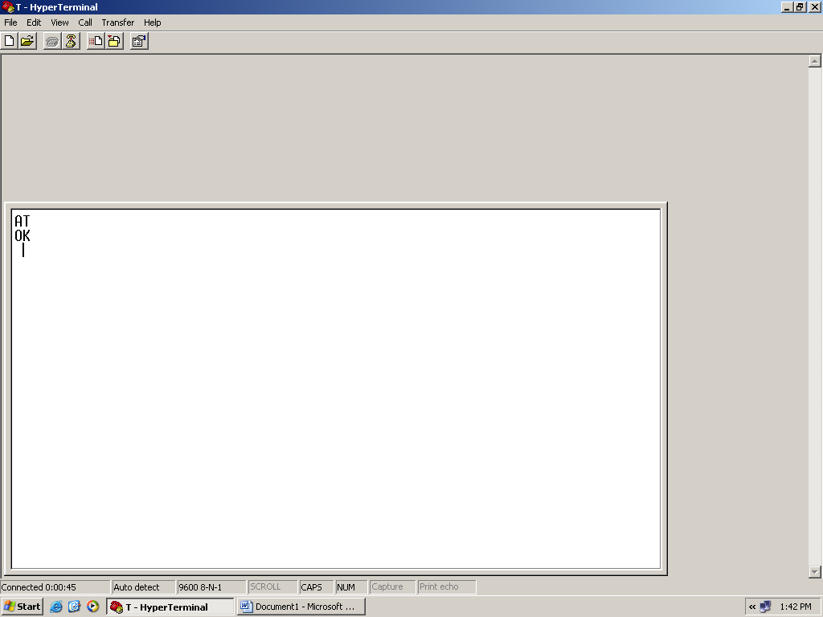

TO CALL A NUMBER

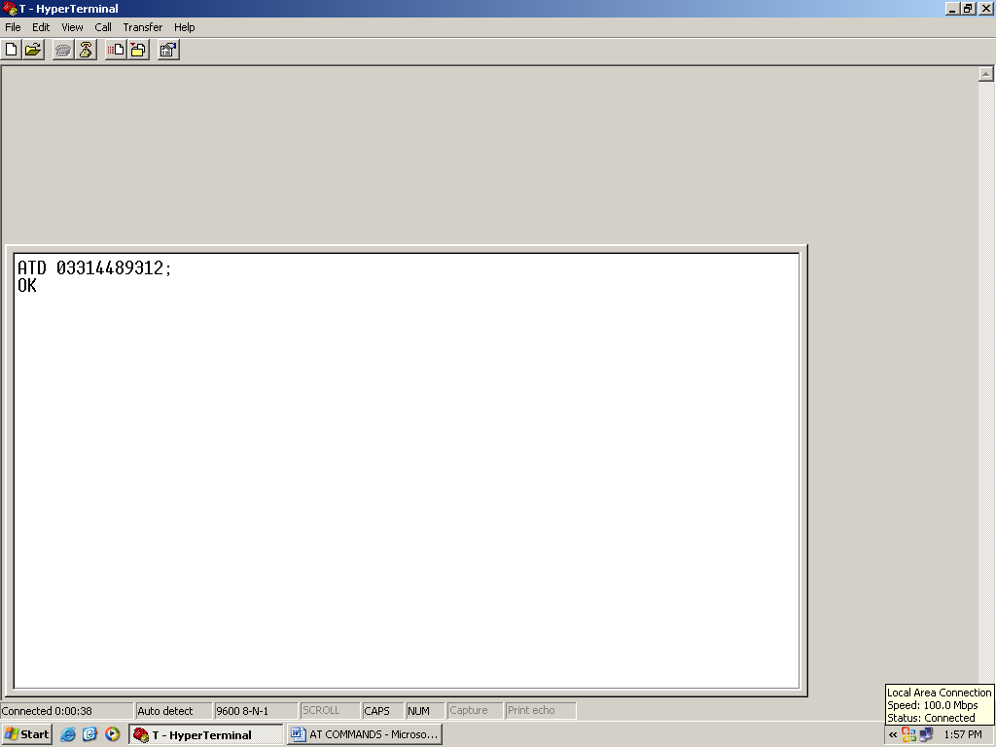
SENDING MSG OF HIGH TEMP TO 0321********

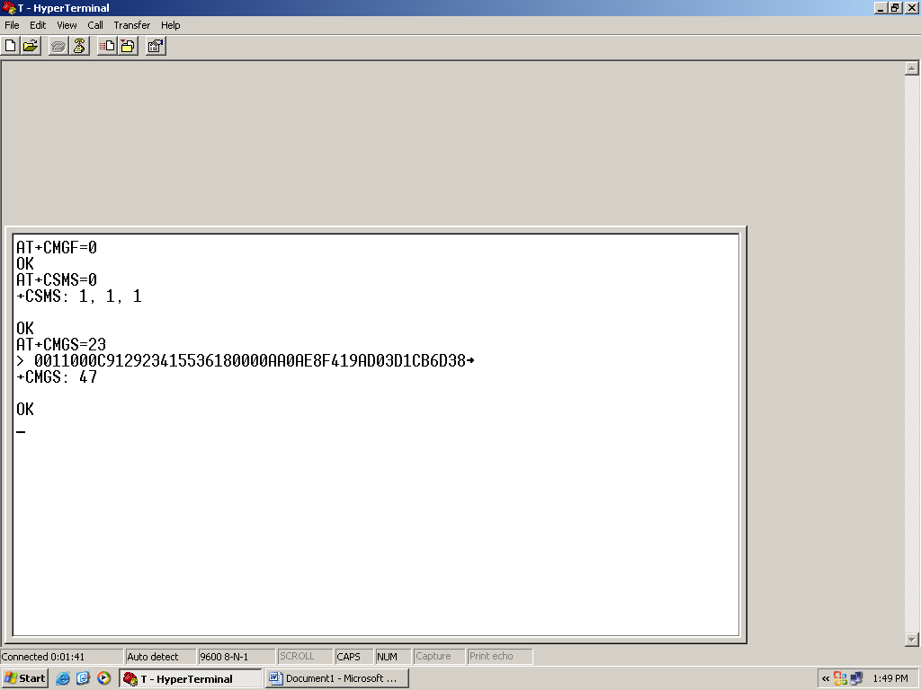

RealTerm Introduction
Real term is a terminal program specially designed for capturing, controlling and debugging binary and other difficult data streams.
Features
- Text or Binary views of data
- Protocol analyzer
- Fixed frame sizes
- Easy to send binary sequences
- Arbitrary baud rates
- Can dump files to serial port

AT Commands on RealTerm
We have tested few of our AT commands on real term as well, to check ASCII for our transmitted commands.

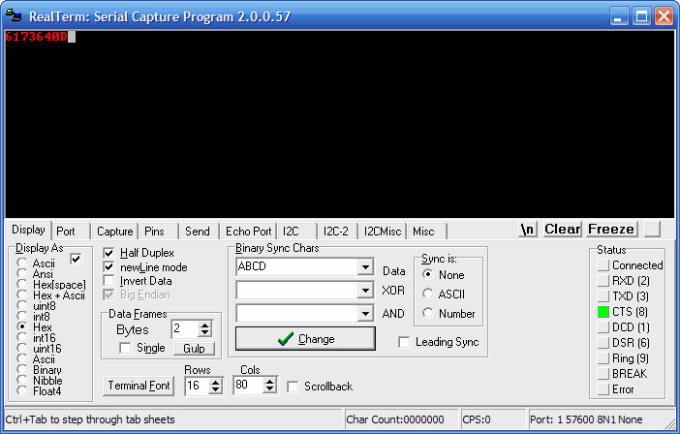

Software for Designing

Keil µVision2 Introduction
The µVision IDE from Keil combines project management, make facilities, source code editing, program debugging, and complete simulation in one powerful environment. The µVision development platform is easy-to-use and helping you quickly create embedded programs that work. The µVision editor and debugger are integrated in a single application that provides a seamless embedded project development environment.

Programming in Keil µVision2
We have been utilizing keil µVision2 for programming, the assembly language codes are first test in this software and then generate hex file for those programs and load those hex files in the microcontroller.
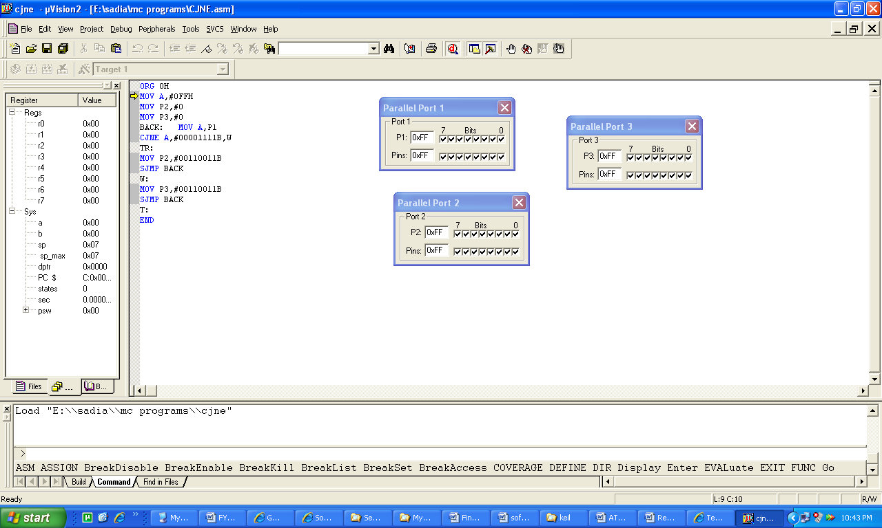

Proteus 7 Professional
Proteus PCB design combines the ISIS schematic capture and ARES PCB layout programs to provide a powerful, integrated and easy to use suite of tools for professional PCB Design.
All Proteus PCB design products include an integrated shape based auto router and a basic SPICE simulation capability as standard. More advanced routing modes are included in Proteus PCB Design Level 2 and higher whilst simulation capabilities can be enhanced by purchasing the Advanced Simulation option and/or micro-controller simulation capabilities.
We have been build our hardware circuit designs in proteus
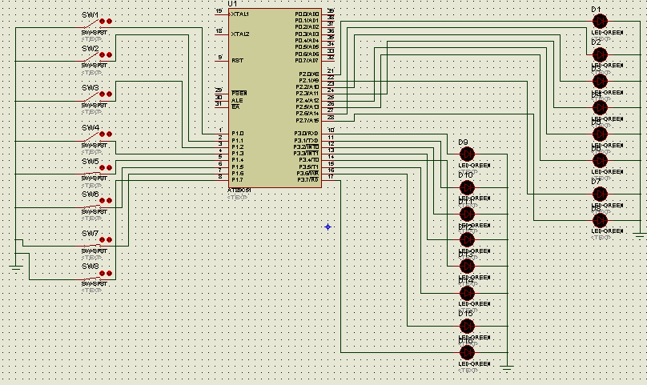
Chapter 7: Hardware Design and Implementation

Hardware Development
The detailed block diagram of our designed hardware circuit is as follows

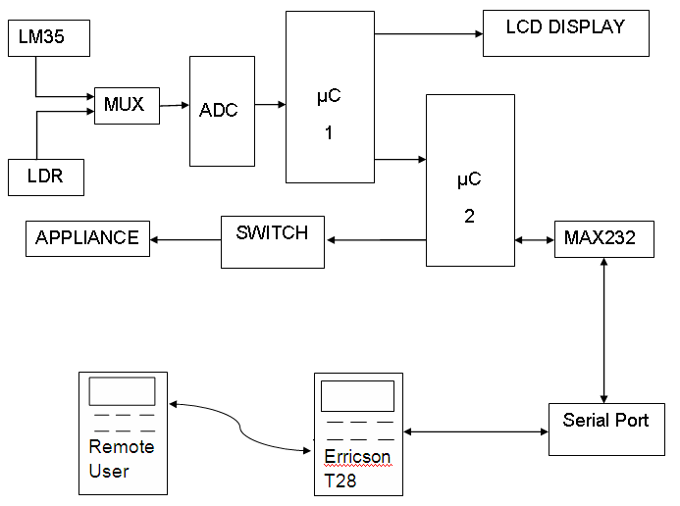
Fig 7.1

Implementation of Hardware circuit design
Our design circuit consists of three parts and that we have implemented in 3 sections which are
- Sensing unit
- Monitoring unit
- Controlling and switching unit

Sensing unit
The function of this unit is to sense environmental variables as we have implemented temperature and light sensing unit. It basically takes analog data from temperature sensor and light sensor (one at a time depending upon our selection) and analog to digital converter(ADC) takes that analog data and convert it in digital format which further processes in microcontroller and microcontroller display that data on LCD.

Sensing unit Block
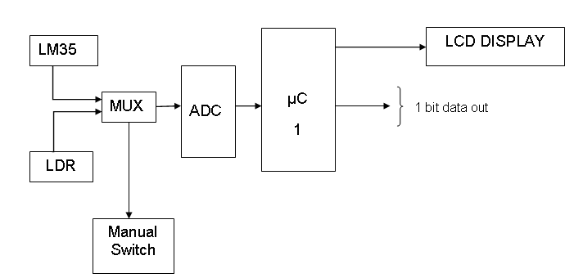
Fig 7.2

Sensing circuit design implementation on Proteous

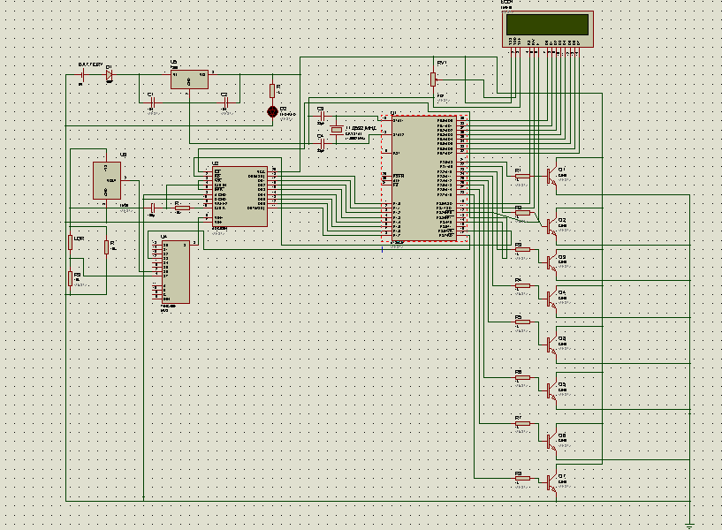
Working:

This circuit monitors the temperature or light intensity of a particular place. LM35 measures the temperature and LDR monitors the light intensity which are displaying on the LCD continuously. LM35 and LDR give the analog input to the ADC which converts it into digital pulse and sends to the microcontroller. 8051 is connected to the LCD so temperature or light display on the screen. A MUX is connected before ADC whose two inputs are temperature and light. The select line of MUX is connected to an analog switch which is handled manually for the selection of environmental variable.

Monitoring Unit:
The monitoring unit utilizes GSM services for communications.
The functions of monitoring unit are to
- Compare data (which is coming from sensing unit) with the defined values.
- If it reaches above from the defined values, then sending a text message to the remote user by using GSM Network connection provided by SIM.
- And then wait for a reply from remote user to take appropriate action.

Monitoring unit Block

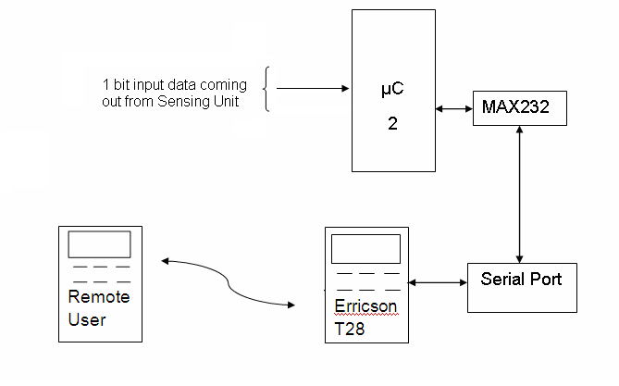
Fig 7.3

Sensing Circuit Design Implementation
We have implement circuit design of monitoring circuit as follows which includes Controller and Max232 IC with the RS 232 Connector. 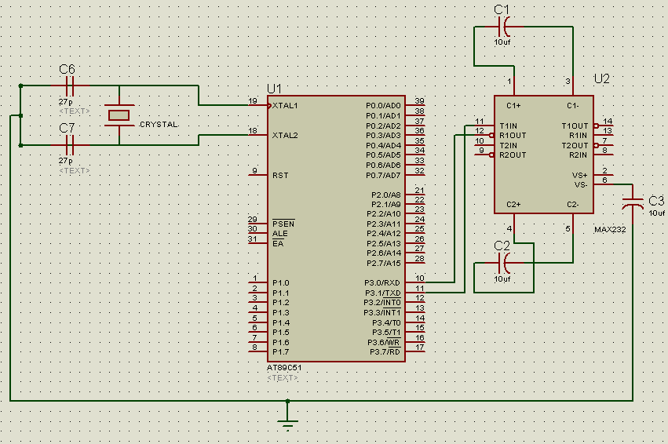
Fig 7.4

The summarize communication block is as follows:
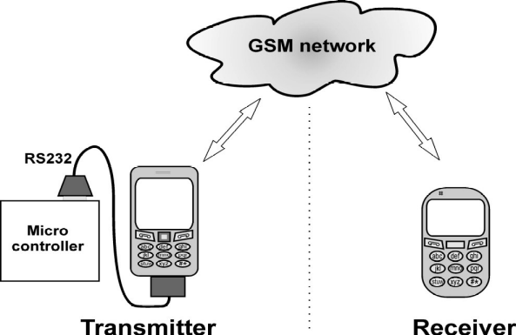
Fig 7.5

Switching Unit:
Switching Unit switches ON and OFF the respective appliance on receiving control input signal giving by microcontroller . We have implemented this as by connecting one port pin of microcontroller with the switching circuit. Once a port pin set to logic 1, 5 V Supply applied to the relay and relay’s normally open terminal becomes closed appliance get 220V supply and switched on.

Switching unit Block
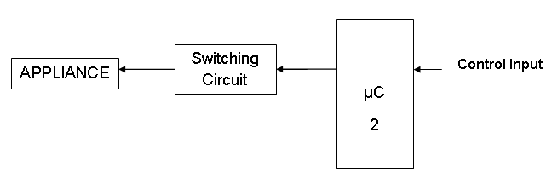
Fig 7.6

Switching Circuit Design Implementation
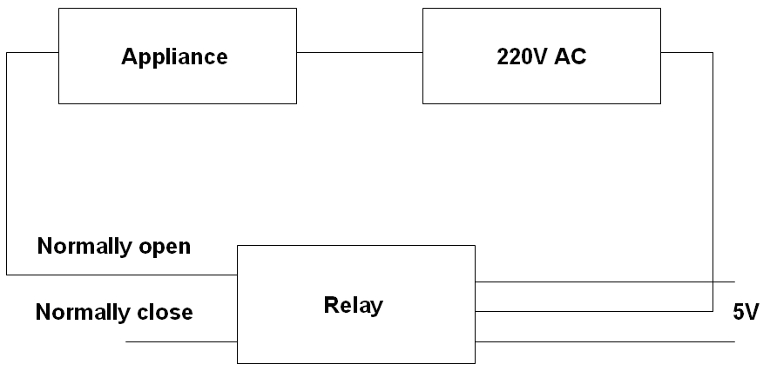
Fig 7.7

Working:
This circuit is designed to switch the device ON or OFF. We have used a relay for this purpose. Relay is operated on 5V and supports 220V, 10amp current.

PCB Design and Layout

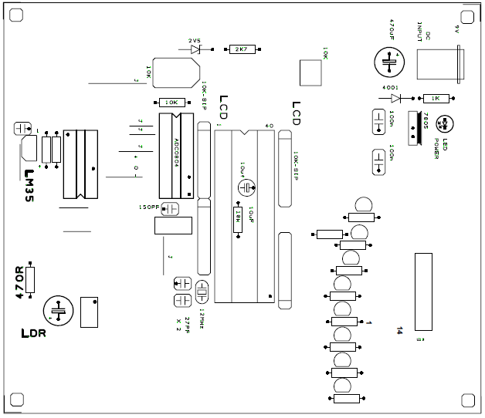

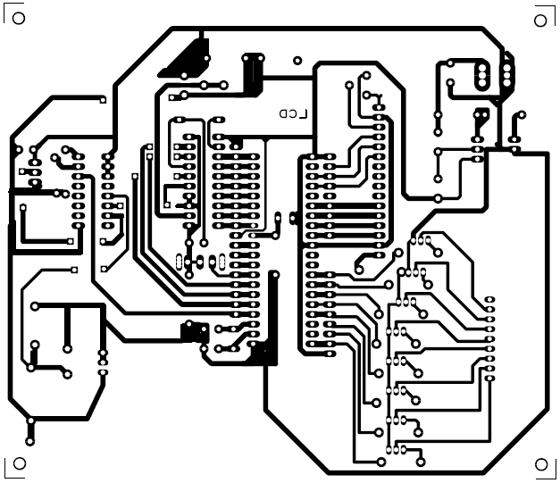
Chapter 8: Software Development

Assembly language Program
This code is build in Keil and load on the microcontroller
Code:
CR EQU 13
LF EQU 10
DISCART EQU 22H ;31H TO SAVE DISCART VALUE
BUFF EQU 23H ;32H TO SAVE BUFFER START
OK BIT 4H
RLY1 BIT P2.3
LED BIT P0.0
;========== TIMER INIT FOR BAUD RATE =============
START: MOV TMOD,#20H ;TIMER 1, MODE 2
MOV TH1,#-3 ;9600 BAUD RATE
MOV SCON,#50H ;8-BIT, 1 STOP, REN ENABLED
SETB TR1 ;START TIMER 1
;======== MAIN ==================================
CLR LED
LCALL DELAY3
;; ACALL LDELAY
SETB LED
LCALL DELAY3
LCALL TX232
DB "ATE0",CR,LF,0
LCALL DELAY3
LCALL TX232
DB "AT+CPMS=",34,77,69,34,CR,LF,0 ;SELECT MEMORY FOR SMS
ACALL SMS_CELLOK
MAIN:
JNB P3.3,SEND_SMS1
MAIN123:
CLR LED
LCALL DELAY3
LCALL TX232
DB "AT+CMGL=0",CR,LF,0
MOV DISCART,#3
MOV R0,#80H
LCALL RX232
MOV DPTR,#_OK
MOV R0,#80H
LCALL COMP1
SETB LED
ACALL DELAY3
JB OK,MAIN
CLR LED
LCALL DELAY3 ;YES THEN READ IT
LCALL TX232
DB "AT+CMGR=1",CR,LF,0
MOV DISCART,#41
MOV R0,#80H
LCALL RX232
LCALL DELAY3
LCALL TX232
DB "AT+CMGD=1",CR,LF,0 ;DELETE MSG
SETB LED
ACALL COMP_SMS
AJMP MAIN
SEND_SMS1:
ACALL CHK
ACALL DELAY3
ACALL DELAY3
ACALL DELAY3
ACALL DELAY3
SJMP MAIN123
CHK:
MOV A,#'A'
ACALL SEND
acall delay
MOV A,#'T'
ACALL SEND
acall delay
MOV A,#'+'
ACALL SEND
acall delay
MOV A,#'C'
ACALL SEND
acall delay
MOV A,#'P'
ACALL SEND
acall delay
MOV A,#'M'
ACALL SEND
acall delay
MOV A,#'S'
ACALL SEND
acall delay
MOV A,#'='
ACALL SEND
acall delay
MOV A,#'A'
ACALL SEND
acall delay
MOV A,#'"'
ACALL SEND
acall delay
MOV A,#'M'
ACALL SEND
acall delay
MOV A,#'E'
ACALL SEND
acall delay
MOV A,#'"'
ACALL SEND
acall delay
MOV A,#0aH
ACALL SEND
acall delay
MOV A,#0dH
ACALL SEND
acall delay
ACALL DELAYS
MOV A,#'A'
ACALL SEND
acall delay
MOV A,#'T'
ACALL SEND
acall delay
MOV A,#'+'
ACALL SEND
acall delay
MOV A,#'c'
ACALL SEND
acall delay
MOV A,#'m'
ACALL SEND
acall delay
MOV A,#'g'
ACALL SEND
acall delay
MOV A,#'f'
ACALL SEND
acall delay
MOV A,#'='
ACALL SEND
acall delay
MOV A,#'0'
ACALL SEND
acall delay
MOV A,#0aH
ACALL SEND
acall delay
MOV A,#0dH
ACALL SEND
acall delay
ACALL DELAYS
;acall rec
MOV A,#'a'
ACALL SEND
acall delay
MOV A,#'t'
ACALL SEND
acall delay
MOV A,#'+'
ACALL SEND
acall delay
MOV A,#'c'
ACALL SEND
acall delay
MOV A,#'s'
ACALL SEND
acall delay
MOV A,#'m'
ACALL SEND
acall delay
MOV A,#'s'
ACALL SEND
acall delay
MOV A,#'='
ACALL SEND
acall delay
MOV A,#'0'
ACALL SEND
acall delay
MOV A,#0aH
ACALL SEND
acall delay
MOV A,#0dH
ACALL SEND
acall delay
ACALL DELAYS
;acall rec
MOV A,#'a'
ACALL SEND
acall delay
MOV A,#'t'
ACALL SEND
acall delay
MOV A,#'+'
ACALL SEND
acall delay
MOV A,#'c'
ACALL SEND
acall delay
MOV A,#'m'
ACALL SEND
acall delay
MOV A,#'g'
ACALL SEND
acall delay
MOV A,#'s'
ACALL SEND
acall delay
MOV A,#'='
ACALL SEND
acall delay
MOV A,#'2'
ACALL SEND
acall delay
MOV A,#'3'
ACALL SEND
acall delay
MOV A,#0aH
ACALL SEND
acall delay
MOV A,#0dH
ACALL SEND
acall delay
ACALL DELAYS

MOV A,#'0'
ACALL SEND
acall delay
MOV A,#'0'
ACALL SEND
acall delay
MOV A,#'1'
ACALL SEND
acall delay
MOV A,#'1'
ACALL SEND
acall delay
MOV A,#'0'
ACALL SEND
acall delay
MOV A,#'0'
ACALL SEND
acall delay
MOV A,#'0'
ACALL SEND
acall delay
MOV A,#'c'
ACALL SEND
acall delay
MOV A,#'9'
ACALL SEND
acall delay
MOV A,#'1'
ACALL SEND
acall delay
MOV A,#'2'
ACALL SEND
acall delay
MOV A,#'9'
ACALL SEND
acall delay
MOV A,#'2'
ACALL SEND
acall delay
MOV A,#'3'
ACALL SEND
acall delay
MOV A,#'4'
ACALL SEND
acall delay
MOV A,#'1'
ACALL SEND
acall delay
MOV A,#'5'
ACALL SEND
acall delay
MOV A,#'5'
ACALL SEND
acall delay
MOV A,#'3'
ACALL SEND
acall delay
MOV A,#'6'
ACALL SEND
acall delay
MOV A,#'1'
ACALL SEND
acall delay
MOV A,#'8'
ACALL SEND
acall delay
MOV A,#'0'
ACALL SEND
acall delay
MOV A,#'0'
ACALL SEND
acall delay
MOV A,#'0'
ACALL SEND
acall delay
MOV A,#'0'
ACALL SEND
acall delay
MOV A,#'a'
ACALL SEND
acall delay
MOV A,#'a'
ACALL SEND
acall delay
MOV A,#'0'
ACALL SEND
acall delay
MOV A,#'a'
ACALL SEND
acall delay
MOV A,#'e'
ACALL SEND
acall delay
MOV A,#'8'
ACALL SEND
acall delay
MOV A,#'f'
ACALL SEND
acall delay
MOV A,#'4'
ACALL SEND
acall delay
MOV A,#'1'
ACALL SEND
acall delay
MOV A,#'9'
ACALL SEND
acall delay
MOV A,#'a'
ACALL SEND
acall delay
MOV A,#'d'
ACALL SEND
acall delay
MOV A,#'0'
ACALL SEND
acall delay
MOV A,#'3'
ACALL SEND
acall delay
MOV A,#'d'
ACALL SEND
acall delay
MOV A,#'1'
ACALL SEND
acall delay
MOV A,#'c'
ACALL SEND
acall delay
MOV A,#'b'
ACALL SEND
acall delay
MOV A,#'6'
ACALL SEND
acall delay
MOV A,#'d'
ACALL SEND
acall delay
MOV A,#'3'
ACALL SEND
acall delay
MOV A,#'8'
ACALL SEND
acall delay
MOV A,#1aH
ACALL SEND
acall delay
ACALL DELAYS
RET
;======== COMP_SMS ==============================
COMP_SMS:
C_SMS_GO: MOV R0,#9EH
MOV DPTR,#MSG02
ACALL COMP1 ;D1 ON
JNB OK,C_SMS_L2
CLR RLY1
RET
C_SMS_L2: MOV R0,#9EH
MOV DPTR,#MSG03
ACALL COMP1
JNB OK,C_SMS_L3
SETB RLY1
RET
;======== REPLY =================================
SMS: ACALL DELAY3
ACALL TX232
DB " ",0 ;03224522526 ;
;SMS_L1: MOV R0,#40H
; MOV B,#10
; ACALL TX232RAM
;SMS_L2: LCALL TX232
; DB "0000AA",0
RET
;======== RX232 =================================
RX232: MOV B,DISCART
SSL1: LCALL RX
DJNZ B,SSL1
MOV B,#64
SSL2: LCALL RX
CJNE A,#CR,RX_DO
RET
RX_DO: MOV @R0,A
INC R0
DJNZ B,SSL2
RET
;======== TX232 =================================
TX232: POP DPH
POP DPL
TX_NEXT: CLR A
MOVC A,@A+DPTR
JZ TX_RET
LCALL TX
INC DPTR
SJMP TX_NEXT
TX_RET: MOV A,#1
JMP @A+DPTR
;======== TX232RAM ==============================
TX232RAM: MOV A,@R0
LCALL TX
INC R0
DJNZ B,TX232RAM
RET
;======== TX ====================================
TX: MOV SBUF,A
JNB TI,$
CLR TI
RET
;======== RX ====================================
RX: JNB RI,$
MOV A,SBUF
CLR RI
RET
DELAY1: MOV R7,#20
D1L1: DJNZ R7,D1L1
RET
DELAY2: MOV R6,#255
D2L2: MOV R7,#255
D2L1: DJNZ R7,D2L1
DJNZ R6,D2L2
RET
LDELAY: MOV R5,#60
SJMP D3L3
DELAYS:
DELAY3: MOV R5,#4
D3L3: MOV R6,#255
D3L2: MOV R7,#255
D3L1: DJNZ R7,D3L1
DJNZ R6,D3L2
DJNZ R5,D3L3
RET
delay:
mov r1,#255
s1:djnz r1,s1
mov r1,#255
s2:djnz r1,s2
mov r1,#255
s3:djnz r1,s3
mov r1,#255
s4:djnz r1,s4
mov r1,#255
s5:djnz r1,s5
mov r1,#255
s6:djnz r1,s6
ret
SEND: MOV SBUF, A
HERE: JNB TI, HERE
CLR TI
RET
;================================================
_OK: DB "OK",0
;: DB "4342900",0
MSG01: DB "30180C76C3D900",0 ;0000786
MSG02: DB "C418E8E904",0 ;D1 ON
MSG03: DB "C418E86904",0 ;D1 OF
END
APPENDICES

Appendix A: Hardware components Specifications Features & details

Specifications of T68i:

General | 2G Network | GSM 900 / 1800 / 1900
General | Announced | April 2002
General | Status | Discontinued

Size | Dimensions | 101 x 48 x 19.5 mm
Size | Weight | 84 g

Display | Type | STN, 256 colors
Display | Size | 101 x 80 pixels
Display |  | - Joystick navigation  - Image handling

Sound | Alert types | Vibration; Downloadable monophonic ringtones, composer
Sound | Speakerphone | No
Sound |  | - Ringtones can be assigned to contacts

Memory | Phonebook | 500 x 8 fields, Photo call
Memory | Call records | 10 dialed, 10 received, 10 missed calls
Memory | Card slot | No
Memory |  | - 1000 sec voice memo  - 300 calendar events

Data | GPRS | Class 4 (3+1 slots), 24 - 36 kbps
Data | EDGE | No
Data | 3G | No
Data | WLAN | No
Data | Bluetooth | Yes, v1.0b
Data | Infrared port | Yes
Data | USB

Camera |  | No

Features | Messaging | SMS, EMS, MMS, Email
Features | Browser | WAP 2.0/xHTML
Features | Radio | No
Features | Clock | Yes
Features | Alarm | Yes
Features | Games | 8 - Arimona, Contrary, Erix, Four piles, Naval Fleet, North territory, Q, Yukon Struggle
Features | Colors | Arctic Blue
Features | GPS | No
Features | Java | No
Features |  | - T9  - Organizer  - Voice dialing  - Voice answering  - Profiles

Battery |  | Standard, Li-Ion 700 mAh (BST-14)
Battery | Stand-by | up to 300 h
Battery | Talk time | Up to 11 h

Misc | SAR US | 0.54 W/kg (head)
Misc | SAR EU | 0.38 W/kg (head)

Detailed Pin Description of 8051

VCC
Supply voltage, which is 5V.
GND
Ground.
Port 0
Port 0 is an 8-bit open-drain bi-directional I/O port. As an output port, each pin can sink eight TTL inputs. When 1s are written to port 0 pins, the pins can be used as high impedance inputs. Port 0 may also be configured to be the multiplexed low order address/data bus during accesses to external program and data memory. In this mode P0 has internal pull-ups. Port 0 also receives the code bytes during Flash programming, and outputs the code bytes during program verification. External pullups are required during program verification.

Port 1
Port 1 is an 8-bit bi-directional I/O port with internal pull-ups. The Port 1 output buffers can sink/source four TTL inputs. When 1s are written to Port 1 pins they are pulled high by the internal pull-ups and can be used as inputs. As inputs, Port 1 pins that are externally being pulled low will source current (IIL) because of the internal pull-ups. Port 1 also receives the low-order address bytes during Flash programming and verification.
Port 2
Port 2 is an 8-bit bi-directional I/O port with internal pull-ups. The Port 2 output buffers can sink/source four TTL inputs. When 1s are written to Port 2 pins they are pulled high by the internal pull-ups and can be used as inputs. As inputs, Port 2 pins that are externally being pulled low will source current (IIL) because of the internal pull-ups.
Port 2 emits the high-order address byte during fetches from external program memory and during accesses to external data memory that use 16-bit addresses (MOVX @ DPTR). In this application, it uses strong internal pull-ups when emitting 1s. During accesses to external data memory that use 8-bit addresses (MOVX @ RI), Port 2 emits the contents of the P2 Special Function Register. Port 2 also receives the high-order address bits and some control signals during Flash programming and verification.
Port 3
Port 3 is an 8-bit bi-directional I/O port with internal pull-ups. The Port 3 output buffers can sink/source four TTL inputs. When 1s are written to Port 3 pins they are pulled high by the internal pull-ups and can be used as inputs. As inputs, Port 3 pins that are externally being pulled low will source current (IIL) because of the pull-ups. Port 3 also serves the functions of various special features of the AT89C51 as listed below:

Port Pin | Alternate Functions
P3.0 | RXD (serial input port)
P3.1 | TXD (serial output port)
P3.2 | INT0 (external interrupt 0)
P3.3 | INT1 (external interrupt 1)
P3.4 | T0 (timer 0 external input)
P3.5 | T1 (timer 1 external input)
P3.6 | WR (external data memory write strobe)
P3.7 | RD (external data memory read strobe)

Port 3 also receives some control signals for Flash programming and verification.
RST
Reset input. A high on this pin for two machine cycles while the oscillator is running resets the device.
ALE/PROG
Address Latch Enable output pulse for latching the low byte of the address during accesses to external memory. This pin is also the program pulse input (PROG) during Flash programming.
In normal operation ALE is emitted at a constant rate of 1/6 the oscillator frequency, and may be used for external timing or clocking purposes. Note, however, that one ALE pulse is skipped during each access to external Data
Memory. If desired, ALE operation can be disabled by setting bit 0 of SFR location 8EH. With the bit set, ALE is active only during a MOVX or MOVC instruction. Otherwise, the pin is weakly pulled high. Setting the ALE-disable bit has no effect if the micro controller is in external execution mode.

PSEN
Program Store Enable is the read strobe to external program memory. When the AT89C51 is executing code from external program memory, PSEN is activated twice each machine cycle, except that two PSEN activations are skipped during each access to external data memory.
EA/VPP
External Access Enable (EA) must be strapped to GND in order to enable the device to fetch code from external program memory locations starting at 0000H up to FFFFH. Note, however, that if lock bit 1 is programmed, EA will be internally latched on reset. EA should be strapped to VCC for internal program executions. This pin also receives the 12-volt programming enable voltage (VPP) during Flash programming, for parts that require 12-volt VPP.
XTAL1
Input to the inverting oscillator amplifier and input to the internal clock operating circuit.
XTAL2
Output from the inverting oscillator amplifier.

Resolution Detail of ADC0804:
The resolution of the converter indicates the number of discrete values it can produce over the range of analog values. The values are usually stored electronically in binary form, so the resolution is usually expressed in bits.
Resolution can also be defined electrically, and expressed in volts.
The voltage resolution of an ADC is equal to its overall voltage measurement range divided by the number of discrete voltage intervals:
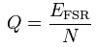
Where:
N is the number of voltage intervals,
E_{FSR} is the full scale voltage range, given by,

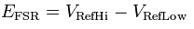
the upper and lower extremes respectively of the voltages that can be coded.
Normally, the number of voltage intervals is given by,
where M is the ADC's resolution in bits.

MAX232 Application Circuit:
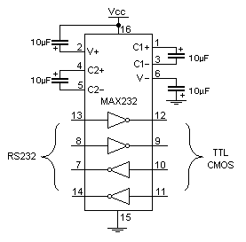

MAX232 Interfacing with Microcontroller:
To communicate over UART or USART, we just need three basic signals which are namely, RXD (receive), TXD (transmit), GND (common ground). So to interface MAX232 with any micro controller (AVR, ARM, 8051, PIC etc..) we just need the basic signals. A simple schematic diagram of connections between a micro controller and MAX232 is shown below
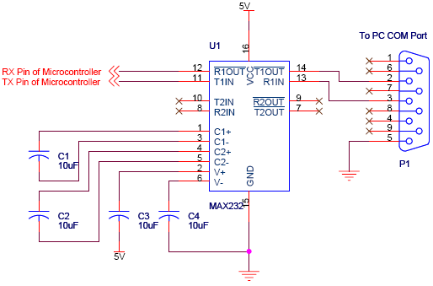

Technical Specifications of LCD

Power Supply | 12Vdc e.g. Order Code PSU445 with connector 778.106
Current Consumption | 20 - 450mA
PC Connection | M-F serial lead (Order Code LDC441)
Display | 4 lines x 16 character
Character Height | 4.8 mm
Message Memory Type | Non-volatile
Illumination option | Yes
Output | 1 x SPDT Relay
Maximum Output  Load (Resistive) | Up to 240Vac or 28Vdc @ 5 Amps max. (Relay Datasheet)
Relay Connections | NO, NC, C (Relay FAQ)
Protection against Inverse Polarity | Yes
LCD Module Dimensions | 80 x 40 mm
LCD Visible Area: | 60 x 25 mm
Board Dimensions (WxHxD) | Display Board: 85 x 30 x 60 mm  Control Board: 105 x 25 x 75 mm
Weight | 280g
Board Connections | Screw terminal blocks
Product Format | PRE-ASSEMBLED Electronic Module more

Block Diagram of 7805:
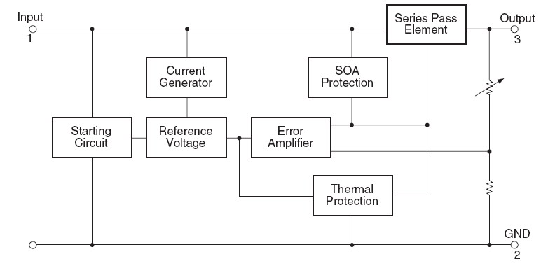

7805 voltage regulator circuit diagram:

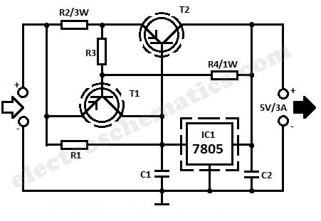

APPENDEX B: AT Commands for ERICSSONT68i

List of AT Commands for Sony Ericsson
AT Attention command
AT+CLAC List all available AT commands
AT+CGMM Request model identification
AT+CGMR Request revision identification
AT+CGSN Request product serial number identification
AT+GCAP Request modem capabilities list
AT+GMI Request manufacturer information
ATA Answer incoming call command
ATH Hook control
ATD Dial command
ATO Return to online data mode
AT+CLCC List current calls
AT*CPI Call progress information
ATE Command echo
ATS4 Response formatting character
ATS10 Automatic disconnect delay control
ATX Call progress monitoring control
AT+IFC Cable interface DTE-DCE local flow control
List of References

Web References
http://www.edaboard.com/thread83420.html#post364860
http://search.edaboard.com/at-commands-from-8051.htm
http://www.google.com.pk/#hl=en&rlz=1W1RNSN_en&q=at+commands+through+microcontroller+in+assembly&aq=f&aqi=&aql=&oq=&gs_rfai=&fp=4f3525b7f2086f30
http://www.google.com.pk/search?hl=en&q=8051+with+built+in+uart&meta=&aq=f&aqi=&aql=&oq=&gs_rfai
http://home.x-pec.com/~ivc/sites/ivc/se/t28cable/
http://logix4u.net/Legacy_Ports/Parallel_Port/A_tutorial_on_Parallel_port_Interfacing.html
http://computer.howstuffworks.com/c.htm/printable
http://electrosofts.com/links/c_cpp.html
http://logix4u.net/Inpout32.dll_Discussion/Programing_Language_is_Best_for_Port_Programing.html#119
http://www.microsoft.com/express/Downloads/#2010-Visual-CPP
http://computer.howstuffworks.com/c.htm/printable
http://www.google.com.pk/#hl=en&source=hp&q=parallel+and+serial+port+programming&rlz=1W1RNSN_en&aq=f&aqi=&aql=&oq=&gs_rfai=&fp=e9a1fb9144c01afc
http://electrosofts.com/links/port_programming.html
http://support.microsoft.com/kb/823179

Book References
The 8051 microcontroller and embedded systems, using Assembly and C
Wireless communications by Theodore S. Rappaport

