Chapter 1 Introduction 1

Chapter 1
Introduction

1.1 Project Introduction

Induction motor is the most widely used motor in industry. It is used in a number of applications such as fans, blowers, crushers, grinders, mixers, pumps, cranes, compressors, and many other modern industrial applications. When the motor starts it draws heavy current normally 7 to 10 times its rated current that is called inrush current: this current causes a number of problems to the system containing the motor.
Induction motors especially squirrel cage type make up a large part of the load industrial applications due to their simplicity of construction, economical matter, reliability and relatively high efficiency. Starting motors at full voltage, referred to as across- the line or direct on line (DOL) results increased mechanical wear through rapid acceleration and very high currents causing considerable stresses on supply[1]. By using soft starter, in many applications, smooth acceleration with reduced stress on the mechanical drive system and reduction of inrush current can be achieved. Therefore eliminating voltage dip and brown out conditions could be avoided [2-3].
Soft Starters allow the machine to start by adjusting the induction motor terminal voltage, thereby reducing the voltage to each phase of a motor and gradually increasing the voltage until the motors gets up to full voltage/speed all at a fixed frequency [4-6].
The profile of voltage increasing depends on the control scheme .The most prevalent type of the soft starters which will be focused in this project comprises three TRIACs. The ac voltage of the motor is reduced and controlled by varying the firing angle (α) of the TRIACs [7-8]. The methods to calculate the firing angle (α) of the TRIACs can be categorized as two groups: open loop and closed loop control.
In open loop methods a start voltage profile is produced independent of the current drawn, or the speed of the motor. The most common closed loop starters are referred to as current controlled soft starter in which the current drawn by the motor during start is

Chapter 1 Introduction 2

monitored and could dynamically modify the voltage profile to reach the desired response. [9-10]

1.2 Methodology

Both experimentation and simulation are involved in this work. Figure 1.1 shows methodology summary [11]
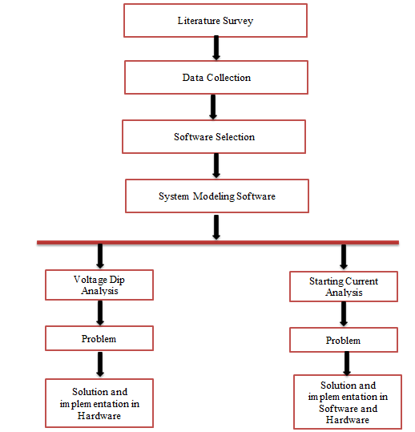
Figure 1.1: Methodology summary

Chapter 1 Introduction 3

1.2.1 Data Collection
Actual data is collected from the industrial facilities and from experiments related to motor starting.
1.2.2. Software Selection
After data collection, some software was required for simulations, Keil u vision4 software is selected for PIC 16f877 microcontroller programming and Proteus software is selected for simulation of complete circuit. It provides much flexibility and close to real environment for the user. The collected data is modelled in software.
1.2.3. Simulation and Implementation
Problem is identified and solution is developed in the form of soft-starter. Performance of the three phase induction motor is checked again after the inclusion of soft-starter. Simulation and practical results show that the efficiency of the motor and power system can be increased using soft starter.

1.3 Three Phase Induction Motor

1.3.1 Motors
Modern electrical motors are available in many different forms, such as single phase motors, three phase motors, synchronous motors, asynchronous motors, brake motors, brushless motors, and so on. They all have their own performance and characteristics.
To ensure a long life for motor it is important to keep it with a correct degree of protection, under heavy-duty condition in a severe environment and satisfy the power quality given to the motor. The end of the motor is defined in the IEC-Standard as D-end and N-end: The D-end is normally the driven end of the motor. The N-end is normally the non-driven end of the motor.

Chapter 1 Introduction 4

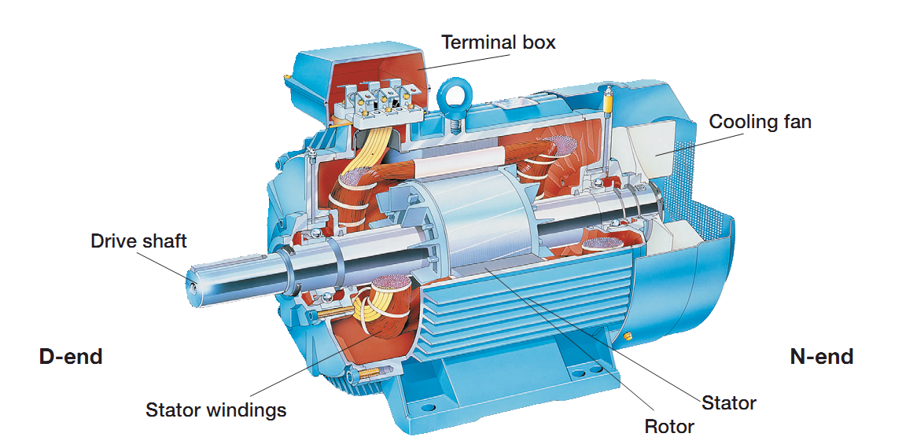
Figure 1.2: Three phase induction motor

1.3.2 Three Phase Induction Motor
Like any of electric motors, a 3-phase induction motor has a stator and a rotor. The stator carries a 3-phase winding (called stator winding) while the rotor carries a short-circuited winding (called rotor winding). Only the stator winding is fed from 3-phase supply. The rotor winding derives its voltage and power from the externally energized stator winding through electromagnetic induction. The induction motor may be considered to be a transformer with a rotating secondary and it can, therefore, be described as a “transformer-type” A.C. machine in which electrical energy is converted into mechanical energy
The three-phase induction motors are the most widely used motors in industry. They run at essentially constant speed from no-load to full-load. However, the speed is frequency dependent and consequently these motors are not easily adapted to speed control. Therefore we usually prefer D.C motors when large speed variation is required. Nevertheless, the 3-phase induction motors are simple, rugged, low priced, easy to maintain and can be manufactured with characteristics to suit most industrial requirements [12].
Chapter 1 Introduction 5

1.3.2.1 Advantages
1) It has simple and rugged construction.
2) it is relatively inexpensive.
3) It requires less maintenance.
4) It has high efficiency and reasonably good power factor.
5) It has self-starting torque.

1.3.2.2 Disadvantages
1) Its speed regulation is not easy.
2) Its starting torque is inferior to D.C shunt motor.

1.3.3 Principle Of Operation
Consider a portion of 3-phase induction motor as shown in Fig 1.2. The operation of the motor can be explained as under:
When 3-phase stator winding is energized from a 3-phase supply, a rotating magnetic field is set up which rotates round the stator at synchronous speed Ns (= 120 f/P).The rotating field passes through the air gap and cuts the rotor conductors, which as yet, are stationary. Due to the relative speed between the rotating flux and the stationary rotor, E.M.F. is induced in the rotor conductors. Since the rotor circuit is short-circuited, currents start flowing in the rotor conductors. The current-carrying rotor conductors are placed in the magnetic field produced by the stator. Consequently, mechanical force acts on the rotor conductors. The sum of the mechanical forces on all the rotor conductors produces a torque which tends to move the rotor in the same direction as the rotating field.
The fact that rotor tends to follow the stator field (i.e., rotor moves in the direction of stator field) can be explained by Lenz’s law. According to this law, the direction of rotor currents will be such that they tend to oppose the cause producing them. Now, the cause producing the rotor currents is the relative speed between the rotating field and the stationary rotor conductors. Hence to reduce this relative speed, the rotor starts running in the same direction as that of stator field and tries to catch it. [12]

Chapter 1 Introduction 6

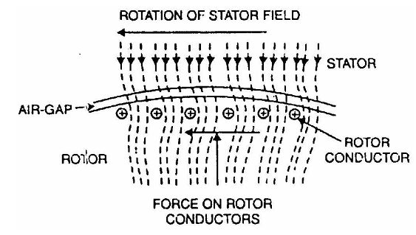
Figure 1.3: Operation of three phase induction motor
When motor is started, it has to provide sufficient torque to derive a load. For that purpose it draws high current. Another reason for high inrush current is the back E.M.F. At starting, back E.M.F is very low and it gradually increases until the motor reaches the full speed.
.
1.3.4 Equivalent Circuit Parameters Calculation For 3-phase induction Motor
After selection of the motor a series of tests are performed to calculate the equivalent circuit parameters of the motor.
1.3.4.1 Stator Resistance:
With the rotor at standstill, the stator phase resistance is measured by applying a dc voltage and the resulting current. While this procedure gives only the dc resistance at a certain temperature, the ac resistance has to be calculated by considering the wire size, the stator frequency and the operating temperature [12-13].
Figure 1.4: DC test for three phase induction motor

Chapter 1 Introduction 7

For a Delta-Connected Stator the resistance can be calculated as follows.
Figure 1.5: DC test for Delta-connected motor

1.3.4.2 No-load Test:
The induction motor is driven at synchronous speed by another motor, preferably a dc motor. Then the stator is energized by applying rated voltage at rated frequency. The input power per phase is measured [12-13].
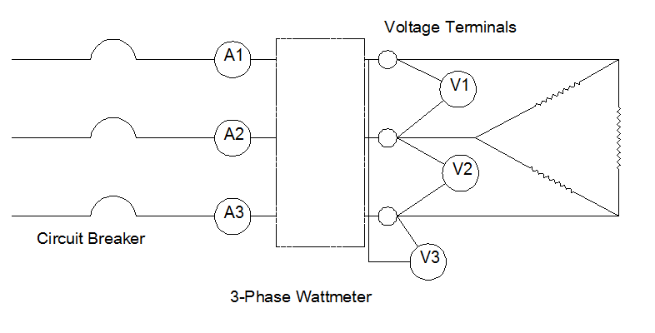
Figure 1.6: No load test for three phase induction motor

Substitute X1 from the blocked-rotor test to determine the value of XM

Chapter 1 Introduction 8

1.3.4.3 Locked-Rotor Test:
The rotor of the induction motor is locked to keep it at standstill and a set of low three phase voltages is applied to calculate rated stator currents. The input power per phase is measured along with the input voltage and stator current. The slip is unity for the locked rotor condition and hence the circuit resembles that of a secondary shorted transformer [12-13].
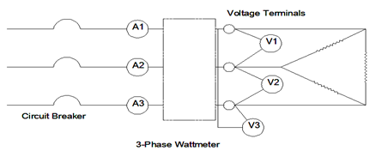
Figure 1.7: Locked rotor test for three phase induction motor

1.3.4.4 Three Phase Induction Motor Equivalent Circuit Parameters
Results of the experiment discussed above are summarized in the Table 2.1 given below.
Table1.1: Equivalent circuit parameters of the three phase induction motor

Parameters | Symbols | Values
Phase | Ø | 3
Number of pole | P | 4
Frequency | F | 50Hz
Line to line voltage | V_{L_L} | 380V
Stator resistance | R₁ | 3.2Ω
Rotor resistance | R₂ | 3.1Ω
Resistance for core losses | R_{C} | 699Ω
Magnetizing reactance | X_{M} | 84Ω

Chapter 1 Introduction 9

1.3.4.5 Equivalent Circuit of Induction Motor
After the equivalent Parameters calculation of 3-phase induction motor, its equivalent circuit can be drawn as shown in Fig 1.8.
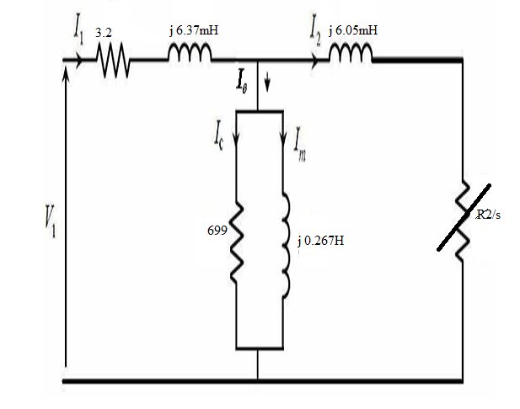
Figure 1.8: Equivalent circuit of 3-phase induction motor
Using these equivalent parameters, induction motor can be modeled in Proteus software.

Chapter 2 Litrature Survey 10

Chapter 2
Literature Survey

2.1 Introduction

The various methods which are used to control speed for three phase induction motor in literature is very vast. Since the industry of motors and especially induction motors include vast fields. The research works on induction motor has many phases and dimensions to control its speed and protection. The chief conventional methods of speed control are
- Variable-Voltage, Constant-Frequency Operation
- Variable-Frequency Operation
- Constant Volts/Hertz Operation
- Variation of Number of Poles
- Variation of Motor Resistance
- Variation of Motor Reactance
- Pulse Width Modulation

2.2 Research From IEEE

The IEEE (Institute of Electrical and Electronics Engineers) is the only worldwide electrical platform to discuss research papers on every topic. So we are including some of advance methods to control three phase induction motor speed. These methods are developed by renowned electrical engineers and researchers to cope with modern day difficulties and also to facilitate with modern approach to produce in depth vision to thoroughly understand them.
The following three modern researches have been produce from the literature surveys published on IEEE .

2.2.1 Thyristor and diode controlled variable voltage drives for 3-phase induction motors

2.2.1.1 Abstract

The steady state and transient operation of thyristor and diode controllers for variable voltage control of three-wire 3-phase induction motors is considered. Throughout the analysis the state-space form of system representation is used, which facilitates the
Chapter 2 Litrature Survey 11

application of switching constraints at the stator (primary) terminals. The steady state solution for constant speed was obtained in a closed form in terms of state transition matrices with the motor represented in stationary d-q-axes. The results of experimental studies on a motor show good correlation with theoretical results. It was found that the losses in thyristor and diode controlled motors are mostly due to operation at high slips, and that time harmonic currents produce very little additional losses, especially at high speed. Compared with an inverse-parallel thyristor pair in each supply line the thyristor-diode or thyrode connection has an economic advantage but results in rather worse copper losses, mainly due to a predominant second harmonic component of current. The start-up transient currents, torques and speed of a 3-phase induction motor were obtained for sinusoidal, thyristor and thyrode control. A comprehensive computer-aided analysis gave good agreement between measured and calculated current transients. The thyrode controller resulted in larger peak currents and larger negative shaft torques than the corresponding thyristor controller.

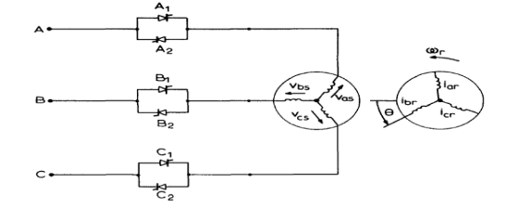
Figure 2.1: Thyrode control of three phase induction motor

2.2.1.2 Introduction:

The speed of a three-wire 3-phase induction motor can be suitably controlled for some applications by variation of the primary voltage. One method of achieving controlled variation of voltage is by the use of an inverse-parallel pair of thyristors in each supply line triggered symmetrically to produce identical load voltages in each motor phase.1 Alternatively, the thyristor pairs can be replaced by reverse conducting thyristors or thyristor-diode combinations that are here referred to as 'thyrodes'. Thyrode control provides identical load voltages if each thyristor is triggered once per supply cycle. Operation of the thyristor and thyrode controllers with passive impedance loads is characterised by modes.

Chapter 2 Litrature Survey 12

2.2.1.3 Conclusions

The steady-state speed of a 3-phase three wire induction motor can be controlled by variation of the terminal voltage using pairs of thyristors or thyristor-diode combinations in the supply lines. The thyristor-diode or thyrode connection has an economic advantage, but does result in greater copper losses owing to waveform distortion, especially at low speed. For the worst case condition, of standstill with the thyrode controller, the additional losses amounted to 30% of the corresponding sinusoidal losses.

2.2.2 Low frequency stability study of a three-phase induction motor

2.2.2.1 Abstract

Most of the researches for adjustable speed drive focused on voltage amplitude control. However, its only control speed in the constraint limits. Adjustable frequency drives have not been widely used with single-phase induction motors.

2.2.2.2 Introduction:

Technological advancements in the field of variable speed drive have widened the field of application of induction motors. Use of the variable speed drives improves the performance of induction motor drives and adds new dimensions to the stability study with other performance criteria of induction motors. There are many problems associated with variable frequency drives that are still being investigated. The stability problem is one of the concerns that require investigation of variable voltage and variable frequency induction motor modeling and solution of models by fast computer aided numerical techniques. It has been found that during at low frequency operation an induction motor is lightly damped which can cause sustained oscillation or lead to pull out of step. At lower frequency range there is a tendency towards greater instability, which might be equivalent to the operation at rated frequency with added armature resistance. One approach to improve the stability of an induction motor is to introduce positive damping by simultaneously adjustment of stator voltage and frequency. This approach stems from the logical inference that in volt/Hz modes of operation of induction motor, maximum torque limit can be enhanced by increasing the amplitude of the stator voltage as well as by decreasing frequency at the expense of lowering the speed. Therefore, simultaneous increase in voltage and decrease in frequency can enhance the maximum torque limit, which should be higher than that caused by either voltage change or frequency change individually.

Chapter 2 Litrature Survey 13

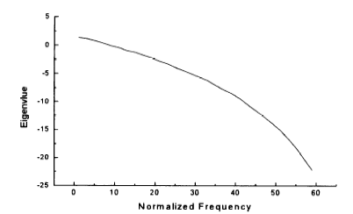
Figure 2.2: Relationship b/w eigen value and normalized frequency

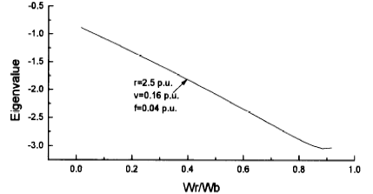
Figure 2.3: Relationship b/w eigen value and Wr/Wb

2.2.2.3 Conclusion:

The stability analysis of variable voltage and variable frequency induction motor have been carried out with an aimed at exploring the advantages of simultaneous adjustment of applied voltage and frequency to improve the stability of the induction motor. A control strategy has been suggested to improve the stability of induction motor by changing the
Chapter 2 Litrature Survey 14

volt/Hz ratio. It has been found that in volt/Hz mode of operation of an induction motor the maximum torque limit increases with increased stator voltage or decreased frequency. Simultaneous increase in stator voltage and decrease in frequency significantly enhance the maximum torque limit. This technique of controlling the maximum torque limit has established the fact that the effective damping may be added in case of sustained oscillations or even in the unstable region of motor operation. The results of the investigation also indicate that this method of control strategy inherits the features of practical importance that may in some applications, offer a convenient means of stabilizing induction motors at low speed operation. To justify the results of stability analysis of induction motor obtained by standard eigen values is cross checked bytransient analysis method. The results in the both the cases demonstrate a very close agreement as evident from the analysis. The effects of non-linearity due to core saturation and eddy currents are not considered in this analysis. Therefore, the analysis and conclusion illustrated of this work are valid for the linear range of operation of the induction motor.

2.2.3 FPGA Based Implementation of Variable-Voltage/ Variable-Frequency Controller for a Three Phase Induction Motor

2.2.3.1 Abstract

This paper presents the design and implementation of a Variable-Voltage Variable-Frequency (VVVF) Controller based on Sinusoidal Pulse Width Modulation (SPWM) Technique for a 3 Phase Induction Motor using a Field Programmable Gate Array (FPGA). The work involves implementation of an Open loop control scheme for an induction motor. The technique is used extensively in the industry as it provides the accuracy required at minimal cost. Voltage/ frequency (v/f) controlled motors fall under the category of Variable Voltage Variable Frequency (VVVF) drives. To maintain maximum torque for a given working condition, the flux in the machine must be maintained constant. The FPGA controller is used to generate SPWM pulses based on the frequency input, that are used to control the inverter. The VVVF output of the inverter can be used as supply to a three phase induction motor and thereby speed of the motor can be controlled.

2.2.3.2 Introduction

Controlling the speed of induction motors has ever since been an important topic of research. The control methodologies have evolved from electromechanical switching to high speed digital controllers using DSP and FPGA [1]. Of late, Pulse-Width Modulation techniques have been the subject of intensive research; as PWM controlled power electronic devices find increasing applications in many new industrial processes
Chapter 2 Litrature Survey 15

involving more stringent performance specifications. This is particularly true in case of high performance drive systems, uninterruptible power supply and programmable AC power sources. Since PWM inverters play an important role in each of these applications, the whole system is dependent on the algorithm controlling the PWM inverter [3]. In recent years, Field Programmable Gate Arrays have drawn much attention due to its short design cycle, low cost and high flexibility in terms of programmability. The Field Programmable Gate Arrays (FPGAs) offer significant advantages over microprocessors and DSPs for high performance, low volume applications,

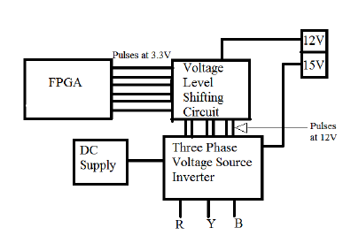
Figure 2.4: Block Diagram
2.2.3.3 Conclusion

The open loop control scheme for a three phase inverter is implemented using FPGA. The versatility in FPGA programming makes the designer to implement an efficient controller in it. The most important factor in support of using FPGA based designs is that it can be started from scratch and the design can be improved along the way by continuously testing and improving the code. One noteworthy fact is that the first version of the VHDL model used 64 percent of the FPGA resources, and the final version uses only 8 per cent of the resources. Furthermore, using a digital controller make the system less susceptible to noise, temperature and other environmental factors. More significantly, the controller size and complexity is considerably reduced. The reconfigurable feature of FPGAs makes it more flexible. In conclusion, the VVVF controller is successfully implemented using FPGA and the experimental results show that the controller enables the inverter to produce a proper supply voltage which is fed to drive the three phase induction motor.

Chapter 2 Litrature Survey 16

2.2.4 Literature on PWM for speed control of induction motor:

From all the researches and data shown proved the fact that the modern techniques are either software complicated or hardware no compactable to get required result. Only PWM (pulse width modulation ) is only solution in literature to get required results on low cost visa-a-wise strategy. Comparing this method with other systems will show us that mentioned method is simple to design and investigate. In order to get better response of the system, one should increase data frequency. Using processor control unit instead of analog control unit increases abilities of operators and flexibility of the system.

Chapter 3 Motor Starter and comparison 17

Chapter 3
Motor Starters and Their Comparison

3.1 Introduction
The motor starter is the heart of the combination motor control unit. Starting is a process in which a motor’s rotor is brought from zero speed to rated speed. There are some reasons due to which we need a soft starter for a motor i.e.
1) Voltage dip.
2) High starting current.
3) High starting torque.
4) Mechanical stresses.

3.2 Methods of Starting Squirrel-Cage Motors
Except direct-on-line starting, all other methods of starting squirrel-cage motors employ reduced voltage across motor terminals at starting.

3.3 Direct On-line Starting (DOL)
The motor in this method is started by connecting it directly to 3-phase supply. The impedance of the motor at standstill is relatively low and when it is directly connected to the supply system, the starting current will be high (5 to 7 times the full-load current) and at a low power factor. Consequently, this method of starting is suitable for relatively small (up to 7.5 kW) machines [1,14].

3.3.1 Relation Between Starting and Full Load Torques
We know that:
$Rotor input=2$π N_{s}T= kT
Rotor Cu loss= s× Rotor input As 3(I₂)² R₂= kT
Chapter 3 Motor Starter and comparison 18

T $∝$(I₂’)²/s or T $∝$(I₁’)²/s as I₂’$∝I$₁
If I_{st} is the starting current, then starting torque (T_{st}) is
T$∝$ I_{st} ² ( as at start s = 1)
If I_{f} is the full-load current and s_{f} is the full-load slip, then,
T_{f}$∝$ I_{f}²/s_{f}
Hence
$$\frac{T_{st}}{T_{f}}={\left(\frac{I_{st}}{I_{f}}\right)}^{2}×s_{f}$$

When the motor is started direct-on-line, the starting current is the short-circuit (blocked-rotor) current I_{sc}. As the starting current is very high and the starting torque is comparatively low. So if this large starting current flows for a long time, it may overheat the motor and damage the insulation.

3.3.2 Characteristics of DOL Starter
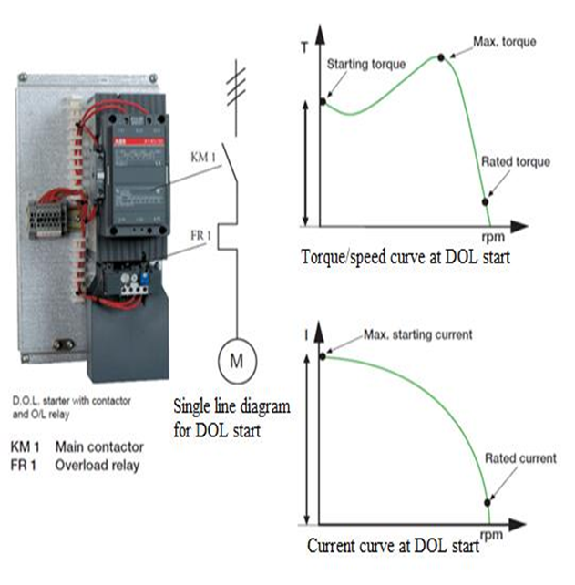
Figure 3.1: Characteristics of DOL starter

Chapter 3 Motor Starter and comparison 19

3.4 Stator Resistance Starting
In this method, external resistances are connected in series with each phase of stator winding during starting. This causes voltage drop across the resistances so that voltage available across motor terminals is reduced and hence the starting current. The starting resistances are gradually cut out in steps (two or more steps) from the stator circuit as the motor picks up speed. When the motor attains rated speed, the resistances are completely cut out and full line voltage is applied to the rotor [1,14].
3.4.1 Drawbacks
This method suffers from two drawbacks. First, the reduced voltage applied to the motor during the starting period lowers the starting torque and hence increases the accelerating time Secondly, a lot of power is wasted in the starting resistances.
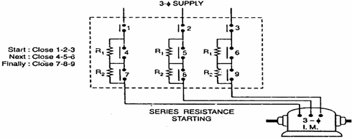
Figure 3.2: Stator resistance starter

3.4.2 Relation Between Starting and Full Load Torques
Let V be the rated voltage/phase. If the voltage is reduced by a fraction x by the insertion of resistors in the line, then voltage applied to the motor per phase will be xV.

$I_{st}$= x $I_{sc}$
Chapter 3 Motor Starter and comparison 20

$$\frac{T_{st}}{T_{f}}={\left(\frac{I_{st}}{I_{f}}\right)}^{2}×s_{f}$$
Now
$$\frac{T_{st}}{T_{f}}=x^{2}{\left(\frac{I_{st}}{I_{f}}\right)}^{2}×s_{f}$$
Thus the starting current reduces by a fraction x of the rated-voltage starting current (I_{sc}), the starting torque is reduced by a fraction x² of that obtained by direct switching. The reduced voltage applied to the motor during the starting period lowers the starting current but at the same time increases the accelerating time because of the reduced value of the starting torque. Therefore, this method is used for starting small motors only.

3.5 Autotransformer Starting
This method also aims at connecting the induction motor to a reduced supply at starting and then connecting it to the full voltage as the motor picks up sufficient speed. Fig 3.3 shows the circuit arrangement for autotransformer starting. The tapping on the autotransformer is so set that when it is in the circuit, 65% to 80% of line voltage is applied to the motor.
At the instant of starting, the change-over switch is set to “start” position. This puts the autotransformer in the circuit and reduced the applied voltage to the circuit. Consequently, starting current is limited to safe value. When the motor attains about 80% of normal speed, the changeover switch is set to “run” position. This takes out the autotransformer from the circuit and puts the motor to full line voltage [1,14].
3.5.1 Advantages
1) Low power loss.
2) Low starting current.
3) Less radiated heat.
This method is used for large machines (over 25 H.P). This method can be used for both star and delta connected motors.

Chapter 3 Motor Starter and comparison 21

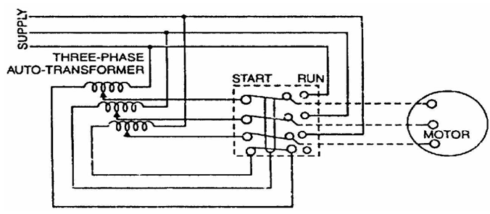
Figure 3.3: Autotransformer starter

3.5.2 Relation Between Starting and Full Load Torques
Consider a star-connected squirrel-cage induction motor. If V is the line voltage, then voltage across motor phase on direct switching is V/$\sqrt{3}$ and starting current is I_{ST} = I_{SC}. In case of autotransformer, if a tapping of transformation ratio K (a fraction) is used, then phase voltage across motor is KV/$\sqrt{3}$ and I_{ST} = K I_{SC},
Now$T_st/T_f =x^2 (I_st/I_f )^2×s_f=((K I_sc)/I_f )^2×s_f=K^2 (I_st/I_f )^2×s_f$
$$\frac{T_{st}}{T_{f}}=x^{2}{\left(\frac{I_{st}}{I_{f}}\right)}^{2}×s_{f}={\left(\frac{K I_{sc}}{I_{f}}\right)}^{2}×s_{f}=K^{2}{\left(\frac{I_{st}}{I_{f}}\right)}^{2}×s_{f}$$

$$\frac{T_{st}}{T_{f}}=K^{2}{\left(\frac{I_{st}}{I_{f}}\right)}^{2}×s_{f}$$
The current taken from the supply or by autotransformer is I₁ = KI₂ = (K²) I_{sc}. Note that motor current is K times, the supply line current is K² times and the starting torque is K² times the value it would have been on direct-on-line starting.

Chapter 3 Motor Starter and comparison 22

3.6 Star-Delta Starting
The stator winding of the motor is designed for delta operation and is connected in star during the starting period. When the machine is up to speed, the connections are changed to delta. The circuit arrangement for star-delta starting is shown in Fig 3.4.
When the motor starts each stator phase gets V/ volts where V is the line voltage. This reduces the starting current. When the motor picks up speed, the changeover switch is thrown to “run” position which connects the stator windings in delta. Now each stator phase gets full line voltage V [1,14].
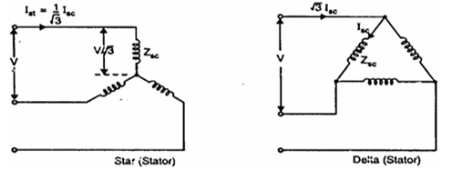
Figure 3.4: Star-Delta starter

3.6.1 Disadvantages
- With star-connection during starting, stator phase voltage is 1/$\sqrt{3}$ times the line voltage. Consequently, starting torque is 1/3 times the value it would have with delta connection. This is rather a large reduction in starting torque.
- The reduction in current is fixed.
- This method of starting is used for medium-size machines (up to about 25 H.P.)

3.6.2 Relation Between Starting and Full Load Torques
In direct delta starting:
Starting current/phase, I_{SC} = V/Z_{SC} where V = line voltage,
Starting line current = $\sqrt{3}×$I_{SC}
Chapter 3 Motor Starter and comparison 23

$$\frac{T_{st}}{T_{f}}={\left(\frac{I_{st}}{I_{f}}\right)}^{2}×s_{f}={\left(\frac{I_{st}}{I_{f}×\sqrt{3}}\right)}^{2}×s_{f}$$
$\frac{T_{st}}{T_{f}}=\frac{1}{3}{\left(\frac{I_{sc}}{I_{f}}\right)}^{2}×s_{f}$${\text{I}}_{\text{st}}\text{=}\frac{\text{V/}\sqrt{\text{3}}}{{\text{Z}}_{\text{sc}}}\text{=}\frac{{\text{I}}_{\text{sc}}}{\sqrt{\text{3}}}$

3.6.3 Characteristics of Star-Delta Starter

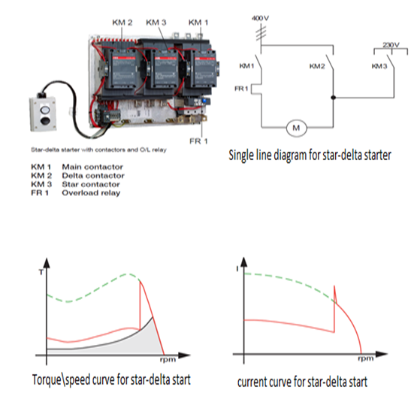
Figure 3.5: Characteristics of Star-Delta starter
3.7 Soft Starting
These devices utilize silicon controlled rectifiers or SCRs. By controlling the firing angle of the SCR the voltage that the device produces can be controlled during the starting of the motor by limiting the flow of power for only part of the duration of the sine wave.
The most widely used type of soft starter is the current limiting type. A current limit of 175% to 500% of full load current is programmed in to the device. Then it will ramp up the voltage applied to the motor until it reaches the limit value, and will then hold that current as the motor accelerates. Tachometers can be used with solid state starters to control acceleration time. Voltage output is adjusted as required by the starter controller
Chapter 3 Motor Starter and comparison 24

to provide a constant rate of acceleration. The same precautions in regards to starting torque should be followed for the soft starters as with the other reduced voltage starting methods. Another problem due to the firing angle of the SCR is that the motor could experience harmonic oscillating torques. Depending on the driven equipment, this could lead to exciting the natural frequency of the system. Reduced voltage soft starter can be used to avoid the effect of harmonics because it is by passed after attained the rated ramp voltage and voltage dip in this method is also negligible[1,14].

3.7.1. Basic Principle of Soft Starter
The soft starter controls motor current and torque by controlling the voltage applied to the induction motor. The voltage is controlled by varying the firing angle at which TRIACs are fired. The firing angle at the start is near 180 degree where conduction phase angle may be considered as zero degree hence zero voltage is attained [7-8,14]. Firing angle is improving back in time toward 0 degrees, making possible the full conduction across the TRIAC as seen in Fig 3.6.
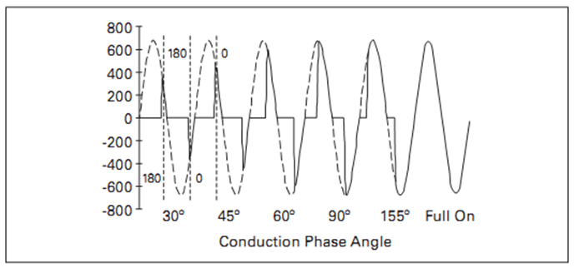
Figure 3.6: Conduction phase angle

At zero degree firing angle, the conduction phase angle is at 180 degree and full voltage is given to the motor phase, because the TRIAC conducts through the full 180 degrees. As the conduction phase angle is progressing back from zero degrees toward 180 degrees on subsequent gating of the TRIACs, the effective voltage to the induction motor increases, resulting in higher current and motor torque. With the proper feedback and control algorithms, current and torque can be controlled during start and stop of induction motor.

Chapter 3 Motor Starter and comparison 25

3.7.2. Characteristics of Soft Starter

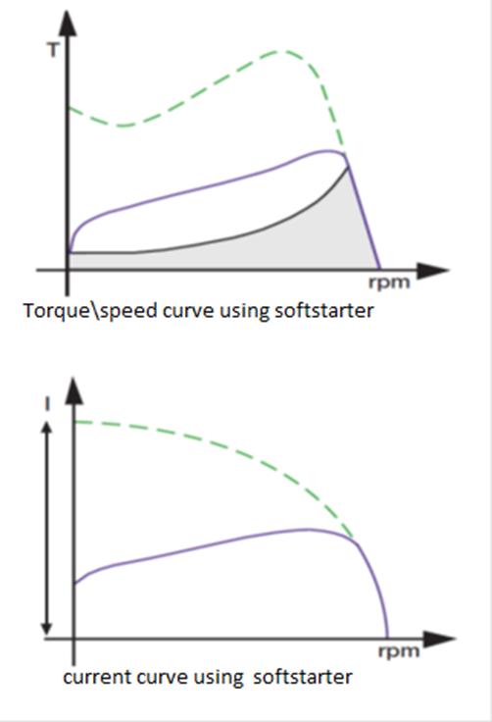
Figure 3.7: Characteristics of soft starter

3.7.3. Soft start devices provide two major benefits in their application
1) Less stress on the motor mechanically coupled to the load due to the reduced starting torque of motor.
2) Smooth the motor acceleration, reduced is the demand for energy flow in electric power systems due to the reduction of inrush current when the motor is started.
Two techniques are applied to control the soft starter.
1) Voltage ramp
2) Current control

Chapter 3 Motor Starter and comparison 26

3.7.4. Voltage Ramp Soft Starter
Voltage ramp soft starters are soft starters producing a start-voltage profile which is independent of the current drawn, by the motor. The start-voltage profiles are programmed to follow a predetermined contour against time. A very basic ‘timed voltage ramp (TVR)’ system, shown in Fig 3.8, operates by applying an initial voltage to the motor, and causing this voltage to slowly ramp up to full voltage [15-19]. Voltage ramp soft starters are also known as open loop soft starter. We choose this voltage ramp soft starting method due to certain reasons.
As compared to current ramp soft starter in which voltage is suddenly increase to achieve the ramp current; in voltage ramp method we gradually increase the voltage avoiding the stress on the system. Secondly current ramp starter always remains in service so its losses and power consumption is larger, while voltage ramp starter is bypassed after ramp time.

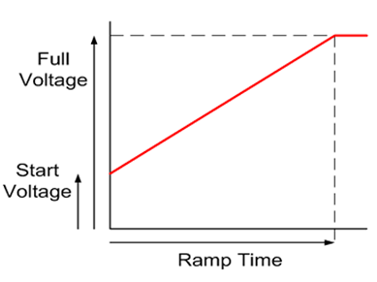
Figure 3.8: Characteristics of Voltage ramp soft starter

3.7.5. Closed Loop Control
Closed-loop starters monitor output characteristics or effects from the starting action and dynamically modify the start-voltage profile to cause the desired response. The most common closed loop soft starter is the current controlled soft starter where the current drawn by the motor during starting is monitored and controlled to give either a constant
Chapter 3 Motor Starter and comparison 27

current, or a current ramp soft start. A very often closed-loop format is the constant acceleration soft start where the motor speed is monitored by a tachometer or shaft encoder and the voltage is controlled to maintain a constant rate of acceleration or a linear increase in the motor speed [3].

3.7.5.1 Controlled Current Soft Starters
In the most basic systems the soft starter controls current on one phase and is monitored and compared to a current limit value. If the current exceeds that value, the ramp is frozen until the current drops below that set point. A comprehensive closed-loop soft starter will monitor the current on all three phases and dynamically change the output voltage to correct the starting current to the required profile.

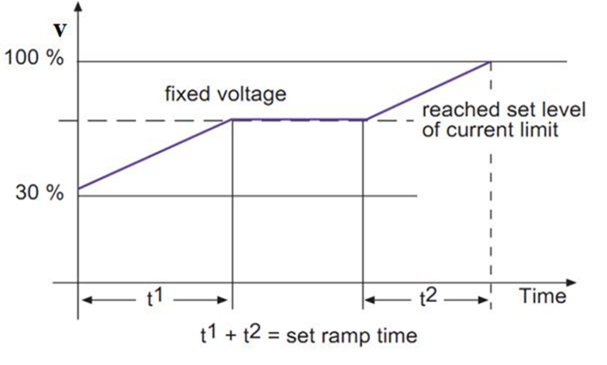
Figure 3.9: Characteristics of controlled current soft starter

Chapter 3 Motor Starter and comparison 28

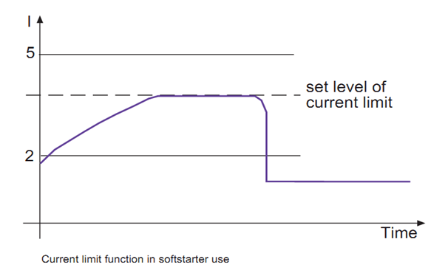
Figure 3.10: Current limit function in soft starter use

3.7.5.2. Constant Current Starters
A constant-current soft starter will start at zero volts and rapidly increase the output voltage until the required current is delivered to the induction motor, and then adjust the output voltage while the induction motor is starting until either full voltage is reached, or the motor overload protection operates. Constant-current starters are ideal for high inertia loads, or loads where the starting torque requirements do not alter.
3.7.6. Methods of Connecting Soft Starter
There are two different methods of connecting the soft starter in a circuit i.e. Inline, which is the most common method, and Inside Delta [20].
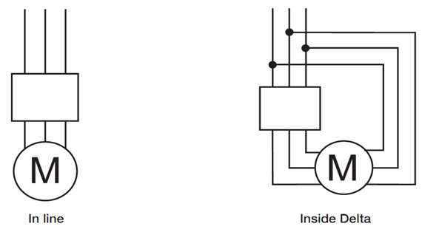
Figure 3.11: Method of connecting soft starter
Chapter 3 Motor Starter and comparison 29

• In-Line Connection
This is the most common way to connect the soft starter in a circuit. All three phases are connected in a series with the circuit breaker, overload relay, the main contactor and then the motor.
• Inside Delta Connection
The Inside Delta connection makes it possible to place the soft starter in the delta circuit and in that way it can easily replace an existing Y/D-starter. When the soft starter is Inside Delta it will only be exposed to 58 % (1/√3) of the In-line current. Therefore it is possible to downsize the devices in order to achieve a more cost-effective solution
• Bypassing Of Soft Starter
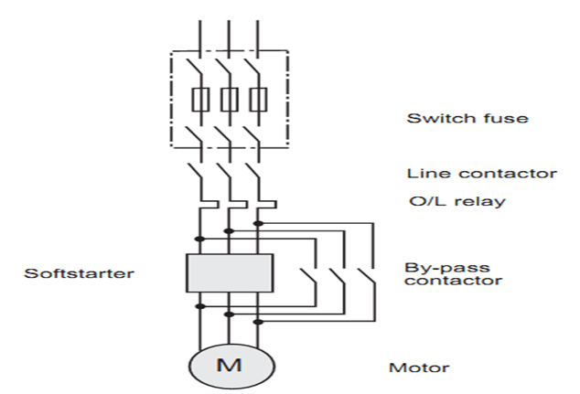
Figure 3.12: Bypassing of soft starter

3.8 Comparison of Soft Starting with Other Starting Techniques
There are different types of starting techniques. The best technique can be sorted out by comparing each technique [1,14].

Chapter 3 Motor Starter and comparison 30

3.8.1. Direct On-Line Starting
Characteristics DOL starting are as follows
1) It can be used for three-phase induction motor with low to medium power rating
2) It has high starting torque
3) It has high starting current
4) It causes voltage dip
3.8.2. Star-Delta Start-Up
Characteristics of star-delta starter are as follows
1) It is used for 3-phase induction motor with low to high power rating
2) It can reduce starting torque, 1/3 times the nominal torque
3) It causes high mains load due to current peak during switchover from star to delta
4) High mechanical stress occurs due to torque surge during switchover from star to delta
5) It requires two or three switching devices, hence more maintenance

3.8.3. Soft Start-Up
The characteristics of soft starter which can distinguish it from other starting methods are as follows.
1) It is used for 3-phase induction motor with low to high power rating
2) It does not cause current peak
3) No torque peaks occurs.
4) It causes negligible voltage dip
5) It is a simple switching device, requires no maintenance.
Chapter 3 Motor Starter and comparison 31

3.8.4. Motor starter comparison with respect to mechanical parameters
Table 3.1: Motor Starters Comparison
Types of Problem | Type of starting Method
 | Direct on line | Star delta | Soft starter
Slipping belt and wear on bearing | Yes | Medium | No
Transmission peaks | Yes | Yes | No
Heavy wear & tear on gear boxes | Yes | Yes(Loaded start) | No

Chapter 4 Design of soft starter and speed control 32

Chapter 4
Design of Soft Starter and speed control for Three Phase Induction Motor

4.1 Proposed Approach
A soft starter work on the principle of reduced voltage starting technique and is connected in series with voltage source and motor. In this technique the voltage applied to the rotating load is first reduced and then increased gradually, the reduced voltage results in reducing the inrush current and torque can also be controlled. The soft starter employs solid-state devices to control the current flow and therefore the voltage applied to the motor. Voltage control is achieved by means of pair of MOSFETs with each phase.
The philosophy of the project is based on voltage control of induction motor through Control circuit and H-bridge. The magnitude of voltage is obtained by controlling the firing angle of TRIACs in both half cycles of AC voltage supply. Voltage of a phase connected to motor is first reduced by step down transformer and then further divided by voltage divider and then given a DC offset by voltage clamper circuit. The voltage sample with DC off set is given to comparator that generates the square wave with rising edge for positive zero crossing and falling edge for negative zero crossing of phase voltage.
The microcontroller receives the square wave output of comparator and Interrupts in microcontroller detects the rising and falling edges of wave and starts the timers. Timer starts and at each iteration it compares the time with the desired triggering time stored in the register, when timer equals the given time it generates the pulse of width 100 µs in each half cycle. The gating signal generated by microcontroller is the given to crystal oscillator of 20MHz which is used to drive the controller.
In this project reduced PWM soft starting technique is used. Initially single phase supply is given to control circuit and bridge circuit independently and is controlled using knob. The block diagram shown in Fig 4.1 below represents the proposed approach of this project.
Chapter 4 Design of soft starter and speed control 33

4.2 Block Diagram
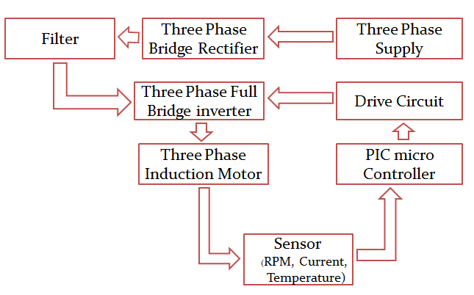
Figure 4.1: Block diagram of soft starter and speed control

4.3 Steps of Implementation
The process of implementation and experimentation can be sub divided into following major sections
1) Control module
2) H-Bridge module
3) Speed drive module

Chapter 4 Design of soft starter and speed control 34

4.3.1. Control module
In control module, we use following devices and components.
1) Step down transformer
2) Sensors
3) PIC microcontroller
4) LEDs
5) Gate drive IC
6) Opto-couplers
7) Regulators
8) Capacitors
9) Resistors
10) Diodes
11) Push buttons
Step Down transformer is used to step down the voltage level from 240V to 15V,required to operate the control module, after that two bridge rectifiers are used to get pure DC of 15 V.This voltage is now applied to regulators which regulate the voltage, capacitors are installed to remove noise from circuit. Push buttons are used to start and stop the motor. A crystal oscillator is an electronic oscillator circuit that uses the mechanical resonance of a vibrating crystal of piezoelectric material to create an electrical signal with a very precise frequency. This frequency is commonly used to keep track of time (as in quartz wristwatches), to provide a stable clock signal for digital integrated circuits, and to stabilize frequencies.this provides a clock to PIC controller IC 18f2431 which operates at 15V . opto couplers are used to isolate the circuit in order to avoid damaging. Gate driver IC ir2110 is used for each phase to drive the control signal and each phase has installed two capacitors to remove noise. This now gives 220V to each phase. diodes are installed in reverse biase so that 220V couldnot come back to control module.
4.3.1.1 Gate drive selection
1) A gate driver tells the MOSFETS, (switches) when to open and close.
2) More advanced models have:
3) Dead time to prevent signal “shoot through”.
4) Over current protection (surge protection).
5) Fault “self-clearing” mechanisms.
6) Enable switches to turn on/shut off drive

Chapter 4 Design of soft starter and speed control 35

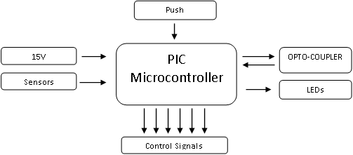
Figure 4.2: Block diagram of Control Module

Given is the block diagram of Control module. The main advantage of bridge rectifier you do not need a center tap on the secondary of the transformer. A further but significant advantage is that the ripple frequency at the output is twice the line frequency and makes filtering somewhat easier.
4.3.1.2 Opto-coupler
In electronics, an opto-isolator, also called an optocoupler , photocoupler, or optical isolator, is "an electronic device designed to transfer electrical signals by utilizing light waves to provide coupling with electrical isolation between its input and output. The main purpose of an optoisolator is to prevent high voltages or rapidly changing voltages on one side of the circuit from damaging components or distorting transmissions on the otherside. Commercially available optoisolators withstand input-to-output voltages up to 10 kV and voltage transients with speeds up to 10 kV/μs.

4.3.2. H-Bridge Module
The Hex bridge takes a DC bus voltage and uses six MOSFETs switches arranged in three phase legs. Each line is then connected to from the middle of each phase leg to the motor itself. The waveforms on these lines must be a balanced three phase sinousidal
Chapter 4 Design of soft starter and speed control 36

waveform in order to drive induction motor properly. This is achieved by carefully controlling the switching waveforms at the gates of switches.
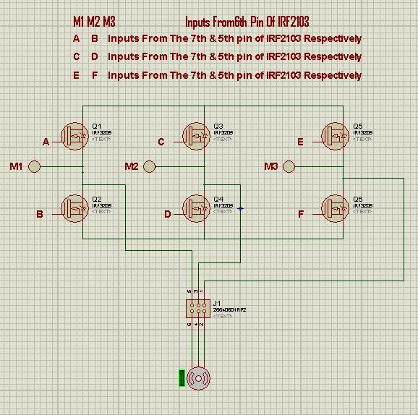
Figure 4.3: Hex bridge Configuration

Chapter 4 Design of soft starter and speed control 37

4.3.3 Speed Drive Module
Speed drive module consists of PIC microcontroller , LCD , and variable knob.
Controller is programmed to display on LCD that motor is running on how much percentage of full rated voltage. Variable knob is used to increase or decrease the speed of motor.

4.4 Microcontroller
The microcontroller to be used in project is PIC 16f877. This is a compact 40 pin microcontroller of PIC series. The PIC microcontroller was developed by General Instruments in 1975. PIC was developed when Microelectronics Division of General Instruments was testing its 16-bit CPU CP1600. Although the CP1600 was a good CPU but it had low I/O performance. The PIC controller was used to offload the I/O the tasks from CPU to improve the overall performance of the system. In 1985, General Instruments converted their Microelectronics Division to Microchip Technology. PIC stands for Peripheral Interface Controller. PIC microcontroller contains an 8-bit ALU (Arithmetic Logic Unit) and an 8-bit Working Register (Accumulator). There are different GPRs (General Purpose Registers) and SFRs (Special Function Registers) in a PIC microcontroller. The overall system performs 8-bit arithmetic and logic functions. These functions usually need one or two operands. One of the operands is stored in WREG (Accumulator) and the other one is stored in GPR/SFR. The two data is processed by ALU and stored in WREG or other registers. Pin configuration of PIC 16f877 is shown in Fig 4.6.

Chapter 4 Design of soft starter and speed control 38

4.4.1 Pin Descriptions
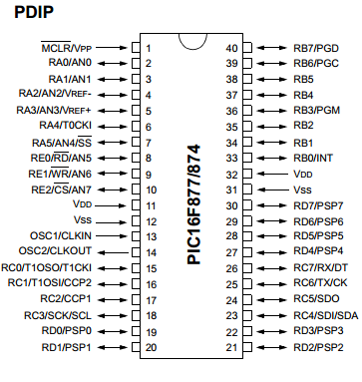
Figure 4.4: PIC 16f877 pin description

Chapter 4 Design of soft starter and speed control 39

Table 4.1: PIC 16f877 parameters
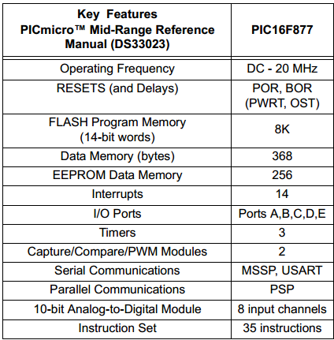

4.5 Opto-Coupler MOC 3021
There are many situations where signals and data need to be transferred from one subsystem to another within a piece of electronics equipment, without making a direct electrical connection. Often this is because the source and destination are (or may be at times) at very different voltage levels, like a microprocessor which is operating from 5V DC but being used to control a TRIAC which is switching 240V AC. In such situations the link between the two must be an isolated one, to protect the microcontroller from overvoltage damage. Schematic diagram of MOC3021 opto-coupler is given below.

Chapter 4 Design of soft starter and speed control 40

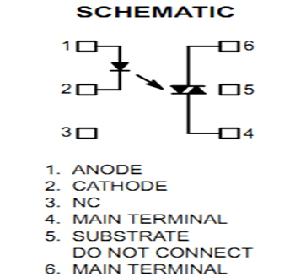
Figure 4.5: Opto-coupler pin description
Opto-couplers typically come in a small 6-pin or 8-pin IC package, but are essentially a combination of two distinct devices: an optical transmitter, typically a gallium arsenide LED (light-emitting diode) and an optical receiver such as a phototransistor or light-triggered DIAC.
The two are separated by a transparent barrier which blocks any electrical current flow between the two, but does allow the passage of light. The basic idea is shown in Fig 4.9, along with the usual circuit symbol for an opto-coupler. Usually the electrical connections to the LED section are brought out to the pins on one side of the package and those for the phototransistor or DIAC to the other side, to physically separate them as much as possible. This usually allows opto-couplers to withstand voltages of anywhere between 500V and 7500V between input and output. Opto-couplers are essentially digital or switching devices, so they are best for transferring either on-off control signals or digital data. The circuit diagram of an opto-coupler for driving a TRIAC is given below
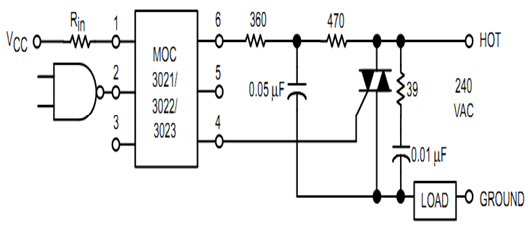
Figure 4.6: Snubber circuit
Chapter 4 Design of soft starter and speed control 41

In the circuit that shown in Fig 4.10, the “hot” side of the line is switched and the load connected to the cold or ground side. The 39 ohm resistor and 0.01µF capacitor are for snubbing of the TRIAC, and the 470 ohm resistor and 0.05µF capacitor are for snubbing the coupler. These components may or may not be necessary depending upon the particular TRIAC and load use.

Chapter 5 Hardware implementation and verification 42

Chapter 5
Hardware Implementation and Verification

5.1 Hardware Implementation

Hardware Implementation is the heart of any project. After simulation is done in software next step is the implementation in practical form so that we could compare and contrast the actual results with simulation results and also with the results of direct online starting.
5.2 Phases Of Implementation
1) Printed circuit board (PCB) layout
2) Placement of components on PCB
3) Combining of all modules
5.2.1 Printed circuit board (PCB) layout
PCB designed is shown in fig 5.1 below.
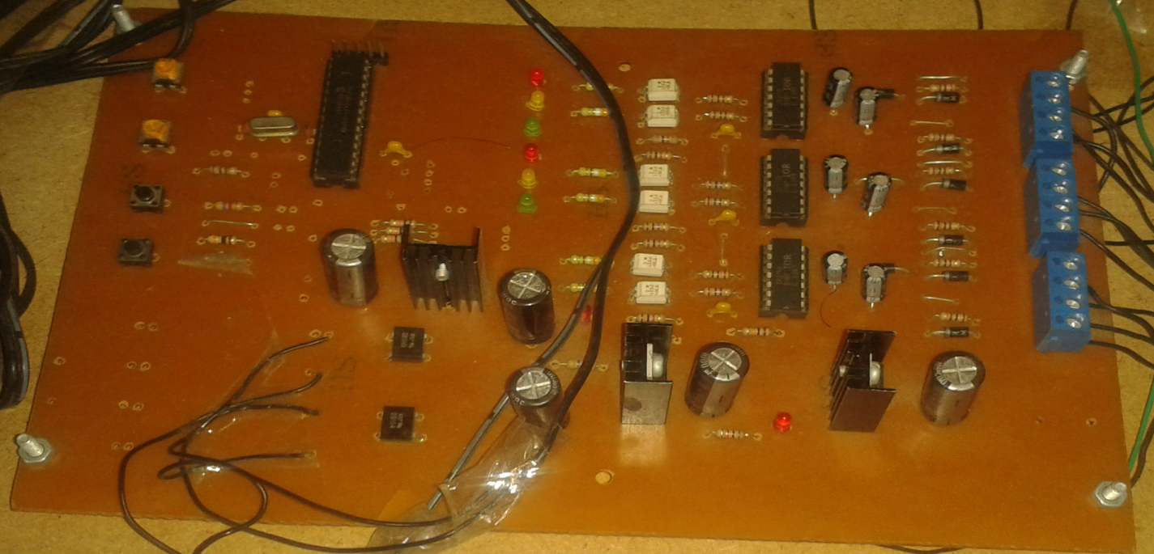
Figure 5.1: Control Module
Chapter 5 Hardware implementation and verification 43

Rectifier and inverter printed circuit board as shown in fig 5.2.
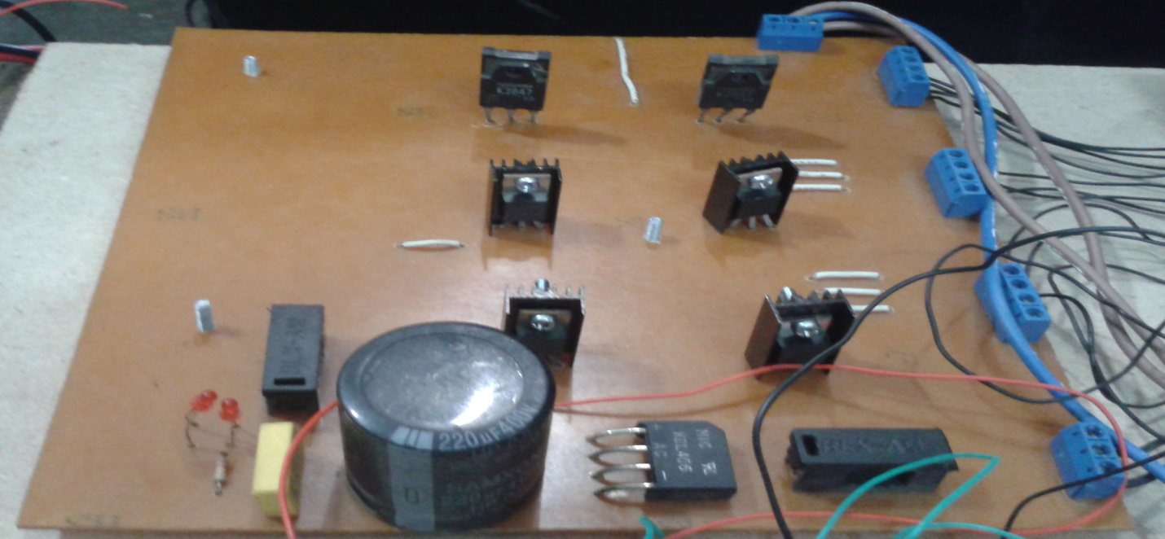
Figure 5.2: H-Bridge Module

Complete view of soft starter

Figure 5.3: Soft starter and speed control in operation
Chapter 5 Hardware implementation and verification 44

The soft starter can operate satisfactorily for current below 16A and voltage range of 190V-240v per phase.
5.2.2 Practical Results Verification
The results of currents both at starting and steady state for DOL method are shown in the table 5.1.
Table 5.1: Direct online starting and steady state currents
I_{ST} (No Load) | I_{SS} (No Load) | I_{ST} (Full Load) | I_{SS} (Full Load)
4A | 2.8A | 14A | 7.0A

The results of currents both at starting and steady state for soft starter are shown in the table 5.2.

Table 5.2: Soft starter starting and steady state currents
I_{ST} (No Load) | I_{SS} (No Load) | I_{ST} (Full Load | I_{SS} (Full Load)
3.2 A | 2.8A | 8A | 7.0 A

To achieve the optimum ramp time, different values of resistor and capacitor are used as shown in the graph in fig. The following equation represents the relationship between capacitor sizes used for generating delay in triggering at different resistors used in RC circuit.

Chapter 5 Hardware implementation and verification 45

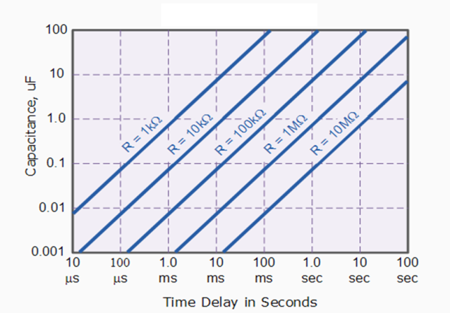
Figure 5.4: Capacitance- time delay Characteristics

Soft Starting For Different Ramp Times For No Load and Full Load Current at R=100kΩ

Table 5.3: Soft starting for different ramp time
Ramp time=(delay$×10)$ | Time delay b/w each triggering | I_{ST}  (No load) | I_{ST}  (Full load) | Capacitor size
10min | 1min | 3.7A | 8.9A | 100uF
5min | 30sec | 3.38A | 8.5A | 10uF
2.5min | 15sec | 3.32A | 8.1A | 4.7uF
20sec | 2sec | 3.3A | 7.7A | 1uF
10sec | 1sec | 3.0A | 7.3A | 0.1uF
1sec | 0.1sec | 3.28A | 7.3A | 0.01uF
0.1sec | 0.01sec | 3.2A | 7.4A | 0.001uF

Experiments are performed to measure the efficiency of the starter for different ramp times. Table 5.3 gives the brief summary about the different ramp times and capacitor selection for providing the ramp time. For greater ramp time, voltage supplied to motor becomes very less for large time so it draws more current. While for smaller ramp time
Chapter 5 Hardware implementation and verification 46

the blockage of current with the help of TRIACs is less. So it draws large starting current. There is an optimum value of ramp time for which motor draws minimum starting current. The Table 5.3 shows that for the starter of this particular motor, optimum ramp time is 10 seconds.

5.3 Comparison of direct online starting and soft starting
Table 5.4: Comparison between DOL and soft starting
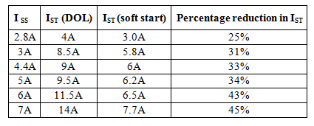
As the load increases on motor, it tends to draw high current. The method of soft starting provides a ramp voltage which is actually not the smooth increase of voltage, but voltage increases in small steps because the triggering of TRIACs occurs in steps. The blockage time of current for a particular ramp is the same weather motor starts at full load or no load. So, for full load heavy current is blocked by this blockage time of TRIAC while for blockage time, the current block at no load is less. That is the reason, percentage reduction in starting current increases with increase in load.

Chapter 5 Hardware implementation and verification 47

5.4 Comparison between simulation and hardware results of soft starter
Table 5.5: Comparison between simulation and hardware of soft starting
Load | Starting current in simulation  I_{ST} | Starting current in hardware  I_{ST} | Percentage error
No-load | 3A | 3.2A | 6%
Full-load | 7.33A | 7.7A | 5%

The results of practical experimentation are much similar to the simulation results. Only 5-10% difference occurs in the results of simulation and hardware implementation.

Chapter 6 Conclusion 48

Chapter 6
Conclusion

The purpose of the project was to reduce the voltage dip and the inrush current especially when the motor has large load and to protect motor by controlling the speed. This purpose has been achieved successfully after installing the designed soft starter and speed control . Percentage reduction in starting current is increased, as the load on motor is increased. At no load the reduction in starting current is almost 25%, while at full load the reduction in starting current is 45-48%. Reduction in inrush current further reduces the voltage dip. After the project is done successfully, some conclusions were made and some recommendations and future considerations are also suggested.
6.1 Recommendations
The soft starter with a modification of speed control and its protections is highly recommended for industrial applications where high power rating motors are used especially when loaded motors are to be started. Rural areas which are far away from substation observe the effect of high voltage dip. So the soft starters are highly recommended for the tube-wells used for irrigation purposes.
6.2 Future Considerations
In future this project can be updated same by using this closed loop method. The same circuit can be modified for soft stop and speed control by changing the programming of controller.
This project can be improved in future by adding these features.
1) Protection of soft starter and motor can be improved using under voltage, over voltage, under frequency and over frequency protection.
2) With a little modification in this project, it can also be used for motors of very very higher rating.
3) Reduction in starting current can be increased.

