ABSTRACT

In this modern world energy and power are extremely important necessities .The demand of energy is increasing each day, so the closing approach to cope with these troubles is just to put in force the renewable sources of energy, but those renewable energy sources ought to have to be adopted in sensible manner through keeping an eye on all elements regarding the studies work. In case of our task we have used the technique of power generation through footsteps as a source of renewable energy, that we can obtain by walking directly over some arrangements like footpaths, stairs, platform etc. and these systems may be deploy anywhere specially in the dense populated regions. The basic operating principle of our project ‘footstep power generation using piezo electric sensor’ is based totally on piezoelectric sensor. We have adjusted the wooden plates above and beneath the sensors and moveable springs are attached to one of the wooden plate, when we stroll on the mat than robotically force is applied which compresses piezo sensors with the help of springs and consequently required power is generated. We've concluded that these sorts of designs and strategies of electricity producing systems are very useful and reachable that allows us to meet the demand of energy during the hours of load shedding.

TABLE OF CONTENTS
Chapter 1 1
INTRODUCTION 1
1.1 Introduction 2
1.2 Motivation 2
1.3 Problem statement 2
1.3.1 Energy crises in Pakistan 3
1.4 Renewable energy sources 4
1.5 Objective of our project 4
Chapter 2 5
LITERATURE SURVEY 5
Chapter 3 8
PIEZOELECTRIC SENSOR 8
3.1 Sensor 9
3.1.1 Piezo electric Sensors 9
3.1.1.1 Geometry 10
3.1.1.2 Materials 11
3.1.1.3 Working of piezoelectric sensor 11
3.1.1.4 Uses of piezoelectric sensor 12
Chapter 4 14
PROJECT DESCRIPTION 14
4.1 Block diagram 15
4.2 Battery charger circuit 15
4.2.1 Circuit diagram of battery charger 16
4.2.2 Description of Components 16
4.2.2.1 Metal Oxide Semiconductor Field Effective Transistor (MOSFET) IRF540 16
4.2.2.2 Capacitor 17
4.2.2.2.1 Electrolytic capacitors 18
4.2.2.2.2 Non-electrolytic capacitors 18
4.2.2.3 PIC microcontroller 19
4.2.2.3.1 PIN configuration and description Of PIC16F877A 19
4.2.3 Working of battery charger circuit 20
4.3 Voltage display circuit through microcontroller 20
4.3.1 What is Liquid Crystal Display (LCD)? 21
4.3.1.1 Pin configuration of LCD 21
4.3.1.2 Pin functions and Pin description 22
4.4 Inverter circuit 22
4.4.1 Description of components 23
4.4.1.1 MOSFET IRFZ44 23
4.4.1.1.1 Description 23
4.4.1.1.2 Features 23
4.4.1.2 IC 4047 24
4.4.1.2.1 Features 24
4.4.1.2.2 Pin Configuration 24
4.4.1.2.3 IC4047 Applications 24
4.4.2 How does inverter circuit Work? 25
Chapter 5 26
HARDWARE IMPLEMENTATION 26
5.1 Introduction 27
5.1.1 Wooden sheet 27
5.1.2 Springs 28
5.1.3 Arrangement of Piezo 28
5.1.4 Battery charger circuit 29
5.1.5 Battery 30
5.1.5.1 Primary batteries: 30
5.1.5.2 Secondary batteries: 30
5.1.5.3 Battery used in project 31
5.1.6 Voltage display circuit 31
5.1.7 Inverter 31
5.2 Final implementation of our project 32
Chapter 6 33
SOFTWARE IMPLEMENTATION 33
6.1 Software used for simulations 34
6.2 Voltage display circuit 35
6.3 PCB layout of voltage display circuit 35
6.4 Simulation of Battery Charger Circuit 36
6.5 PCB layout of battery charger circuit 36
Chapter 7 37
RESULTS, CONCLUSION AND FUTURE SCOPE 37
7.1 Calculations and results 38
7.1.1 Second law of motion 38
7.1.2 Einstein Mass-Energy relation 39
7.1.3 Steps for calculation 39
7.1.4 Time taken by project to charge 12V battery 41
7.2 Applications 42
7.3 Conclusion 43
7.4 Future scope 43
LIST OF REFERENCES 45
APPENDICES 47
Appendix A- codes and libraries 47
Appendix B - datasheets 49

LIST OF FIGURES
Figure 3-1 piezo senor 10
Figure 3-2 internal structure of piezo without applying pressure 11
Figure 3-3 internal structure of piezo sensor after applying force 12
Figure 3-4 working of piezo sensor 13
Figure 4-1 block diagram 15
Figure 4-2 schematic diagram of battery charger 16
Figure 4-3 IRF540 symbol and pin configuration 17
Figure 4-4 electrolyte capacitor 18
Figure 4-5 non-electrolyte ceramic capacitors 18
Figure 4-6 microcontroller IC 19
Figure 4-7 pin configuration of PIC16F877A 20
Figure 4-8 schematic diagram of voltage display circuit 21
Figure 4-9 pin diagram of LCD 21
Figure 4-10 circuit diagram of inverter 22
Figure 4-11 pin configuration on left and symbol on right 23
Figure 4-12 IC4047 configuration for astable 24
Figure 5-1 upper and bottom wooden sheets 27
Figure 5-2 springs used in our project 28
Figure 5-3 piezo sensor and parallel-series arrangement of piezoes on the lower wooden sheet 28
Figure 5-4 upper wooden sheet having nut and bolt on left and bottom side of upper wooden sheet having springs on right 29
Figure 5-5 piezo sensor mat (2 wooden sheets are one above the other) 29
Figure 5-6 hardware implementation of battery charger circuit 30
Figure 5-7 12V Lead acid battery 31
Figure 5-8 microcontroller circuit for battery voltage display 31
Figure 5-9 inverter and load of our project 32
Figure 5-10 final model of our project 32
Figure 6-1 Simulation of voltage display circuit 35
Figure 6-2 PCB layout of voltage display circuit 35
Figure 6-3 simulation of boost converter used in battery charger 36
Figure 6-4 PCB layout of battery charger circuit 36
Figure 7-1 final implementation and results according to applied force 42
Figure 7-2 flooring tiles installed at japan 43
Figure 7-3 dance floor installation 44

Chapter 1

INTRODUCTION

This Chapter summarizes the basic ideas behind the project. It gives necessary introduction to energy sources, recognizing the main problem due to energy crisis and concluding its solution.

- Introduction
Energy surrounds us in all elements of life, it depends on us weather we use it constructively for the benefit of human being or we use it destructively to harm others. Alternative power refers to electricity resources, which aren't based at the burning of fossil fuels or the splitting of atoms. The renewed concern in this area of examine comes from the undesirable outcomes of pollutants both from burning fossil fuels and from nuclear waste byproducts. Luckily there are many means of harnessing electricity, which have less damaging impacts on our surroundings.
Alternative energy sources are:
- Solar energy.
- Wind power.
- Geothermal.
- Hydroelectric.
- Nuclear.
We’re introducing a new way to overcome the growing demand of electricity. We are utilizing human footstep pressure and we titled it “footstep power generation system using piezoelectric sensor (FSPG)”.
  - Motivation
Human are hunter of energy since the beginning of life. First he tried to get electricity from animals and plant life. Then he commenced cultivation of land to get food and gave a new trend to power through schooling animals for his help in doing task. Demand is constantly increasing day by day so he started to use wind for riding ships inside the sea and water to turn water wheel.
  - Problem statement

In Pakistan the demand is greater than the electricity produced so we are dealing with power-cut after approximate 1 hour and industries are in hell nowadays. Humans make use of rechargeable batteries (UPS) or diesel/petrol engine to meet their demands.
    - Energy crises in Pakistan

Power is essential basis in aid of economic growth of a nation. There will be energy crises that Pakistan has to look in future for next two to three years in power, oil and natural fuel. Now Pakistan is suffering energy crises in almost every area, that’s why Pakistan gross home product is low because of business shut down, shut down of local factories as well as home factories. Today broadly speaking every business is depended upon power. Now electricity is the spine of everything and in Pakistan (A nuclear united states).
There are many reasons that cause energy crises in Pakistan. Recession is one of them. Pakistan is facing “recession and economic crises” for the past eight years. Inflation is improved to its better extent, so that’s why investment from foreigner is reduced to high-quality extent, because of a majority of these problems there are power crises in Pakistan.
Another reason of short fall is shortage of money for independent electricity producers. These independent power producers could not deliver full power, so they shut down their units. Moreover no money is given to oil delivers and oil producers as well as to Pakistan state oil .Pakistan is under great debt so that it doesn’t get any loan from global bank. That’s why electricity is not produced within the plants so they close down their units and consequently our economic growth decreases.
Main cause of energy crises is insufficient construction of new dams; as a result we are unable to produce sufficient electricity. Other reason for energy crises in Pakistan is improper maintenance of already existing power plants whenever the power plant is broken because of any cause then that unit might be absolutely shut down. And burden on different units boom which in turns boom the quick fall, moreover the staffs don’t cope with electricity plants .Another cause of energy crises is corruption in power plants. As the corruption ratio in Pakistan is very high mainly in government sectors. So due to bad management, corrupt staff and illegible officers working in power plants increases crises in Pakistan. Mismanagement also causes problem while running the power plants. If power plant unit is not turning off and on completely at specific time it will result in the increase of energy crises.
Industries and factories in Pakistan require huge quantity of fuel and gas, however availability of these is very low, and due to discontinuous deliver of gas and fuel some of the unit shut down their work and energy crises increases. Because of above stated crises economic system is low so we need to find a manner to generate energy that's most cheap and efficient.
  - Renewable energy sources
Because of global warming and worldwide heating now globe is stirring to renewable electricity resources. Different opportunity assets which can be used for producing electricity are either very highly-priced or their devices are shut down in Pakistan. Preservation of already existing power assets prompted huge quantity of price; so many prices is because of the heavy machinery involving in it which need maintenance, exertions and engineering work. Those present energy sources are also harmful for human beings, the rays from nuclear generator induce most cancers to the nearer cities, and hydroelectric initiatives prompted flood to cities and additionally damaged the fields. So because of those problems globe is stirring to renewable electricity assets which might be fairly low value, efficient, dependable and causes no uneasiness to human nature. The renewable energy sources together with sun panels, wind turbine, geo thermal, bio gas and so on, all of them use natural matters for generating electrical power so the danger to mankind will not be as much as more in the case of nuclear electricity. The maintenance costs of those plants are very low. Those plants not include any heavy equipment for producing electric energy. So when those plants are out of working or some error in it and it required renovation then the protection price is not so much high and moreover it don’t need hard effort because it isn't involving any heavy equipment in it and it simplest calls for engineering work in it. So that’s why our venture is of renewable energy resources and we harvest power by means of footsteps and it is fairly low price and efficient approach.
  - Objective of our project
Our purpose is to provide electricity by means of a supply that has no bad effect on surroundings and its output can be used to overcome the crises in Pakistan.

Chapter 2

LITERATURE SURVEY

This chapter describes some previous work of researchers about piezoelectric sensor and existing systems.

Energy harvesting has been concern of many researchers for decades. Researchers have put much attempt into electricity conversion and latest researches has determined that piezoelectric materials are one the fine choice in power conversion from mechanical into electrical or vice versa. Those materials are also widely used as sensors and actuators.
Many researchers have derived mathematical models for energy harvesting beam; maximum of them have used Euler–Bernoulli beam theory which is likewise called thin beam theory [1]. Models derived the usage of this principle are applicable for each micro- and Nano-beams.
A beam with piezoceramic patches has been used as a method to harvest energy. A unimorph piezoelectric cantilever beam generates electric current or voltage from the piezoelectric strain effect [1]. Piezoelectric material has property to couple mechanical and electrical properties. When a piezoelectric is strained it produces an electric field. Piezoelectric materials have long been used as sensors and actuators [2].
Diaphragm movement in certain material will cause generation of electric charge. Pressure polarizes some crystals, such as quartz [3].
According to research there are various sources of energy generation via which we can generate the electricity with footsteps. It’s far particular and unique kind of power generation system it requires a technology and big quantity of studies work that’s why this sort of generation system is in use of developed nations.
This sort of power generation may be executed through various techniques like piezoelectric sensors, through mechanical association like fly wheel and gear wheel, pedal and staircase power generating system by means of rotating the generator, then also by enforcing the faraday’s law of electromagnetic induction via shifting magnet into the coil via spring gadget.
Different people have developed Rack-pinion and pulley (mechanical-to-electrical) surfaces in the past, but the Crowd Farm has the capacity to redefine city area through adding an experience of fluidity and encouraging people to spark off spaces with their movement. The crowd Farm floor is composed of standard parts which might be replicated without problems but it’s highly-priced at this level. This technology would facilitate the destiny introduction of latest urban landscapes athletic fields with a spectator region, tune halls, theatres, nightclubs and a large collecting space for rallies, demonstrations and celebrations, railway stations, bus stands, subways, airports etc. like able to Harnessing human locomotion for power generation.
Proposal for the usage of waste energy of foot power with human locomotion may be very much relevant and crucial for rather populated countries like India and China in which the roads, railway stations, bus stands, temples, and so forth are all over crowded and hundreds of thousands of people pass around the clock. This entire human/bio energy being wasted, if it can be made possible for utilization it'll be great invention and crowd energy farms can be very useful energy sources in crowded countries. Walking throughout a "Crowd Farm," ground, then, may be a fun for idle individuals who can improve their fitness via workout in such farms. The electricity generated at such farms could be useful for many applications.

Chapter 3

PIEZOELECTRIC SENSOR

This chapter gives introduction to piezo electric sensors; it tells about its geometry, material, its working and uses.

  - Sensor
A sensor is basically a device that can measure a physical quantity and converts it into waveform which can be examined by an observer. We know that as mercury indicates the temperature of the body by way of the liquid expansion. Sensors are calibrated with the aid of a scale which is easy for observer.
- Piezo electric Sensors
A device which is capable of measuring the force, pressure, strain and vibration and converts it into electrical signals is called piezo electric sensor. Those substances show off a property called piezo electric effect wherein vibration is produced. An electric field is created which creates a potential difference throughout these substances and as a result current begin flowing via it.
The word Piezoelectricity means pressure electricity and it is a Greek word. There are a lot of crystals for example Zirconate Titanate, PZT that produce electric charges whenever pressure is applied on them or they vibrate when subjected to potential difference. The amount of charges depends upon the frequency of vibration. AC voltage vibrates the piezo electric material at the equal frequency at which we're providing AC.
Quartz is the good example of piezo material. Materials with ABO3 have the strong property of piezo power, in which ‘A’ denotes large divalent ion (lead) while ‘B’ is for small tetravalent ion (titanium).
- Piezoelectric generation rises because of set of inherent advantages i.e.
- High modulus of elasticity (N/).
- Piezo material could be very rugged.
- Have very high natural frequency.
- Insensitive to EM radiation (can be used in every conditions).
- No impact of radiations.
- Tourmaline is stable at high temperature also (even sensor works at a thousand°C).
- As piezo material is touchy to strain, a few are also sensitive to temperature they're referred to as pyroelectrical.
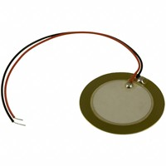
Figure 3-1 piezo senor
The piezoelectric sensor proven in fig 3.1 is of tourmaline material. It’s very effective for everyday usage because it could bear high temperature; it is hard and is linear over amplitude. The material and not using a center of symmetry then it'll exhibit the property of piezoelectricity.
- Geometry
We think that a simple material that is having an ordinary crystal has a property of producing electrical spike, what it has that make him do this type of top notch task. Questions arises in thoughts that
- What make it distinctive from different other materials?
- Are free electrons present in its atom?
- Is that material show off the property of magnet and coil?
The solution to these questions is present in the structure of piezoelectric material. The answer to why an electric spike is produced when pressure is applied lives behind its crystal’s shape.
Most of the piezoelectric material is ionic salts containing cations and anions, these ions shape a unit cell. The crystal of piezoelectric material includes 3 dimensional array of unit cell. The unit cell has a +ve charge center and a –ve charged center. If those centers are at same place i.e. center coincide then there may be no electrical dipole and subsequently no spike. However if their centers do not coincide then the electrical spike value could be according to the magnitude of charges and distance of +ve and -ve charges. There are symmetric and asymmetric unit cell and vibration or pressure reasons each unit cell to distort however the symmetric cell’s center will keep on coinciding after pressure. In case of uneven cell, force will cause the center of +ve and –ve ions for you to create electrical voltage. There are 32 unit cells of which almost 20 have piezoelectric property due to the fact they are unsymmetrical.
- Materials
There are numerous substances which has the property of piezo electricity for example:
- Quartz SI.
- Ammonium di-hydrogen phosphate (ADPN).
- Potassium sodium tartrate (KNa).
- Rochelle salt.
All others have very strong piezo electric effect except quartz and are utilized in low cost projects because of the fact that their strength is weak.
- Working of piezoelectric sensor
This effect is because of its geometry which contains a unit cell. Unit cell of piezoelectric material has a cubic shape which has positive charge at its respective ends as shown in fig 3-2. In this fig. we're discussing only those substances which are having asymmetric nature because otherwise no voltage spike will produce and no working could be there. We want to create electric charges or field from movement of charges so it's far our prime objective to produce current and voltage. Now we're going towards working principle. Suppose we've got a unit cell of tourmaline which has positive anions and negative cations in its unit cell. Few piezo electric materials have positive charges at the center and negative charges at corner. And some piezo materials have negative charges at the center and positive charges at corner of cubic cell. We have used material that is having positive chargers at the center and negative charges surrounding them. A small positive particle is present at the center that's denoted as black dot in the middle of crystal as shown in fig 3-2.
Figure 3-2 internal structure of piezo without applying pressure
In the beginning no stress is applied at the unit cell so positive charge is at the middle and length between negative and positive is equal.
Whenever pressure, stress or vibration is carried out on the material then space between positive and negative will increase which will cause voltage to produce and we will sense it via any device or we can use it for our advantage or power necessities. The fig 3-3 shows unit cell after pressure is applied
Figure 3-3 internal structure of piezo sensor after applying force
It’s very much clear in above picture that the positive charges have misplaced from its original place because of which the space between charges changes. Space changes indicate the voltage spike because of this it’s good to use them as power generation.
- Uses of piezoelectric sensor
It can be used in many applications:
Piezoelectric sensors are perfect contrivance for the measurement of many processes. They are used for eminence statement, progression manage and for studies and development in lots of unique industries. In 1950s piezoelectric effect were used for industries. Due to the fact then it appeared as a grown-up technology with a stupendous steadfastness. It is used for various applications for example.
- Medical.
- Aerospace.
- Nuclear instrumentation.
- Touch pads of mobile telephones.
- Energy generations.
- Toys.
- Microphone and ultrasound detector.
- Convert oscillations of diaphragm (caused by the wave) into electric signal.
- Ignition devices.
- Electronics lighter.
- Ignition system for gas stoves.
Figure 3-4. Shows block explanation of a piezoelectric sensor that is used to convert pressure or stress into electrical spike. As clear from Figure 3-4 when pressure is applied over the sensor then analog voltmeter which is also known as galvanometer shows the deflection of few volts. If vibration is severe then it is able to give spike up to 15V or in some case 30 V. This single piezo has very low power rating due to the fact its current is low so we combine them to make preferred output.
The working of piezoelectric sensor is shown below.
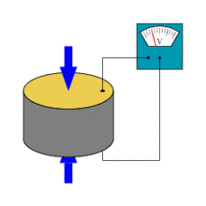
Figure 3-4 working of piezo sensor [10]

Chapter 4

PROJECT DESCRIPTION

In this chapter, the block diagram and its sub-blocks are described in detail.

- Block diagram
The block diagram of our project is show in the Figure 4-1. Here the vibrating energy is converted into electric energy using piezoelectric sensors. A battery charger circuit helps to maintain the constant voltages ($≅$14.7V) using boost converters. The voltages produced are used to charge 12V, 5amp lead acid DC re-chargeable battery. The battery is connected to the inverter. This inverter is basically used to convert the 12 Volt D.C into the 220 Volt A.C. This 220 Volt A.C voltage is used to spark off the loads.

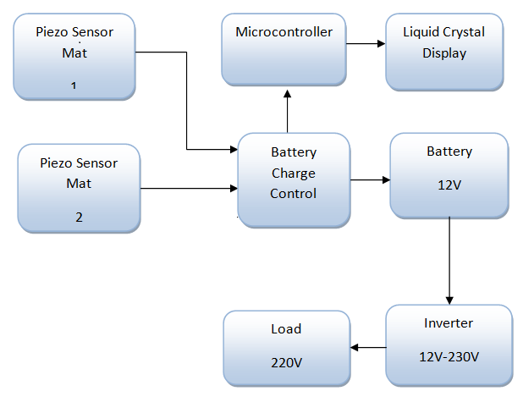
Figure 4-1 block diagram
- Battery charger circuit
A battery charger is also known as recharger. It is a device that is used to put energy into a secondary cell or battery by forcing an electric current through it.
The size and type of the battery being charged are dependent on the charging protocols. Some battery types are having very high tolerance for overcharging the battery and can be recharged by connecting to a constant voltage source or a constant current source; manual disconnection may require at the end of the charge cycle, or it may have a timer in order to cut off charging current at a fixed time. Some of the other batteries cannot withstand the long high-rate over-charging; the battery charger may consist of temperature or voltage sensing circuits and a microcontroller in order to adjust the charging current, and cut off at the end of charging.
- Circuit diagram of battery charger
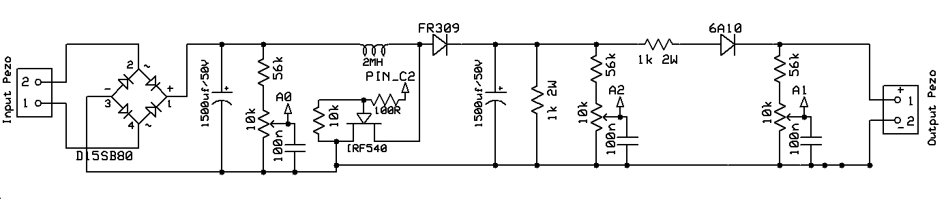
Figure 4-2 schematic diagram of battery charger
List of components
- Capacitor 100nF, 1500uF/50V.
- Resistor 56k, 10k, 100R,1k 2W.
- Potentiometer 10k.
- MOSFET IRF540.
- Light Emitting Diode (LED).
- Inductor 2MH.
- Microcontroller PIC16F877a.
- Bridge rectifier D15SB80.
- Description of Components
- Metal Oxide Semiconductor Field Effective Transistor (MOSFET) IRF540
- IRF540 is enhancement mode, n-channel, power MOSFET
- Mainly designed for high speed and high power applications e.g. switching power supplies, UPS, relay drivers and high energy pulse circuits.
- The IRF540 is supplied in the TO-220 conventional leaded package.

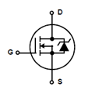
Figure 4-3 IRF540 symbol and pin configuration
IRF540 Features
- Dynamic dV/dt Rating.
- Operating Temperature 175 °C.
- Fast Switching.
- Ease of Paralleling.
- Simple Drive Requirements.
- Lead Pb-free Available.
IRF540 Applications
- High Current, High Speed Switching.
- Relay Drivers.
- DC to DC Converter.
- DC to AC Converter.
- Locomotive Environment (LAMP Drivers, Injection, AIR-BAG etc.).
Data sheet of IRF540 is attached in appendix B
- Capacitor
Capacitor is an electrical device which stores electric charge. It is also used for filtering purposes so we can say it filtering device as well.
Based on general classification capacitors are divided into two categories
- Fixed capacitors.
- Variable capacitor.
Fixed capacitors
Fixed capacitors are those whose value is fixed during manufacturing and we cannot alter it after manufacturing .Fixed capacitors are further divided into two types
- Electrolytic capacitor
- Non-electrolytic capacitor
- Electrolytic capacitors
Electrolytic capacitors are also called polar capacitors. They have electrolyte as dielectric. This type of capacitors has positive and negative terminals as shown in fig and allows high capacitance with small leakage current.
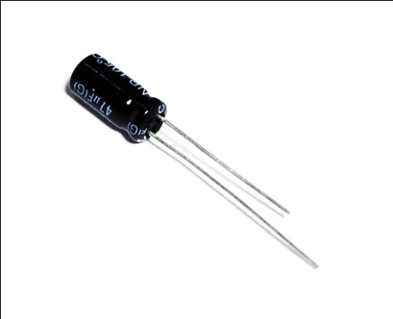
Figure 4-4 electrolyte capacitor
- Non-electrolytic capacitors
Non-electrolytic capacitors are those that does not use electrolyte in its construction. These are paper capacitors, mica capacitors and ceramic capacitor. Most commonly used non-electrolytic capacitor is ceramic capacitor because it is inexpensive. As shown in fig the non-electrolytic capacitors do not have specific +ve and –ve terminals. So we can use this type of capacitors in circuit without taking any care of terminals.
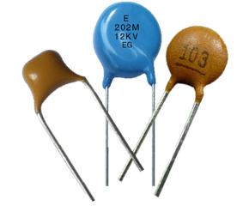
Figure 4-5 non-electrolyte ceramic capacitors
- PIC microcontroller
PIC microcontroller PIC16f877a is one of the most popular microcontrollers in the field of engineering. This controller could be very suitable as coding or programming of this controller is less difficult. One of the primary advantages is that it can be write-erase as many times as viable as it practice FLASH memory technology. It has a total of 40 pins and there are 33 i/p and o/p pins.

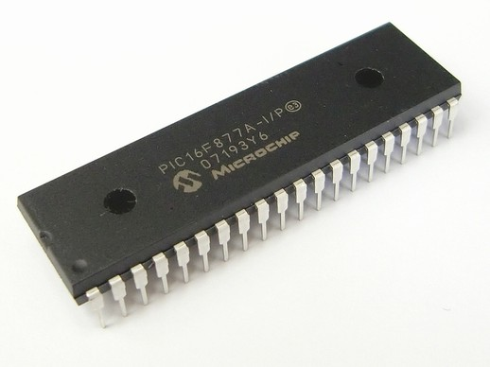
Figure 4-6 microcontroller IC [9]
PIC16F877A finds its applications in tremendous devices. It’s far utilized in protection, security and safety devices, remote sensors, domestic automation and in many manufacture devices. An EEPROM is also introduced in it which makes it viable to store some data unendingly like transmitter codes and receiver frequencies and a few other associated information [9]. The cost of this controller is low and its control is very easy. It’s flexible and may be utilized in areas where microcontrollers have not been used before as in coprocessor applications and timer features and so on.
- PIN configuration and description Of PIC16F877A
As there are forty pins of this microcontroller IC. It includes two 8 bit and one 16 bit timer. Capture and compare modules, serial ports, parallel ports and 5 input/output ports are also there in it.
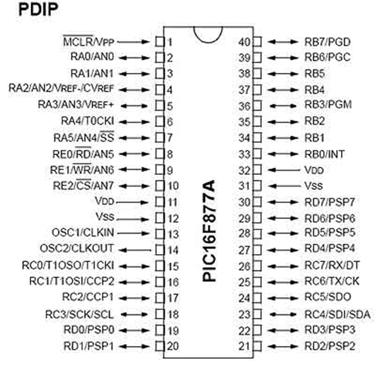
Figure 4-7 pin configuration of PIC16F877A [9]
Data sheet of pic16F877A is attached in appendix B
- Working of battery charger circuit
Battery charger circuit includes mainly rectifier and boost converter. Piezo generates AC spikes. For purpose to convert AC into DC we have used Full Wave Bridge Rectifier in the beginning of charger circuit. After that we have used boost converter to boost up the voltages generated through sensors. This microcontroller is used to adjust the charging voltage, and cut off at the end of charging. Voltage divider are used to divide the output voltage to an appropriate voltage range which is adequate for the built-in ADC in the microcontroller. The calculations are performed by PIC16F877A which is based on the control algorithm and produces a PWM signal with a set of duty cycle. The frequency can be programmed by PIC16F877. The signal of PWM is transmitted to power MOSFET in power stage via a power MOSFET driver in order to perform on and off state. We have set the output of boost converter to 14.7 volts through PIC16F877a microcontroller.
- Voltage display circuit through microcontroller
We have also used PIC16F877A microcontroller to display our voltages of piezo plates and as well as of battery. Voltage display circuit is shown in Figure 4-8.
Figure 4-8 schematic diagram of voltage display circuit
For displaying these voltages we have used 2X16 LCD.
- What is Liquid Crystal Display (LCD)?
A liquid-crystal display abbreviated as LCD .It is a flat-panel display which uses the light-modulating properties of the liquid crystals [14]. Liquid crystals do not produce light directly. LCDs are used in variety of applications that include computer monitors, televisions and many more similar devices.
- Pin configuration of LCD

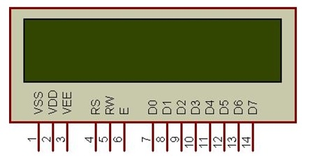
Figure 4-9 pin diagram of LCD
- Pin functions and Pin description
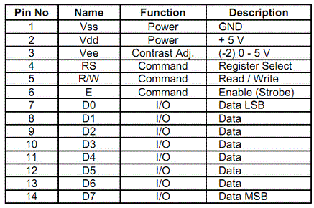
- Inverter circuit
An inverter is a digital device that mainly changes direct current (DC) to alternating current (AC). The input and output voltage, frequency, and overall power handling rely upon the design of the particular device [14].We are using push-pull inverter in our project.
Figure 4-10 circuit diagram of inverter [13]
List of Components
- IC4047.
- IRFZ44.
- Center tapped Transformer 12v-0-12v.
- Variable resister 22k.
- Capacitor 0.22uF.
- Resistor 100$Ω$/0.5W.
- Description of components
- MOSFET IRFZ44
- Description
According to the IRFZ44 datasheet that is a third generation power MOSFET that suggests the best combination of speedy switching, low on-resistance and price-effectiveness. The TO-220AB package is universally chosen for commercial-industrial packages at power dissipation ranges to about 50 W. The low thermal resistance and low package cost of the TO-220AB make contributions to its wide attractiveness all through the industry.
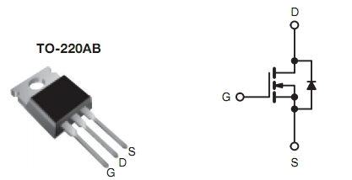
Figure 4-11 pin configuration on left and symbol on right
- Features
- Advanced Process Technology.
- Extremely Low On-Resistance.
- Dynamic dv/dt Rating.
- 175°C Operating Temperature.
- Fast Switching.
- Fully Avalanche Rated.
Data sheet of IRFZ44 is attached in appendix B
- IC 4047
- Features
The IC 4047 is capable of operating in two modes the monostable or astable mode. It requires an external capacitor between pins 1 and pin 3 and an external resistor between pins 2 and pin 3 to operate in both modes. It is used to determine the output pulse width within the monostable mode, and the output frequency in astable mode.
- Pin Configuration
Within the free running astable mode, connect pins 4, 5, 6, 14 to positive terminal of the source voltage or Vdd; connect pins 7, 8, 9, 12 to ground terminal of source voltage or Vss.
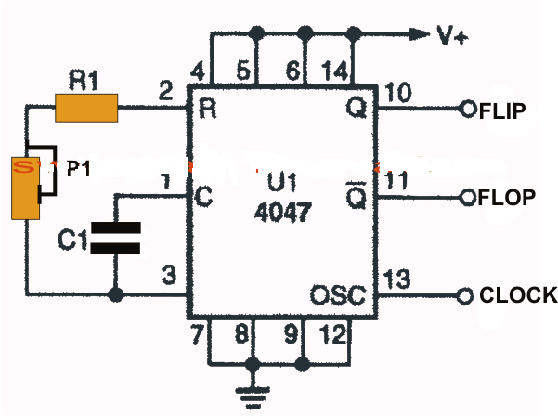
Figure 4-12 IC4047 configuration for astable
The output may be obtained through pin 10, 11 (push-pull) and clock at pin 13.
The capacitor and resistor determine the oscillator frequency of the IC and the output is obtained across pin10, 11 and 13.
Essentially potentiometer has to be no longer than 10K, and above 1M, at the same time capacitor should not be much less than 100pF in order to maintain proper functioning of the chip.
Pin number 10 and 11 are the complementary outputs that behave in a push-pull manner, which means when pin10 is high pin11 is low and vice versa.
- IC4047 Applications
- Frequency discriminators.
- Timing circuits.
- Time-delay applications.
- Envelope detection.
- Frequency multiplication.
- Frequency division.
Data sheet of CD4047 is attached in appendix B
- How does inverter circuit Work?
We have used simple DC to AC inverter in our project that delivers 220V AC when a 12V DC power is being supplied to it. In inverter circuit for driving the output power, we have used two power IRFZ44 MOSFETs. We have used IC4047 as an astable multivibrator that operates at a frequency of approximately 50 Hz. The output pins (10, 11) of the IC4047 drive “power MOSFETs” directly. At the output we use center tapped transformer that has 12V-0-12V on the secondary and 220V on the primary side of the transformer. We use appropriate heat-sinks for MOSFETs. This inverter circuit can be used to drive light loads like mobile phones and night lamps, but can be modified into improved powerful inverter by increasing number of MOSFETs.
Basically inverter that we have used in our project is not a sine-wave inverter. We have used simple square-wave inverter. For this project it is suitable because we just have to power up light bulbs only, and small power tools that do not need a frequency having sin waveform.
When this system would install at higher level than inverter circuit could be changed according to requirement.

Chapter 5

HARDWARE IMPLEMENTATION

In this chapter, we have described hardware implementation of our project.

- Introduction
We on the whole, rely on our hydro source for energy which is not enough as we require, and our country is not making use of it in a great way, so it’s number one need of our country to produce power by renewable source that could satisfy the need of the human beings. To initiate new large projects first we want lot of cash i.e. nuclear power and hydro wants a great deal of extra money. Large amount of energy coming from some natural sources is being wasted daily.
The idea behind this project is that the human walking is a natural system which can’t be stopped, so instead of wasting it we have utilize it for generating power. We are able to use it in highly populated country like china however additionally in our state wherein energy crises are headline of the day. We have erased this hassle on cheap and small projects implementation. The great implementation of this idea will be at railway stations, crowded department shops, universities, faculties, government workplaces and areas with huge crowd every day.
In our project we're producing energy by virtually walking or running that's nonconventional source of energy. We can make it viable through mechanical layout or electrically. The hardware implementation of our project includes:
- Wooden sheet
We have used wooden sheets as shown in figure 5-1 for the purpose of stepping. We have made 2 wooden plates/piezo sensor mats each containing 2 wooden sheets total area is 1 sq. feet and piezo electric sensors are arranged over them. We have used piezoelectric sensors of PZT material because of its high electro-mechanical coupling capability. Theses wooden plates are actually walking track. Whenever we put step over it power is generated which is used to charge battery.
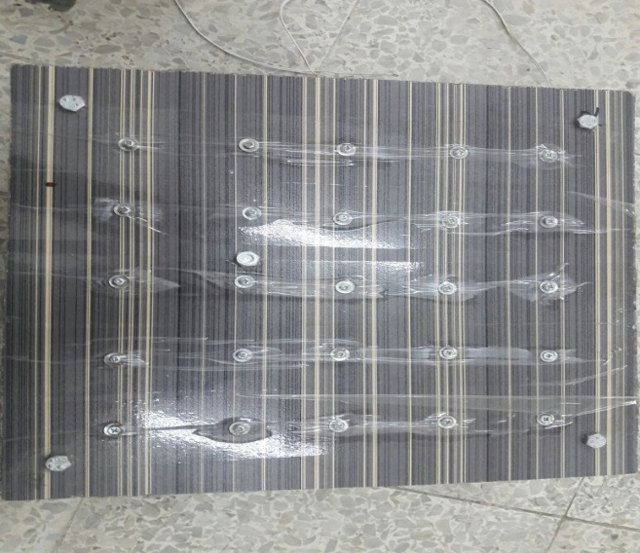
Figure 5-1 upper and bottom wooden sheets
- Springs
As there are 25 sensors on each plate so we have used 25 springs of diameter 4mm (from upper side) and 12mm (from lower side) each attached to its respective sensor in order to apply full pressure on all the sensors equally because without using the springs we were unable to press all the piezo sensors on our plate simultaneously. Springs also give protection to sensors.
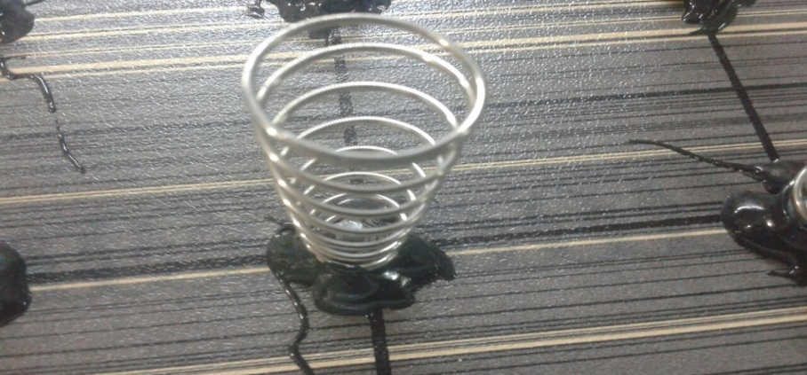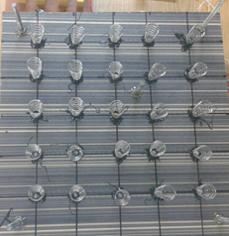
Figure 5-2 springs used in our project
- Arrangement of Piezo
We have made parallel series combination of 25 piezo sensors; all of them are placed on the lower wooden sheet. We have used such arrangement because we got maximum power through parallel series combination. Between the sensors and lower wooden sheet we have inserted foam like material which gives extra protection to the sensors.
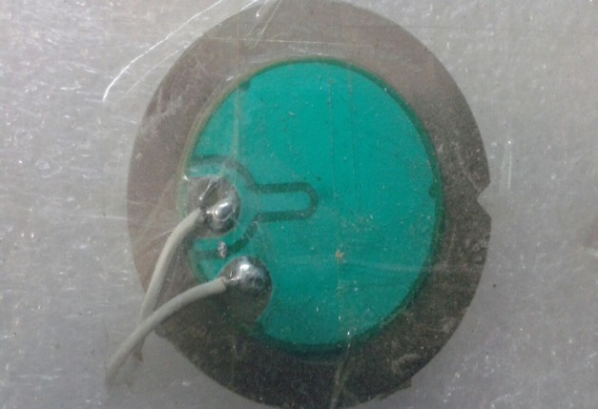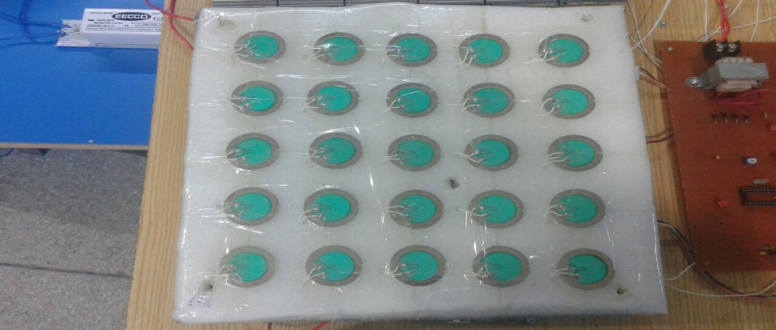
Figure 5-3 piezo sensor and parallel-series arrangement of piezoes on the lower wooden sheet
In the upper wooden sheet there are 25 holes each of diameter 3mm, these holes are used to attach springs using bolts and nuts to the bottom side of the upper plate.
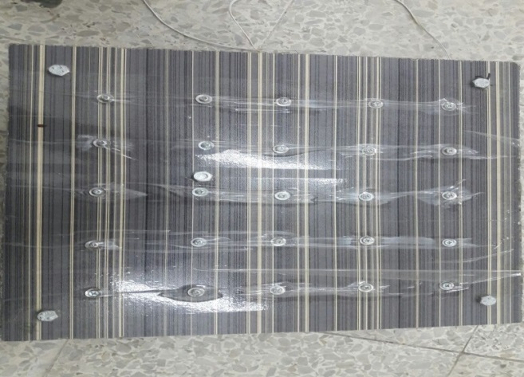
Figure 5-4 upper wooden sheet having nut and bolt on left and bottom side of upper wooden sheet having springs on right
In such a way lower side of upper plate springs is exactly placed on the individual sensor when both the wooden sheets are one above the other.
Figure 5-5 piezo sensor mat (2 wooden sheets are one above the other)
- Battery charger circuit
After arrangement of piezo sensors we have designed the battery charger circuit for charging of the battery. Voltages generated through piezo depends upon sensitivity of weight applied on the plates of sensors, it might be possible that the generated voltages are less than battery voltages that’s why to charge the 12V battery we have used charger circuit in our project
Microcontroller and MOSFET are the major components of this circuit. 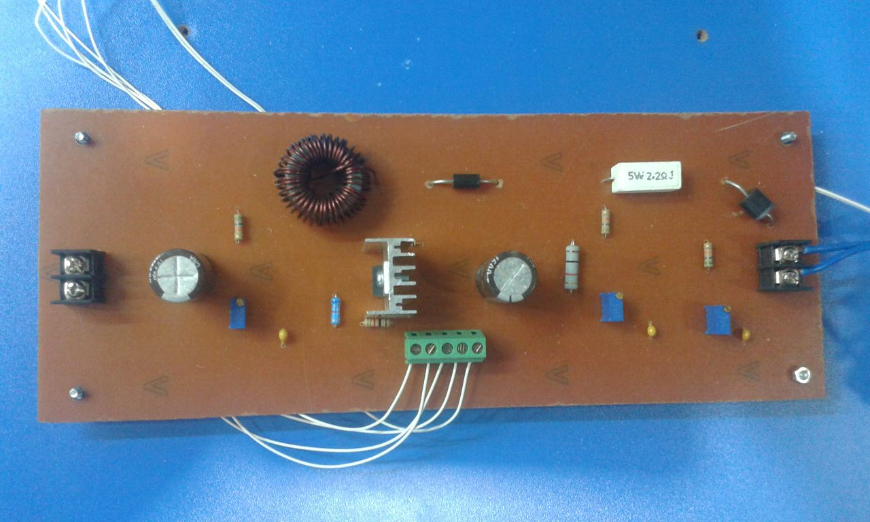
Figure 5-6 hardware implementation of battery charger circuit
- Battery
A battery, in concept, can be any device that store energy for later use. Basically an electrical battery consists of a number of electrochemical cells, linked either in series or parallel. A cell, which is elementary unit of a battery, may be well-defined as a power generating device, which is capable of transforming deposited chemical energy into electrical energy.
Generally batteries are separated into two types
- Primary batteries.
- Secondary batteries.
- Primary batteries:
If the stored energy is characteristically present in the chemical substances, it is called primary cell or non-rechargeable cell [5]. Primary cell cannot be recharged but the chemicals have to be replaced. The examples of primary cells are Leclanche cell, zinc-chlorine cell; alkaline-manganese cell etc.
Primary batteries are disposable and designed to be used once, after that these are useless. These types of batteries are only used occasionally and used in handy devices that drain low current.
- Secondary batteries:
If energy (by applying an external source) is induced in the chemical substances, it is called a secondary cell or rechargeable cell. Secondary batteries are also called accumulators or storage batteries. Secondary batteries have high primary cost but low lifecycle cost if charging is low-priced. These types of batteries used in emergency no-fail and stand by power sources e.g. laptops, mobile phone. Lead acid batteries and Edison alkali batteries are ordinarily used secondary batteries [5].
- Battery used in project
We have used Lead Acid battery of 12 V and 5Amp. We want to store charges so that we are able to use the electricity generated by means of foot step not only effective in busy hour but additionally in other parts of the day.
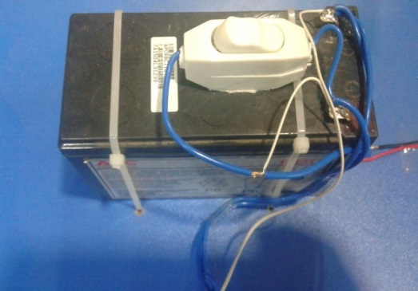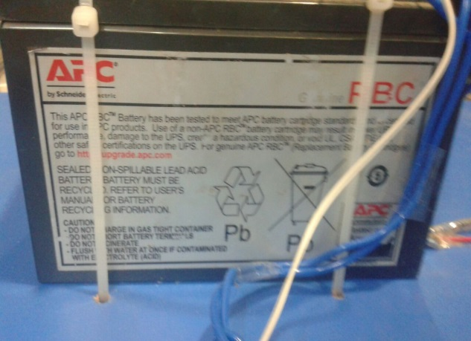
Figure 5-7 12V Lead acid battery
- Voltage display circuit
This circuit we have used to display voltages of our piezo sensor mats as well as of battery. We use micro PRO C software for coding. PIC16F877A microcontroller is used for voltage display because PIC has built in ADC converter.
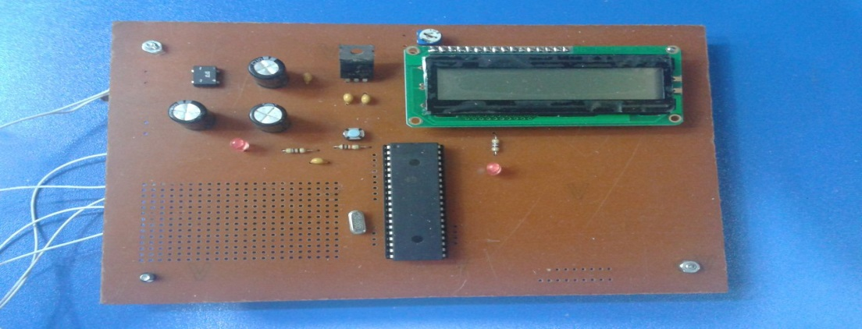
Figure 5-8 microcontroller circuit for battery voltage display
- Inverter
Battery have DC voltage, however we required AC voltage to run AC loads that’s why we have used inverter circuit in our project. MOSFET (IRFZ44) and CD4047 are primary ICs of inverter circuit. Transformer is part of inverter. We are using center tape transformer of 12-0-12 V / 220 V.
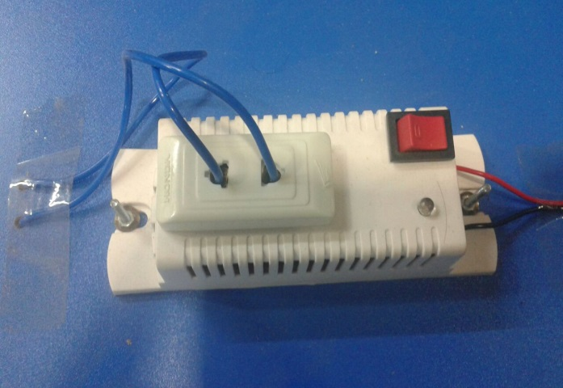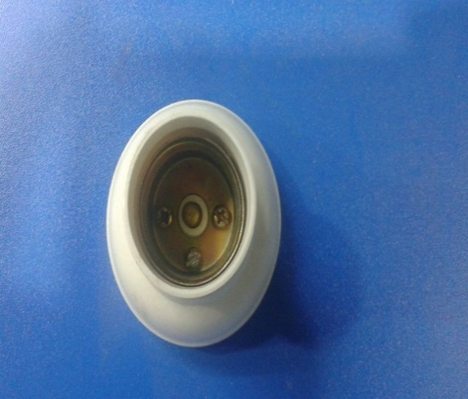
Figure 5-9 inverter and load of our project
- Final implementation of our project
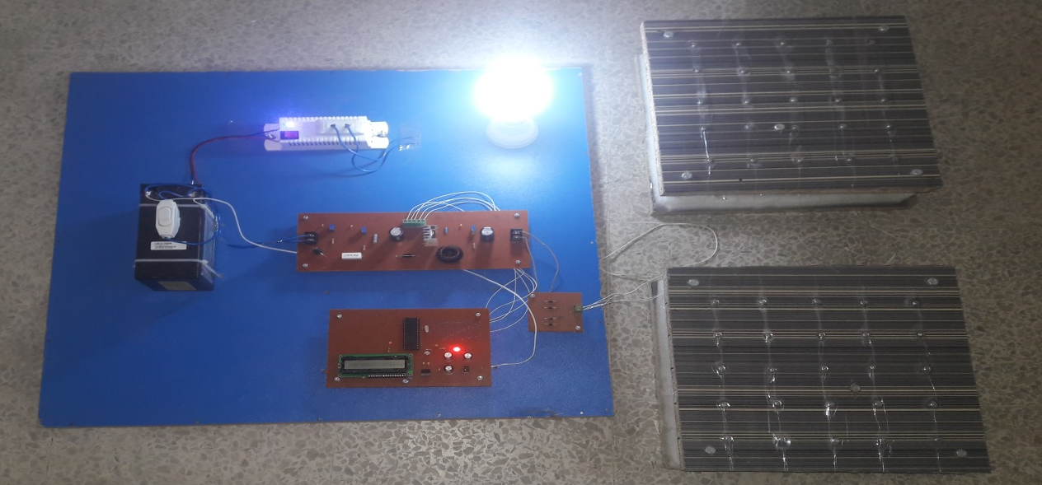
Figure 5-10 final model of our project

Chapter 6

SOFTWARE IMPLEMENTATION

This chapter contains software simulations and PCB layouts of electronic circuits.

- Software used for simulations
We have used Proteus version 8 for software simulations and easy-PC NumberOne version 15.0.3-BAJWA window for PCB layout design.
- Proteus version 8
Proteus Professional version 8 is a system of circuit simulation based on the models of electronic components. Proteus Professional is the best provider of modeling programmable devices to work with microcontrollers, microprocessors, DSP and others [16].
The main features of Proteus are simulations available for PIC, ATMEL, TI, ARM 8051, AVR, HC11, and ARM7/LPC2000. More than 8000 analogue and digital device models, interactive peripheral models for displays, integrated 3D viewer and keypads are also available in Proteus. Proteus is the world class shape base auto-router and works with popular compilers and assemblers [16].
- Easy-PC version 15.0.3
Easy-PC is the “PCB design software”. It is easy to use.
Key features of PCB layout design are [8]
- Integrated component Auto-place.
- Trace-Router or Pro-Router.
- Shape-based copper pour.
- Full, split and partial power planes.
- 3D visualization of board.
- Automatic track smoothing mode.
- Automatic track metering mode.
- Star/Delta points.
- Apply Layout Pattern.
- Back annotate name changes to Schematic.
- Automatic component rename.

- Voltage display circuit
Voltage of battery and piezo plates are being displayed on LCD.
Figure 6-1 Simulation of voltage display circuit
- PCB layout of voltage display circuit

Figure 6-2 PCB layout of voltage display circuit
- Simulation of Battery Charger Circuit

Figure 6-3 simulation of boost converter used in battery charger
- PCB layout of battery charger circuit

Figure 6-4 PCB layout of battery charger circuit

Chapter 7

CONCLUSION AND

FUTURE SCOPE

This chapter contains step wise calculations. Results and conclusion and it tells the future scope of our project.

- Calculations and results
For the calculation of power/energy of our project we consider basic two laws that has energy-mass relation
- 2nd law of motion
- Einstein Mass-energy relation
    - Second law of motion
According to Newton’s 2nd law of motion
“Net force acting on a body equals the product of the mass and the acceleration of the body.”
In equation form
F=ma
The weight of a body is the gravitational force with which earth attracts the body. The weight of the body is the force that causes it to be accelerated downward with the acceleration of gravity g. hence from the 2nd law of motion[15].
F=w=mg ----------------------8.1
Where
F= Gravitational force =weight of the body
a= acceleration of gravity=g=9.8 m/$\sec^{2}$
m= mass of the body
So
Gravitational force= (mass) (acceleration of gravity)
The unit of force is N
N = kg $×$ $m/{\sec^{2}}$
    - Einstein Mass-Energy relation
According to Einstein, energy is equal to the product of mass and square of speed of light.
Mathematically
E= m$c^{2}$---------------------8.2
Equation states that mass and energy are the same things and expresses us how much energy contained a certain quantity of mass.
The unit of energy is joule
J = kg $×$ ${m^{2}}/{\sec^{2}}$
J= N.m
    - Steps for calculation
Power estimation of our project is set up by some calculations.
- Firstly we have to compute magnitude of force that we put on piezo plates while walking. So, we calculate weight of the body/force by using
F=w= mg
There is supposition from a research that while walking human apply force 1-1.6 times more than his body mass. So we multiply weight of the body/force with constant value to find the actual force that a body can put on the piezo plates.
- To convert this force into energy we use
J= N-m
- After that we convert J/step into Kwh. For that purpose we use equation
1 Kwh= 3.6 $×$ ${10}^{6}$ J
Finally we can calculate the units produced from a person and we can easily calculate the power produced by the whole day or semester.
Now let’s we calculate for 200ft distance where our system is installed and the distance between two tiles is 0.01m.
Assume
- Average mass of a single person is 50 kg
- Force exerted is 1.3 times the weight of body
- Distance b/w piezo tiles/plates 0.01m
- Efficiency of plates is 60%
- Acceleration of gravity g=9.8$m/{s^{2}}$
- Total distance where system is installed 200ft
- Distance b/w person steps is 4ft

F = 1.3 $×50 kg ×9.8 m/{\sec^{2}}$
F = 637 N
Energy/step = 637 $×0.01 m$
Energy = 6.37 $J/{step}$
Efficiency of each plate is 60% so energy will be
Energy = 3.822 $J/{step}$
As we have approximated that the distance at which if we have installed our system is 200 ft and stride is 4 ${ft}/{step}$ then
Total energy = 3.822 $J/{step } × \frac{200 ft}{4 {ft}/{step}}$
Total energy = 191.1 J
Units produced by a single person is
Units produced = 191.1 J $× \frac{1 KWh}{3.6 × {10}^{6} J}$
Units produced by a person = 0.00005308 KWh/person
If we install this system in populated area where footstep as a source will available, where approximately 3500 people walk on these plates by 4 times in a day, then units produced in a day will be
Units produced in a day = 0.00005308 ${kWh}/{person }$ $×$14,000
Units produced in a day = 0.74312 kWh
So this is the calculation of our project per day.
    - Time taken by project to charge 12V battery
We design 2 plates of 1 sq-ft, each plate contain 25 piezo sensors. As voltage generated through piezo varies according to weight, so our 1 plate generates Minimum Voltage = 1V per step and Maximum Voltage =11V per step.
We assume average weight of a person is 50kg. 1 plate of our project requires 400-500 steps to charge 1 volt of battery.
So for 12V we require
=12$×$500
=6000 steps
As we have 2 plates in our project so each plate need 3000 steps for 12V battery to be charged completely.
If we install our project at most populated area where average 2 persons in a second will pass through a single plate, the time require to charge 12V battery will be
=$\frac{ 3000}{2×60}$ min
=25 min
Hence we can charge 12V battery in 25 minutes with the help of just 2 plates so if we increase number of plates we can get our battery charge more fastly.
Here are the pictures of final implementation and results
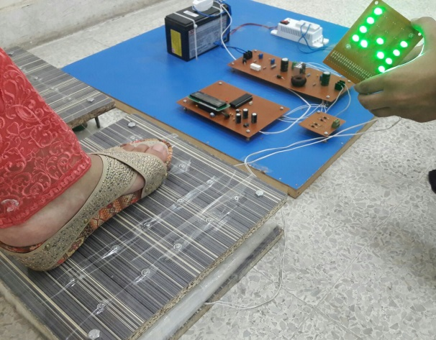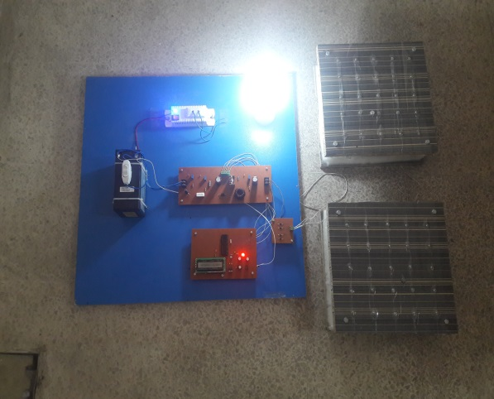
Figure 7-1 final implementation and results according to applied force
- Applications
- The power generated can be used for mobile charging and street lightning.
- When there is any sort of emergency power failure situation then it can be used as a source of electricity.
- Other application areas involves metro, railway and bus stations, rural areas and many other crowded areas mostly in densely populated countries.
- Conclusion
The project is successfully tested which is the best inexpensive, affordable energy solution for the common people. This can be used for many applications in city areas where there is need of more power. Pakistan is a under developing country where energy management is a big challenge for huge population. By installing our project, we can drive both A.C and D.C loads according to the force applied on the piezo electric sensor.
- Future scope
Use of waste energy is very much important for densely populated areas and countries in future.
Flooring Tiles-
Japan has already started testing the use of piezoelectric effect for the generation of energy. They have implemented piezoelectric effect on the stairs of the bus stations. So every time passenger put his/her step over the tiles; a small vibration is produced that can be stored as energy.

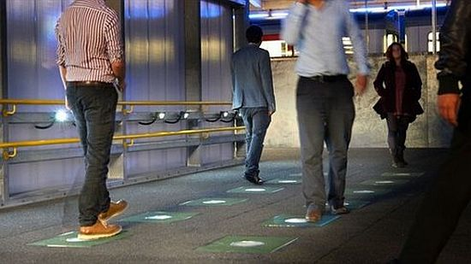

Figure 7-2 flooring tiles installed at japan
Dance floors-
Europe is any other one of the country which started out experimenting the use of piezoelectric sensors for power production in night clubs. Floor is compressed with the aid of the dancer’s feet and piezoelectric materials generate energy. Generated electricity is nothing but 2-20 watt. Which is dependent on effect of the dancer’s feet? Continuous compression of piezoelectric sensors causes a large amount of electricity.
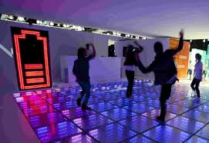
Figure 7-3 dance floor installation
In Pakistan and similar under developing countries which are having huge amount of crowded area this project and similar idea can be installed very successfully and can produce efficient results. We can install piezo plates under the running exercise machines of gyms .it can also be installed at the entry and exit point of bus station, railway stations, air ports shopping malls, parks and other similar places. If we are able to install piezo material under the railway tracks and runway of airplane successfully then we will be able to convert huge amount of wasted weight into electricity.

LIST OF REFERENCES

[1] Fakhzan, M. N., and Asan GA Muthalif. "Vibration based energy harvesting using piezoelectric material." Mechatronics (ICOM), 2011 4th international conference on. IEEE, 2011.

[2] Kumar, Anil. "Electrical Power Generation Using Piezoelectric Crystal." International Journal of Scientific & Engineering Research 2.5 (2011).
[3] Ramakrishna, K., Guruswamy Revana, and Venumadhav Gopaka. "Generation of Electrical Power through Footsteps." International Journal for Multidisciplinary and Current Research 2 (2014): 961-964p.

[4] Boby, Kiran, et al. "Footstep Power Generation Using Piezo Electric Transducers." International Journal of Engineering and Innovative Technology (IJEIT) 3.10 (2014). 2014

[5] www.voltaicsystems.com

[6] www.scribd.com/doc/88678560/Foot-Step-Power-Generation

[7] www.scribd.com/doc/22302487/Electricity-From-Walking

[8] http://www.ohioautomation.com/easypc.htm

[9] http://microcontrollerslab.com/pic16f877a-introduction-features/

[10] www.explainthatstuff.com/piezoelectricity.html

[11] www.americanpiezo.com/piezo-theory/whats-a-transducer.html

[12] www.comsol.com/video/piezoelectricsimulations-comsol-multiphysic

[13] www.electroschematics.com/9155/12v-to-220v-voltage-inverter/

[14] www.wikipedia.com

[15] Wiberg, Donald M. Schaum's outline of theory and problems of state space and linear systems. McGraw-Hill Companies, 1971.

[16] http://www.itechsoul.com/proteus-professional-is-one-of-the-best-automated-design-software-for-electronic-circuits

APPENDICES

Appendix A- codes and libraries

include <pic16f877a.h>
long volt,b_volt,boost_volt;

//#define set_volt pin_v,volt
unsigned char pwm=0;
void bost_converter(){
int far;
for(far=0;far<100;far++){
volt = read_adc(A0,500);
//************************
boost_volt = read_adc(A2,500);
if(volt > 40){
if(boost_volt > 147){if(pwm){pwm--;}}
if(boost_volt < 145){if(pwm < 190){pwm++;}}
PWM_Change_Duty(pwm);
delay_ms(10);}
else{PWM_Change_Duty(0);delay_ms(10);}
}}

//**********************
void interrupt() {
timer1_set(100);
//if(timer1_off == high)return;
}
//**********************
void main() {
//***************
system_init();
timer1_init();
//********input_output_init***********
pin_mode(17,output);
PWM_Init(20000);
PWM_Start();
PWM_Change_Duty(0);
//************Lcd_Init****************
basic_lcd_init();
//*******************
while(1){
//************************
volt = read_adc(A0,500);
b_volt = read_adc(A1,500);
boost_volt = read_adc(A2,500);
//**************************
lcd_print_d(1,1,"B=",b_volt,xxx,dx);
lcd_print_d(2,1,"V=",volt,xxx,dx);
bost_converter();
}}

Appendix B - datasheets

