**Abstract**

Project deals with the power factor improvement and detection as well as deterioration of harmonics by designing an effective harmonic filter for non-linear single phase 220 Volts. Besides the main objectives discussed above it also helps in the protection of electronic devices, gives an idea to implement the theoretical approach on large AC systems such as Grid Stations, High and low level Industries and domestic purposes for energy consumption and efficiency. Hardware consists of power factor improvement by reactive power compensation-Capacitor Banks and Active Harmonic Filter combined or supervised by a PIC Microcontroller for sensing and controlling.

**Chapter No 1**

1. **INTRODUCTION**

In order to supply electricity effectively to the consumers, the [Electrical power quality](http://www.efxkits.com/electrical-projects/) plays an important role. Now a day’s power has become an essential and the most valuable resource for the whole earth, the maintenance of power quality has become important, so that the usage of all the appliances and equipment’s could be maintained. Nonlinear loads which are mostly used in industry and also used domestically causes a lot of distortions in current and voltage which causes power losses.

When such distorted voltage and current is applied to equipment it gives poor performance. So during these times when energy demands are increasing every day we cannot afford losses of electricity and also if the quality of power is good the life expectancy and performance of equipment increases drastically.

**1.2. Factors Affecting Power Quality**

The end user decides whether the power quality is good enough or not. If the performance of the equipment is good then the power quality is satisfactory. The power quality would be considered bad if the equipment doesn’t perform well. Given below are the reasons for bad power quality or power quality.

**1.2.1 Power frequency disturbances**

**1.2.1.1 Voltage sags and swells**

[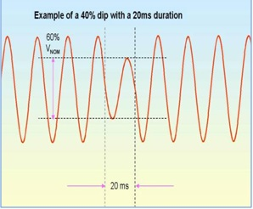](https://www.elprocus.com/wp-content/uploads/2014/01/Voltage-sags.jpg)

Voltage sags

When the voltage level decreases from its nominal position it causes voltage dip or sag. These voltage sags or dips could last half of a cycle to several seconds. These low voltages are caused from several factors like ups, computers, and flickering, electrical motors.

Induction motors are usually used in industries. These motors when started take a large amount of current which causes decrease in voltage which results in voltage dips or sag. Same thing can be seen in other equipment’s like arc furnaces which take large amount of current initially in order to achieve high temperature. Factors like lightning, birds, contact of trees with power lines and animals to power supply lines causes the utility drops of the voltage.

[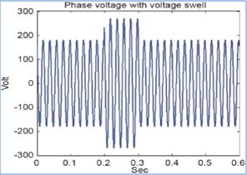](https://www.elprocus.com/wp-content/uploads/2014/01/voltage-swells.jpg)

Voltage swells

When the loads transfers between sources it causes voltage swells. These can also occur by sudden rejection and application loads. Flickering is a low frequency problem that occurs mainly at low voltage conditions or at starting.

Flickering is caused by low frequencies which can be observed by human eye or low voltages. Mostly the bad performance or malfunction of equipment is caused by voltage sags and swells, which also leads towards loss of efficiency of insulation failures, motors, fluctuation of light illumination, and contractors etc.

If these power frequency disturbances are raised at source level then they not easily cured. But these disturbances can be controlled if they occur internally due to loads. This can be done by separating off end loads from the sensitive loads.

**1.2.1.2 Electrical Transients**

[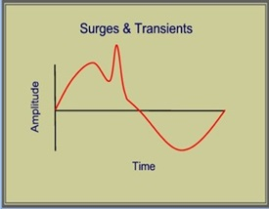](https://www.elprocus.com/wp-content/uploads/2014/01/Electrical-transients.jpg)

Electrical transients

The disturbances which can only last for less than one cycle of AC waveform are called transients. Transients are sub-cycle disturbances. Many factors like limited frequency response or sampling rate make the detection and measurement of transients very difficult.

These transients can also be called as surges, power pulses, spikes, etc. factors like solar flares or atmospheric disturbances causes them to occur. Switching the loads and switching capacitor banks also causes transients.

Transients are kept in mind while designing some of the devices while in most of the cases devices can handle transients which depends on the life expectancy of the equipments and severity of transients. These transients can be overcome by using surge protection suppressors, filters and other transient suppressors**.**

**1.2.1.3 Harmonics**

Harmonics in current and voltage is basically the deviation from original sine waves. Harmonic frequencies are integral multiples of fundamental frequency and can be very commonly found in electric power systems like motors, computers and ups etc.

Harmonics can be differentiated on the basis of order into two types. Even types (2, 4, 6, 8, 10) and odd types (3, 5, 7, 9, 11). Odd harmonics are mostly produces in major nonlinear loads. While even harmonics occurs because of the uneven operations of electrical systems e.g. transformer eddy currents etc.

[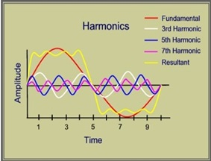](https://www.elprocus.com/wp-content/uploads/2014/01/Harmonics.jpg)

Harmonics

Order of harmonics determine the frequency like 2nd order harmonic has frequency of two times the fundamental frequency. These harmonics are generated by non linear loads like arc furnaces, electric motors, UPS systems etc.

The fundamental waveform is superimposed by odd harmonics, which results in the distorted waveforms. The harmonics produced can seriously effect many electrical systems i.e. overheating of the equipment, interference of communication lines, errors while indicating electrical parameters, probability to produce resonant conditions, etc.

Harmonic analyzer can be used to measure the harmonics and harmonic filters can be used to reduce harmonics. There are two types of harmonic filters which are active and passive filters.

**1.2.2. Power Factor**

Power factor is considered as one of the main factors which affect the quality of electrical power. If the power factor is low then it can have severe affects on the electrical equipments, which can result in overheating and in some cases less life of the equipment. It also leads the way to the users being penalized in order to meet electric demands. Power factor can be defined as the ratio of active power to reactive power and determines the amount of electrical power utilization.

Power factor can be explained by an example like if power factor is 0.7, it shows us that that 70 percent of the power is utilized and remaining energy is wasted as losses. Low power factor is due to induction motors, reactive power elements in electrical power system network, etc. So if the power factor is close to 1 then the system will be more efficient.

[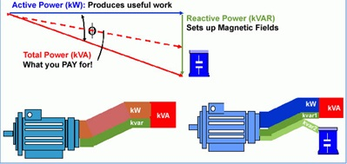](https://www.elprocus.com/wp-content/uploads/2014/01/Power-factor-improvement-by-capacitor.jpg)

Power factor improvement by capacitor

In order to overcome the low power factor wean se power factor correction devices e.g capacitor banks are main used to overcome power factor problem and other compensation equipments can also be used.

When power factor is improved by capacitor bank it have a strong impact n reducing our energy bills. Here reactive power taken from supply is reduced by capacitors bank which in return offer leading power in nature.

**1.2.3. Grounding**

The safety of the appliances and their operators depends upon the good power quality. The protection of both system and equipment depends upon grounding. Earth acts as a constant reference potential with one unknown potential which is to be measured.

The equipment’s which are not grounded properly can result in giving shocks to its operators. So grounding is very important as it protects many types of equipment from faults and other un-wanted conditions which occur in electrical power systems.

[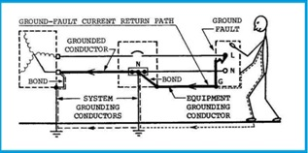](https://www.elprocus.com/wp-content/uploads/2014/01/Equipment-and-system-groundings.jpg)

Equipment and system groundings

There is a lot of difference between signal reference ground and normal grounding because it doesn’t provide any protection to the systems or the operators. But low impedance path is a necessity so that electronic equipment’s can work properly.

**1.3. Aims of Project**

This prototype is designed for non linear loads like inductors, chokes and motors etc. only domestic loads can be made efficient by using this prototype. In order to obtain better results of harmonics and power factor we implement this prototype on single phase non linear loads. Its purpose is to make energy efficient devices and also to improve the power quality. This design can also be implemented on three phase AC systems which are used on higher levels. During these times of energy crisis world demands more efficient and reservoirs of energy at present and in future. In an underdeveloped country like Pakistan the shortage of energy could lead to poor economy and engineering growths so there is an utmost demand of power engineering solutions like smart and Hybrid grid stations and power improvement techniques.

**1.4. Importance of power factor**

Most AC electric machines draw from the supply apparent electricity in phrases of kilovolt amperes (kVA) which is in excess of the beneficial energy, measured in kilowatts (kW), required by using the machine. The ratio of these portions is called the energy thing of the weight, and relies upon the kind of machine in use. Assuming a steady supply voltage, this implies that more modern-day is drawn from the electricity authority than is absolutely required.

**Power aspect = (genuine power) / (obvious energy) = kW / kVA**

A large proportion of the electrical equipment utilized in enterprise has an inherently low electricity component, because of this that the deliver government must generate a whole lot greater cutting-edge than is theoretically required. This extra modern flows via generators, cables, and transformers inside the identical manner as the useful current. The cause strength necessities are generally more than the resistive loads such as lighting and heating. If steps are not taken to enhance the energy issue of the burden, the entire gadget from the power station to the factory sub-circuit wiring has to be large than important. This results in elevated capital expenditure and better transmission and distribution losses at some point of the entire deliver community.

**1.5 Tariffs**

The bills for electricity are primarily based on various price lists which vary each in structure and fee from place to area. Various status expenses and a connection charge are also made. Generally, the electricity charged for can be primarily based on:

(i) A status price based totally on the overall kilo wattage of the hooked up cars or at the kilo wattage of the most important mounted motor;

(ii) On the quantity of units used;

(iii) a further price for devices while an agreed maximum degree is passed - known as the most call for charge.

The status charge (i) is carried out regardless of the amount of strength consumed or of ways regularly the gadget is used. The rate (ii) is an accumulative charge to take account of the amount of power used in a specific length. Not all gadgets are always charged on the same charge. A meter is provided by the deliver project for this. The maximum demand rate (iii) is a penalty price which is implemented if the amount of energy utilized in a special duration (typically 0.5 hours) exceeds a level which has been formerly agreed between the supplier and consumer. It’s far intended to level out call for by using discouraging users from consuming a large amount of power for just a short time. A separate meter is supplied for this; it measures kVA instead of kW. a few authorities provide reduced tariffs depending upon how and while the energy is used.

**1.6. Generators**

If grid electricity is not available or not suitable in some way, an alternative method of obtaining electricity is to use a generating set. Small sets of a few kVA capacities can be petrol driven, but normally they are diesel-engine driven. The size of the set required depends upon the output required and upon the starting characteristics of the various items of equipment. The supplier of the feed mill machinery can usually advise on the size most suitable for the particular installation. When the installation consists of a number of small motors, then a set slightly larger than the sum total of the motor kilo wattages is usually adequate, but expressed in kVA based on a power factor normally of 0.8. If however just one of the motors is large in comparison with the total load, a larger generating set is necessary so as to prevent undue voltage dips occurring when that particular motor is started, as such dips will effect equipment already running. For satisfactory operation, the diesel engine will require regular maintenance.

Most people don't realize that harmonics have been around a long time. Since the first AC generator went online more than 100 years ago, electrical systems have experienced harmonics. The harmonics at that time were minor and had no detrimental effects.

**1.7. Basic Concept**

A natural sinusoidal voltage is a conceptual amount produced through a really perfect AC generator built with finely allotted stator and discipline windings that function in a uniform magnetic field. Given that neither the winding distribution nor the magnetic subject is uniform in a operating AC gadget, voltage waveform distortions are created, and the voltage-time relationship deviates from the natural sine function. The distortion on the point of generation is very small (about 1% to 2%), however despite the fact that it exists. because this is a deviation from a natural sine wave, the deviation is in the shape of a periodic characteristic, and by using definition, the voltage distortion includes harmonics.

Whilst a sinusoidal voltage is implemented to a sure sort of load, the present day drawn by using the burden is proportional to the voltage and impedance and follows the envelope of the voltage waveform. These hundreds are called linear loads (loads wherein the voltage and modern comply with each other with none distortion to their pure sine waves). Examples of linear hundreds are resistive heaters, incandescent lamps, and steady velocity induction and synchronous vehicles.

In evaluation, some hundreds motive the present day to vary disproportionately with the voltage in the course of every half cycle. Those hundreds are categorized as nonlinear hundreds, and the current and voltage have waveforms which might be non-sinusoidal, containing distortions, wherein the 60-Hz waveform has numerous additional waveforms superimposed upon it, growing multiple frequencies within the everyday 60-Hz sine wave. The couple of frequencies are harmonics of the essential frequency.

Normally, current distortions produce voltage distortions. but, when there is a stiff sinusoidal voltage supply (while there's a low impedance course from the power source, which has enough capacity so that loads positioned upon it'll no longer effect the voltage), one want not be worried approximately current distortions generating voltage distortions.

Examples of nonlinear loads are battery chargers, digital ballasts, variable frequency drives, and switching mode strength materials. As nonlinear currents glide via a facility's electrical device and the distribution-transmission lines, additional voltage distortions are produced because of the impedance related to the electrical community. Thus, as electrical energy is generated, allotted, and applied, voltage and modern-day waveform distortions are produced.

Electricity structures designed to function on the fundamental frequency, that's 60-Hz in the U.S., are liable to unsatisfactory operation and, at instances, failure when subjected to voltages and currents that incorporate sizeable harmonic frequency factors. Very regularly, the operation of electrical device may also appear regular, but under a certain aggregate of conditions, the impact of harmonics is enhanced, with unfavorable consequences.

**1.8. Motors**

There’s an growing use of variable frequency drives (VFDs) which provide energy to electric motors. The voltages and currents emanating from a VFD that goes to a motor are rich in harmonic frequency additives. Voltage supplied to a motor sets up magnetic fields in the center, which create iron losses in the magnetic body of the motor. Hysteresis and eddy cutting-edge losses are part of iron losses that are produced inside the center due to the alternating magnetic area. Hysteresis losses are proportional to frequency, and eddy modern losses range because the square of the frequency. therefore, better frequency voltage additives produce additional losses within the middle of AC vehicles, which in turn, boom the working temperature of the center and the windings surrounding inside the core. Application of non-sinusoidal voltages to cars outcomes in harmonic contemporary circulate in the windings of motors. The net RMS current is Irms= √ [(I1)2 + (I2)2 + (I3)2 + …], where the subscripts 1, 2, 3, etc. represents the different harmonic currents. The I2R losses in the motor windings vary as the square of the RMS current. Due to skin effect, actual losses would be slightly higher than calculated values. Stray motor losses, which include winding eddy current losses, high frequency rotor and stator surface losses, and tooth pulsation losses, also increase due to harmonic voltages and currents.

The phenomenon of torsional oscillation of the motor shaft because of harmonics isn't actually understood, and this circumstance is often overlooked by means of plant personnel. Torque in AC motors is produced with the aid of the interaction between the air gap magnetic area and the rotor-brought about currents. Whilst a motor is furnished non-sinusoidal voltages and currents, the air hole magnetic fields and the rotor currents comprise harmonic frequency additives.

The harmonics are grouped into positive (+), negative (-) and zero (0) sequence components. Positive sequence harmonics (harmonic numbers 1, 4, 7, 10, 13, etc.) produce magnetic fields and currents rotating in the same direction as the fundamental frequency harmonic. Negative sequence harmonics (harmonic numbers 2, 5, 8, 11, 14, etc.) develop magnetic fields and currents that rotate in a direction opposite to the positive frequency set. Zero sequence harmonics (harmonic numbers 3, 9, 15, 21, etc.) do not develop usable torque, but produce additional losses in the machine. The interaction between the positive and negative sequence magnetic fields and currents produces torsional oscillations of the motor shaft. These oscillations result in shaft vibrations. If the frequency of oscillations coincides with the natural mechanical frequency of the shaft, the vibrations are amplified and severe damage to the motor shaft may occur. It is important that for large VFD motor installations, harmonic analyses be performed to determine the levels of harmonic distortions and assess their impact on the motor.

**1.9. Transformers**

Usually in transformers it’s hard to notice harmonic voltage and current until they led to a failure. Sometimes transformer failed even though they were operating satisfactorily for a long time because plant loads were changed or a facility's electrical system was reconfigured. Application of non-sinusoidal excitation voltages to transformers increases the iron losses in the magnetic core of the transformer in much the same way as in a motor. Eddy current losses have a more serious effect of harmonic loads, which are produced within transformers.

Eddy currents are produced due to the leakage magnetic field on the conductors. Eddy currents are basically circulating currents. Eddy current concentrations increases towards the ends of the transformer windings. This is caused because of the crowding effect of the leakage magnetic fields at the coil extremities. The increase in eddy current losses is square of the current in the conductor and the square of the frequency of current. The temperature on which transformer operates is greatly affected by the harmonics which produces eddy current. Transformers that are required to supply power to nonlinear loads must be derated based on the percentages of harmonic components in the load current and the rated winding eddy current loss.

One method of determining the capability of transformers to handle harmonic loads is by k factor ratings. The k factor is equal to the sum of the square of the harmonic currents multiplied by the square of the frequencies.

**k = [([I.sub.1]).sup.2]([1.sup.2]) + [([I.sub.2]).sup.2]([2.sup.2]) + [([I.sub.3]).sup.2]([3.sup.2]) + . . . + [([I.sub.n]).sup.2]([n.sup.2]).**

where [I.sub.1] = ratio of fundamental current to total rms current, [I.sub.2] = ratio of second harmonic current to total rms current, [I.sub.3] = ratio of third harmonic current to total rms current, etc., and 1,2,3, ... n are harmonic frequency numbers. The total rms current is the square root of the sum of square of the individual currents.

By providing additional capacity (larger-size or multiple winding conductors), k factor rated transformers are capable of safely withstanding additional winding eddy current losses equal to k times the rated eddy current loss. Also, due to the additive nature of triple harmonic (3, 9, 15, etc.) currents flowing in the neutral conductor, k rated transformers are provided with a neutral terminal that is sized at least twice as large as the phase terminals.

**Chapter no 2**

**Literature Survey**

The research analysis is also an important part of the project. A rough idea has been developed for the future needs and demands of these kinds of industrial as well as domestic purposes. Detailed study has been conducted by various research papers as mentioned in this chapter and taking in account the special needs of industry and power engineering the study of panels designed by the companies like PEL, ABB etc and their specifications.

The literature survey consists of three main topics:

1. The research papers or articles regarding Harmonic fiter and power factor improvement
2. Panels designed by different companies like ABB,Schneider Electric, Siemens and PEL
3. Alignment of the research papers and practical applications to our design

**2.1 Research papers regarding Harmonic filter and Power Factor improvements**

**The Design of Harmonic Filter and Reactive PowerCompensation in Power Supply System By:**

**LIU Zhengzhi-A research conducted by Chinese institute of plasma physics, Chinese Academny of Sciences (english.ipp.cas.cn)**

**Introduction**

The Electro-Magnetic-Compatibility (EMC), i.e. Power Quality (PQ), for a power supply system in Tokamaks is one of the essential issues in fusion technology because of its impact of high demands of pulsed power and reactive power, and harmonics as well.

The power supplies in EAST super-conductive Tokamak mainly consist of thyristor converters, pulse-width-modulation inverters, switching power supplies, and so on. All of those power converters with power electronics in EAST power supply system are inherently impulsive and non-linear.

The study and design of power quality control in power supply system of EAST super- conductive Tokamak have been carried out in order to ensure the safety and reliability in operation and to realize the compatibility between the power supply system and high voltage grid. On the one hand, in the design of power supplies of magnets, one of the principles is to reduce the impact of pulsed power and reactive power, harmonics, and unbalanced components in AC power system as much as possible. On the other hand, Static Var. Compensation (SVC) and Harmonic Filter (HF) are very important and indispensable.

**Design Principle and Features of SVC & HF**

The analysis and estimation of pulse power level and harmonic contents have been carried out.

The reactive power profile may see Fig.1.

Q

|  |  |
| --- | --- |
| MVAR MW | P |
|  |  |
|  |  |
|  |  |
|  |  |
|  |  |

Table.1. Harmonic Current (A) and Voltage Distortion in 110KV PCC

|  |  |  |  |  |  |  |  |  |  |
| --- | --- | --- | --- | --- | --- | --- | --- | --- | --- |
|  | 5th | 7th | 11th | 13th | 17th | 19th | 23rd | 25th | THDU |
| LVS | 25.3 | 17.9 | 11.4 | 9.8 | 7.4 | 6.6 | 5.5 | 5.0 | 1.5 |
| No PPF | 27.3 | 27.3 | 16.4 | 8.2 | 4.7 | 2.3 | 1.4 | 2.5 | 3.2 |
| With PPF | 4.3 | 2.7 | 1.2 | 0.7 | 1.4 | 0.7 | 0.5 | 0.9 | 0.5 |

Table.2. Harmonic Current (A) and Voltage Distortion in 10KV Line

|  |  |  |  |  |  |  |  |  |  |
| --- | --- | --- | --- | --- | --- | --- | --- | --- | --- |
|  | 5th | 7th | 11th | 13th | 17th | 19th | 23rd | 25th | THDU |
| LVS | 65.4 | 49.0 | 30.4 | 25.8 | 19.6 | 17.7 | 14.7 | 13.4 | 3.2 |
| No PPF | 300 | 350 | 180 | 90 | 55 | 45 | 30 | 30 | 19.5 |
| With PPF | 47.2 | 29.4 | 13.5 | 7.3 | 15.2 | 8.0 | 5.3 | 10 | 3.0 |

Based on the progress of Custom Power Technology (CusPow) in power system engineering. The design principal is to integrate static compensation with dynamic compensation, and Passive Power Filter (PPF) with Active Power Filter (APF) together in

10KV intermediate line. The design features are as the followings:

(1)A proper amount of PPF will be installed first and kept without switching during the whole time of Tokamak pulse operation.

(2)Multi-group switching capacitor banks and thyristor-controlled reactor (TCR) are designed to realize the dynamic compensation in a wide range but with a reduced capacity of TCR comparatively.

(3)A novel high voltage AC compound switch that is based on the ordinary vacuum switch and thyristor valves for frequent operation in capacitive circuits is developed for group switching capacitor. It may be named as Compound Switching Capacitor (CSC) here.

(4)A novel topology of Hybrid Active Power Filter (HAPF) is proposed to minimize the capacity of APF.

(5)A new definition of instantaneous power theory in the integration vector plane is derived and a novel approach to detect reactive power and harmonic current is investigated.

(6)The dynamic compensation control with high precision and fast response is applied. The system schematic of SVC & HS may see Fig.2.

**Passive Power Filter (PPF)**

The PPF is designed to minimize fundamental var. capacity within a limited value of

Voltage Total Harmonic Distortion (THDu), and then to distribute it to different harmonic

branches and check up the current, voltage and capacity balance respectively.

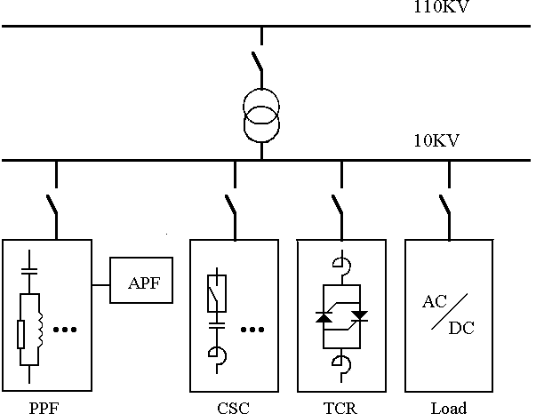

Fig.2 System schematic of SVC & HS

The design parameters of PPF are given in Tab.3. The assessment of PPF can be found in Tab.1 and Tab.2 as well. The voltage fluctuation in the 10KV intermediate line is reduced from –10.9% to (+2.4 ~ −6.7)% within LVS ( ±7%).

Table.3. Design parameters of PPF

|  |  |  |  |  |  |  |  |
| --- | --- | --- | --- | --- | --- | --- | --- |
|  | SF(Kvar  (Fundamental  Capacity) | R  ( ) | L (mH) | C  ( F) | UN  (KV) | I (A) | SI (Kvar) (Installed Capacity) |
| 5th | 1097 | 0.21 | 4.11 | 100.0 | 8.4 | 346 | 2246 |
| 7th | 865 | 0.19 | 2.61 | 80.88 | 9.7 | 321 | 2406 |
| 11th | 451 | 0.23 | 2.00 | 42.74 | 10.9 | 190 | 1585 |
| 13th | 254 | 0.35 | 2.54 | 24.11 | 8.8 | 87 | 592 |

**Compound Switching Capacitor (CSC)**

The switching capacitor banks are divided into three groups with 4Mvar, 6Mvar and

8 MVAR capacity respectively. The step difference is just 2Mvar as the same capacity as TCR. The design parameters of CSC are given in Tab.4. The harmonic resonance is checked up and the harmonic current amplifications are within the limited value of standard. The voltage fluctuation in the 10KV intermediate line will be reduced further to (− 0.61 ~ 1.2)% because of the operation of CSC.

Table.4. Design parameters of CSC

|  |  |  |  |  |
| --- | --- | --- | --- | --- |
| SN (Kvar) | C ( F) | LS (mH) | UCN (V) | SI (Kvar) (Per phase) |
| 4000 | 112 | 11.0 | 6600 | 1515 |
| 6000 | 168 | 7.24 | 6600 | 2273 |
| 8000 | 224 | 5.43 | 6600 | 3030 |

**Reactive Power Detection and SVC Control**

Studying on instantaneous power theory by integrated vector, a novel approach for reactive power detection and control has been found

A microcomputer-based system for SVC control is designed to determine the control logic to ensure the control precision and to avoid the switching oscillation. The stabilization of line voltage can be further improved with closed-loop control of TCR as shown.

**Summary**

With the power quality control in EAST power supply system, the grid voltage fluctuation and total harmonic distortion are within the limitation of standards. The compatibility between the power supply system and high voltage grid is realized. The feasibility and availability of the design are demonstrated.

**2.2 Panels designed by different companies like ABB, Schneider Electric, Siemens and PEL**

Since the evolution of power engineering the engineers have developed the techniques to overcome the power deficiencies and its effective usage by designing the panels for the power factor improvements and harmonics mitigations etc.

Different companies all over the world have devoted their share to design such panels for the industries as well as grid stations. Let’s look at some of the panel’s designs to have the idea about the concept and how this survey is going to help us out in the hardware formation of our project. Automatic power factor correction panel is fully automatic in operation and can achieve desired power factor under fluctuating load conditions by Schneider Electric

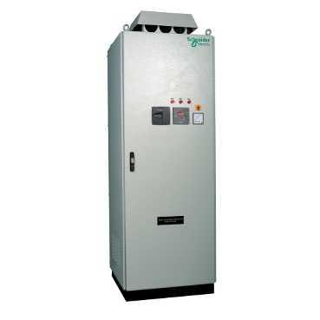

**Panel-courtesy Schneider**

Used in Fluctuating loads such as Steel Rolling mills, Chemical industry, cement plant, Sugar plant, Textile, Hospitals and Hotels, Building segment, Automobile industry etc.

**2.2.2 Harmonic Filtering units by ABB**

The main apparatus generating harmonics are:

- Personal computers

- Fluorescent and gas discharge lamps

- Static converters

- Continuity groups

- Variable speed drives

- Welding machines

- Arc and induction furnaces

To overcome the problems of harmonics different type of panels have been designed by the ABB Company for different type of situations like Grid capacity, Factories etc.



Harmonic Filtering Panels

**2.2.3 Power factor correction approximations by SIEMENS and Panels by PEL**

SIEMENS just like ABB and other world class companies has started to contribute since the old times. They not only solve the problems in the industries for Power Factor Corrections but also provide practical solutions by designing the capacitor banks and related panels to be used worldwide.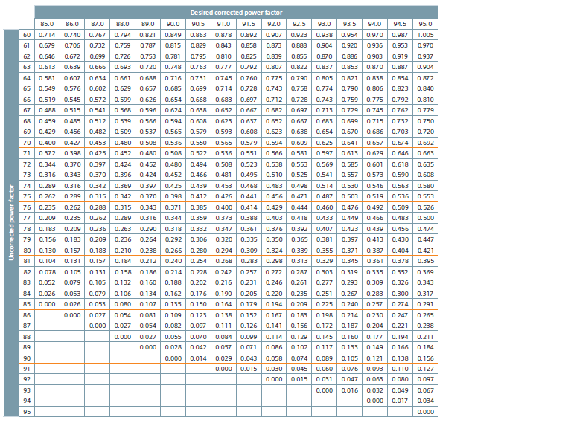

**Table designed for the Power factor responses before and after corrections by SIEMENS**

PEL, A Pakistani Company which is the leading consumer electronics as well as transformer and switch gear production firm played its role by also manufacturing the panels for its industrial premises and demands of energy consumptions.

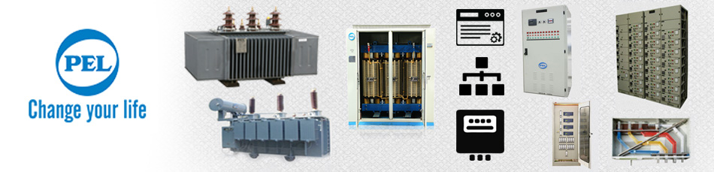

**2.3 Alignment of the research papers and practical applications to our design**

A survey has been conducted for the better understanding on how we can make a prototype for domestic purposes such that a single phase supply has been isolated for experimentation and production of the problem manually.

Home appliances like chokes, motors etc which are mostly inductive loads plays a minor role for the generation of harmonics for the actual grid capacity but it can significantly heat up the appliances, increases the energy demands and also effect the billing.

Secondly, the power factor also decreases the power quality and efficiency of the system respectively. For a deep study and analysis of the behaviours of harmonics and its reductions an active Harmonic filter has been designed for a single phase 220 Volts so that the study of Power Factor as well as the Harmonics can be carried out.

The results and conclusions later on can be utilised on industrial scales for the manufacturing of the product as well as the efficiency details could be more fruitful for upcoming projects and evolutions of power engineering.

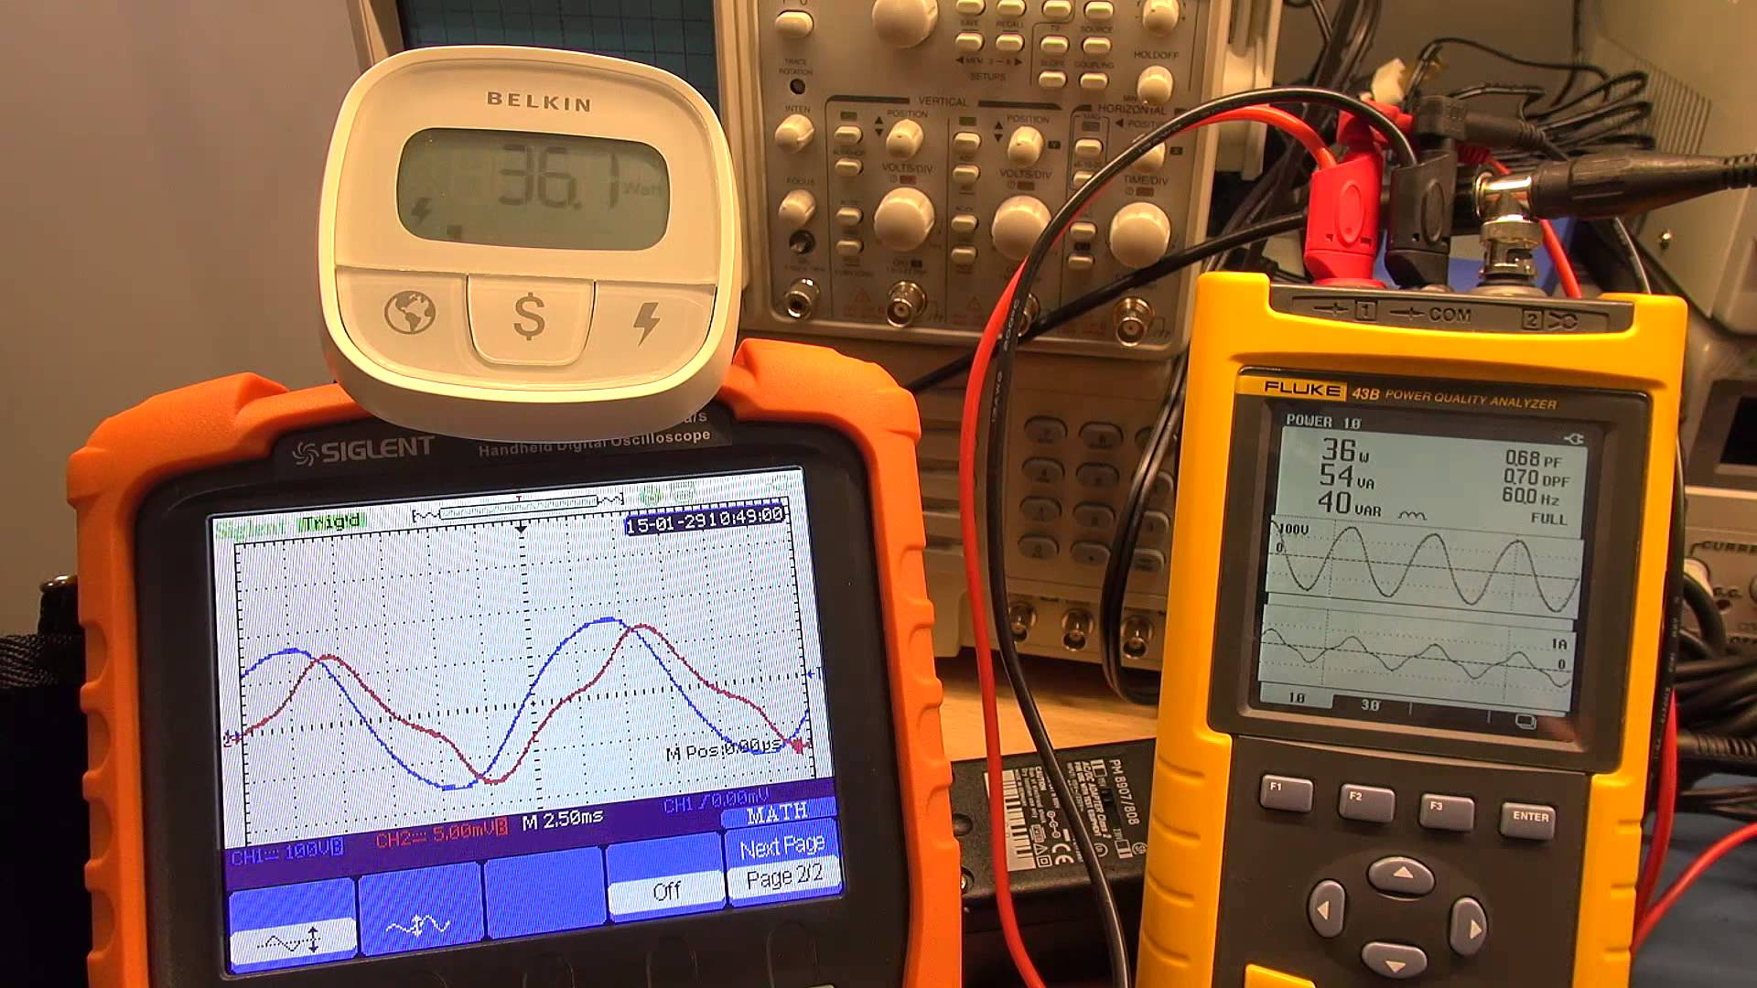

References

* [[1]](http://www.sciencedirect.com/science/article/pii/S1876610212002433#bib0005)

Wang Zhao-an,Yang Jun,Liu Jin-jun.Harmonic suppression and reactive power compensation (Second Edition)[M].beijing: Machinery Industry Press, 2006.

* [[2]](http://www.sciencedirect.com/science/article/pii/S1876610212002433#bib0010)

Zhou Hong-liang.Active Power Filter Control Technology and Application [D]. PhD thesis, Zhejiang University, 2002.

* [[3]](http://www.sciencedirect.com/science/article/pii/S1876610212002433#bib0015)

Li Qiao,Wu Jie.Adaptive Harmonic Current Detection Method for Active Power Filter [J].Electrical Technology, 2004, 19(12), 86-90.

* [[4]](http://www.sciencedirect.com/science/article/pii/S1876610212002433#bib0020)

Li Zi-cheng,Sun Yu-kun.A Neural Adaptive Harmonic Current Detecting Method of digital simulation [J], Power System Protection and Control, 2009, 37(5), 1-5R. Nicole, “Title of paper with only first word capitalized,” J. Name Stand. Abbrev., in press.

* [[5]](http://www.sciencedirect.com/science/article/pii/S1876610212002433#bib0025)

Lu Xiu-ling,Zhou La-wu.Instantaneous reactive power theory based on harmonic-voltage detection method [J] High Voltage Engineering, 2006, 32(1), 88-90, M. Young, The Technical Writer's Handbook. Mill Valley, CA: University Science, 1989.

* [[6]](http://www.sciencedirect.com/science/article/pii/S1876610212002433#bib0030)

Ji Tie-jun,Ren Li-jin,Liu Ai-ming.Not synchronous signal average weak coherent signal detection method [J] Journal of Harbin Institute of Technology, 2002, 7(3), 35-37.

* [[7]](http://www.sciencedirect.com/science/article/pii/S1876610212002433#bib0035)

QiuTian-shuang,WeiDong-xing,Tang Hong.Communication in adaptive signal processing [M].beijing:Electronic Industry Press, 2005.

* [[8]](http://www.sciencedirect.com/science/article/pii/S1876610212002433#bib0040)

Jiang Jun-feng,Liu Hui-jin,Chen yun-ping,SunJian-jun.Active filter voltage space vector double hysteresis current control method [J], Chinese Society for Electrical Engineering, 2004, 24(4), 82-86.

* [[9]](http://www.sciencedirect.com/science/article/pii/S1876610212002433#bib0045)

XueDing-yu, ChenYang-quan.Based on MATLAB /SIMULINK simulation technology and application of the systemM], Tsinghua University Press, 2002.

* [[10]](http://www.sciencedirect.com/science/article/pii/S1876610212002433#bib0050)

Wang Jin-Xing, Wang Qing-ping,Jia Chang-zhu,Yang Gang,Chen Chao-ying.MATLAB simulation in active filter design [J], Proceedings of, 2001(4), 43-46.

open in overlay

Copyright © 2012 Published by Elsevier Ltd. By http://www.sciencedirect.com/science/article/pii/S1876610212002433

**Chapter no 3**

**Experimental Work**

Project was basically divided into five stages.

* Research
* Planning
* Implementation on Software
* Experimentation on Hardware
* Report Writing

[Software](http://searchsoa.techtarget.com/definition/software) or [hardware](http://searchnetworking.techtarget.com/definition/hardware) implementation and experimentation encompasses all the processes involved in something operating properly in its environment, including analyzing requirements, installation, [configuration](http://searchexchange.techtarget.com/definition/configuration), customization, running, testing, systems integrations and making necessary changes.

Experimental work was started on Hardware. Before the Hardware implementation the whole idea was implemented and Designed on a Software (Proteus). Step by step different parts of the hardware were made and checked and then at the end all were combined to make a hardware prototype which reflected our idea.

* 1. **Block diagram**

First of all a basic BLOCK DIAGRAM was made by research. Different Techniques, ideas, calculations and proper guidance of the supervisor led us to finalize the block diagram on early stages. By keeping in mind the basic purpose of the project a block diagram was developed which was further implemented on software. Different blocks were first implemented separately and then at the end a combined software implementation was done. Similar steps were taken for its Hardware implementation.

* 1. **Method and Materials**

After developing the block diagram a study was carried out this involved the reading of data sheets of different components which were to be use in the Hardware Prototype. The details of the components used in the Hardware prototype are described as follows:

* + 1. **Isolation Transformer**

Isolation transformer has a basic function of isolation the electrical system from the Ac power source. This helps in protecting the equipment from electric shocks. Galvanic isolation is provided by isolation transformer which is used in reducing electrical noises. Another use of isolation transformer is that it can provide power transfer between two circuits which are not supposed to be connected. In isolation transformer isolation is present between the secondary and primary wiring and it can bear high voltages.

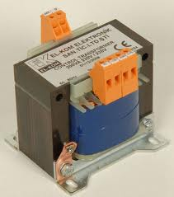

In isolation transformers on AC component is allowed to pass and the entire DC component is blocked. Secondary circuits can be protected if there is 1 to 1 ratio in the transformer.

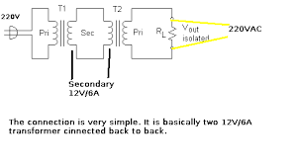

**Operation**

The designing of isolation transformer is done by keeping in mind the capacitive coupling between primary and secondary windings. Due to the presence of capacitance between the windings it would lead to the coupling of the AC current from primary wiring to the secondary wiring. The coupling of the common mode noise can be reduced if Faraday shield is applied between the two windings.

* + 1. **Current Transformer**

Current transformer is basically used to measure current. In CT the alternating current produced in the secondary is proportional to the alternating current produced in the primary winding. Current transformers provides a save environment for the measurement of current using a ammeter by reducing the high voltage alternating current to a very low voltage current. The main functioning principle of the current transformer is same as any other transformer. The only difference is that the CT has only one or very few windings in its primary.

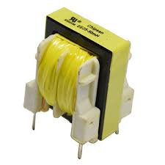

Current transformers are sometimes also called as series transformer because of its arrangement. Main reason of referring CT as current transformer is that it has a few or just one turn in its primary. While the secondary wiring can have a very large number of turns. Usually these secondary windings are rated at 1 or 5 Ampere standards.

**Current Transformer Figure**

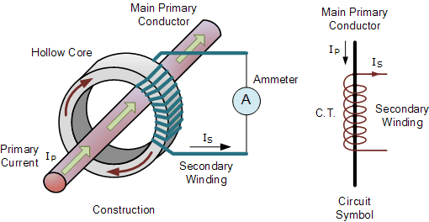

**3.2.3 Potential Transformer**

Potential transformer (PT) which are also known as voltage transformers are used to measure voltages. Unlike current transformers these are connected in parallel. It has a simple functioning of stepping down the high voltage t a very low voltage which in return can be measured by using some specific standards. Unlike CT these transformers have a very large no of coil windings in the primary and small number of turns in the secondary winding.

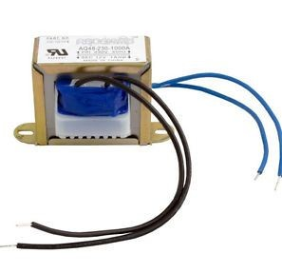

usually the ratio of primary windings to the secondary windings are used to express a potential transformer.

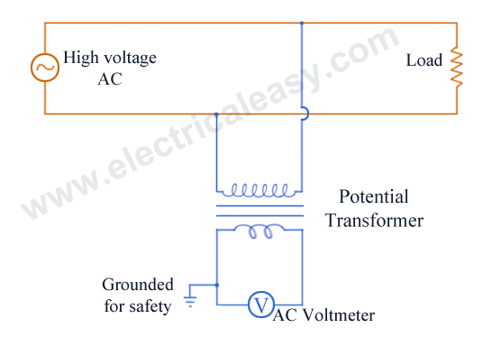

Parallel connection is required when using potential transformers. PT’s are designed in such a way so that they can read voltage phase and ratio while performing metering. There are two configurations available in potential transformer. One is line to line configuration and other is line to neutral configuration.

Power, demand, voltage and energy are the certain quantities which need to be scaled before using a potential transformer. Some basic wiring knowledge with experience is all that required to used potential transformers and other ordinary transformers.

**3.2.4 Capacitors**

Capacitors are electrical components having two terminals.  Capacitors are two-terminal electrical elements.  Capacitors are essentially two conductors, usually conduction plates - but any two conductors - separated by an insulator - a dielectric - with connection wires connected to the two conducting plates.

        Capacitors occur naturally. On printed circuit boards two wires running parallel to each other on opposite sides of the board form a capacitor. That's a capacitor that comes about inadvertently, and we would normally prefer that it not be there. But, it's there.  It has electrical effects, and it will affect your circuit.  You need to understand what it does.

        At other times, you specifically want to use capacitors because of their frequency dependent behavior. There are lots of situations where we want to design for some specific frequency dependent behavior. Maybe you want to filter out some high frequency noise from a lower frequency signal. Maybe you want to filter out power supply frequencies in a signal running near a 60 Hz line. You're almost certainly going to use a circuit with a capacitor.

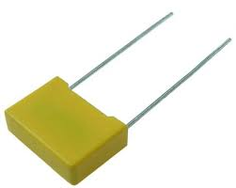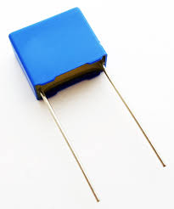

        Sometimes you can use a capacitor to store energy.  In a subway car, an insulator at a track switch may cut off power from the car for a few feet along the line. You might use a large capacitor to store energy to drive the subway car through the insulator in the power feed.

        Capacitors are used for all these purposes, and more. In this chapter you're going to start learning about this important electrical component. Remember capacitors do the following and more.

* Store energy
* Change their behavior with frequency
* Come about naturally in circuits and can change a circuit's behavior

 In a capacitor charge can accumulate on the two plates. Normally charge of opposite polarity accumulates on the two plates, positive on one plate and negative on the other. It is possible for that charge to stay there. The positive charge on one plate attracts and holds the negative charge on the other plate. In that situation the charge can stay there for a long time.

Voltage-Current Relationships In Capacitors

        There is a relationship between the charge on a capacitor and the voltage across the capacitor.  The relationship is simple. For most dielectric/insulating materials, charge and voltage are linearly related.

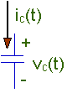Q = C V

where:

* V is the voltage across the plates.

You will need to define a polarity for that voltage. We've defined the voltage above. You could reverse the "+" and "-".

* Q is the charge on the plate with the "+" on the voltage polarity definition.
* C is a constant - the capacitance of the capacitor.

        The relationship between the charge on a capacitor and the voltage across the capacitor is linear with a constant, C, called the capacitance.

Q = C V

        When V is measured in volts, and Q is measured in couloumbs, then C has the units of farads. Farads are really coulombs/volt.

        The relationship, Q = C V, is the most important thing you can know about capacitance. There are other details you may need to know at times, like how the capacitance is constructed, but the way a capacitor behaves electrically is determined from this one basic relationship.

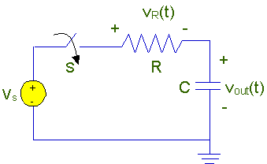       Shown to the right is a circuit that has a voltage source, Vs, a resistor, R, and a capacitor, C. If you want to know how this circuit works, you'll need to apply KCL and KVL to the circuit, and you'll need to know how voltage and current are related in the capacitor. We have a relationship between voltage and charge, and we need to work with it to get a voltage current relationship. We'll look at that in some detail in the next section.

        The basic relationship in a capacitor is that the voltage is proportional to the charge on the "+" plate. However, we need to know how current and voltage are related. To derive that relationship you need to realize that the current flowing into the capacitoris the rate of charge flow into the capacitor. Here's the situation. We'll start with a capacitor with a time-varying voltage, v(t), defined across the capacitor, and a time-varying current, i(t), flowing into the capacitor. The current, i(t), flows into the "+" terminal taking the "+" terminal using the voltage polarity definition. Using this definition we have:

ic(t) = C dvc(t)/dt

        This relationship is the fundamental relationship between current and voltage in a capacitor. It is not a simple proportional relationship like we found for a resistor. The derivative of voltage that appears in the expression for current means that we have to deal with calculus and differential equations here - whether we want to or not.

The larger the surface area of the "plates" (conductors) and the narrower the gap between them, the greater the capacitance is. In practice, the dielectric between the plates passes a small amount of [leakage current](https://en.wikipedia.org/wiki/Leakage_(electronics)) and also has an electric field strength limit, known as the [breakdown voltage](https://en.wikipedia.org/wiki/Breakdown_voltage). The conductors and [leads](https://en.wikipedia.org/wiki/Lead_(electronics)) introduce an undesired [inductance](https://en.wikipedia.org/wiki/Equivalent_series_inductance) and [resistance](https://en.wikipedia.org/wiki/Equivalent_series_resistance).

Capacitors are widely used in [electronic circuits](https://en.wikipedia.org/wiki/Electronic_circuit) for blocking [direct current](https://en.wikipedia.org/wiki/Direct_current) while allowing [alternating current](https://en.wikipedia.org/wiki/Alternating_current) to pass. In [analog filter](https://en.wikipedia.org/wiki/Analog_filter) networks, they smooth the output of [power supplies](https://en.wikipedia.org/wiki/Power_supply). In [resonant circuits](https://en.wikipedia.org/wiki/LC_circuit) they tune [radios](https://en.wikipedia.org/wiki/Radio) to particular [frequencies](https://en.wikipedia.org/wiki/Frequency). In [electric power transmission](https://en.wikipedia.org/wiki/Electric_power_transmission) systems, they stabilize voltage and power flow.

**Capacitor’s application for Power factor correction**

In electric power distribution, capacitors are used for [power factor correction](https://en.wikipedia.org/wiki/Power_factor_correction). Such capacitors often come as three capacitors connected as a [three phase](https://en.wikipedia.org/wiki/Three_phase) [load](https://en.wikipedia.org/wiki/Electrical_load). Usually, the values of these capacitors are given not in farads but rather as a [reactive power](https://en.wikipedia.org/wiki/Reactive_power) in volt-amperes reactive (VAR). The purpose is to counteract inductive loading from devices like [electric motors](https://en.wikipedia.org/wiki/Induction_motor) and [transmission lines](https://en.wikipedia.org/wiki/Transmission_line) to make the load appear to be mostly resistive. Individual motor or lamp loads may have capacitors for power factor correction, or larger sets of capacitors (usually with automatic switching devices) may be installed at a load center within a building or in a large utility [substation](https://en.wikipedia.org/wiki/Electrical_substation).

When an inductive circuit is opened, the current through the inductance collapses quickly, creating a large voltage across the open circuit of the switch or relay. If the inductance is large enough, the energy will generate a spark, causing the contact points to oxidize, deteriorate, or sometimes weld together, or destroying a solid-state switch. A [snubber](https://en.wikipedia.org/wiki/Snubber" \o "Snubber)capacitor across the newly opened circuit creates a path for this impulse to bypass the contact points, thereby preserving their life; these were commonly found in [contact breaker](https://en.wikipedia.org/wiki/Contact_breaker)ignition systems, for instance. Similarly, in smaller scale circuits, the spark may not be enough to damage the switch but will still radiate undesirable radio frequency interference(RFI), which a filter capacitor absorbs. Snubber capacitors are usually employed with a low-value resistor in series, to dissipate energy and minimize RFI. Such resistor-capacitor combinations are available in a single package.

**3.2.5 Inductor**

An inductor called a coil or reactor is a passive element having two-terminal which resists changes in electric current passing through it. It consists of a conductor or metal such as a wire, usually wound or wrapped into a coil. Energy is stored in a magnetic field within the coil as long as current flows. When the current flowing through an inductor changes, the time varying magnetic field induces a voltage around or in the conductor, according to Faraday’s law of electromagnetic induction. According to Lenz's law the direction of induced electromotive force (e.m.f.) is always such that it opposes the change in current that created it. As a result, inductors always oppose a change in currents.

An inductor is characterized by its inductance characteristics, the ratio of the voltage to the rate of change of current, which has units of henries (H).  Many inductors have magnetic cores made of iron or ferrite materials inside the coil, which serves to increase the magnetic field and thus the inductances. Along with capacitor and resistors, inductor is one of the three passive linear circuit element that make up electric circuits. Inductors are widely used in AC electronic equipment, particularly in radio equipments etc. They are used to block AC while allowing DC to pass through them.

**Toroidal core inductors**

In an inductor wound on a straight rod-shaped core, the magnetic field lines emerging from one end of the core must pass it through the air to re-enter the core at the other end of it. This reduces the field because much part of the magnetic field path is in air rather than the higher permeability core material. A higher magnetic field and inductance can be achieved by forming the core in a closed magnetic circuit. The magnetic field lines form closed loops within the core without leaving the core materials of it. The shape often used is a toroidal or doughnut-shaped ferrite core. Because of their symmetry shape, toroidal cores allow a minimum of the magnetic flux to escape outside the core which is called leakage flux, so they radiate less electromagnetic interferences than other shapes. Toroidal core coils are manufactured of various materials such as primarily ferrite, powdered iron and laminated cores.

**Inductor constructions**

[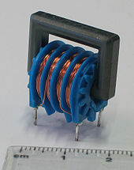](https://en.wikipedia.org/wiki/File:Choke_electronic_component_Epcos_2x47mH_600mA_common_mode.jpg)

**A ferrite core inductor with two 47 mH winding**

An inductor usually consists of a coil of conducting materials typically insulated copper wire, wrapped around a core either of plastic or of ferromagnetic or ferrimagnetic material thus the latter is called an iron core inductor. The high permeability of the ferromagnetic core increases the magnetic field and confines it closely to the inductor body, thereby increasing the inductance of inductor. Low frequency inductors are constructed like transformers, with cores of electrical steels laminated to prevent eddy currents formations. Soft ferrites are widely used for cores above audio frequencies, because they do not cause the large energy losses at high frequencies that ordinary iron alloys do. Inductors come in many shapes in the market. Most are constructed as enamel coated wire or magnet wire wrapped around a ferrite bobbin with wire exposed on the outside of it while some enclose the wire completely in ferrite and are referred to as "shielded types". Some inductors have an adjustable core, which enables changing of the inductance respectively. Inductors used to block very high frequencies are sometimes made by stringing ferrite beads on a wire.

Small inductors can be fetched directly onto a printed circuit board or PCB by laying out the trace in a spiral pattern. Some such planar inductors use a planar core for the operations.

Small value inductors can also be built on integrated circuits or IC using the same processes that are used to make transistors. Aluminium interconnect is typically used, laid out in a spiral coil pattern. However, the small dimensions limit the inductances, and it is far more common to use a circuit called a gyrator that uses a capacitor and active components to behave similarly to an inductor but these devices are now being used in the place of an inductor.

**Applications**

Inductors are used extensively in analog circuits and signal processing units. Applications range from the use of large inductors in power supplies, which in conjunction with filter capacitors remove residual hums known as the mains hums or other fluctuations from the direct current outputs, to the small inductance of the ferrite bead or torus installed around a cable to prevent radio frequency interferences from being transmitted down the wire. Inductors are used as the energy storage device in many switched mode power supply to produce DC current. The inductor supplies energy to the circuit to keep current flowing during the "off" switching periods of the circuits.

An inductor connected to a capacitor forms tuned circuits which act as a resonator for oscillating current. Tuned circuits are widely used in radio frequency equipment such as radio transmitters and receivers, as narrow bandpass filters to select a single frequency from a composite signal, and in electronic oscillators to generate sinusoidal signals for the study and analysis.

Two or more inductors in proximity that have coupled magnetic flux or mutual inductance form a transformer, which is a fundamental component of every electric power grid. The efficiency of a transformer may decrease as the frequency increases due to eddy currents in the core materials and skin effects on the windings. The size of the core can be decreased at higher frequencies. For this reason, aircraft use 400 hertz alternating current rather than the usual 50 or 60 hertz of world wide usage, allowing a great saving in weight from the use of smaller transformers.

Inductors are also used in electrical transmission systems, where they are used to limit switching currents and fault currents. In this field of industry or power engineering, they are more commonly referred to as reactors.

Because inductors have complicated side effects which cause them to depart from ideal behavior, because they can radiate electromagnetic interferences (EMI), and most of all because of their bulk mass which prevents them from being integrated on semiconductor chips, the use of inductors is decreasing in modern electronic devices, particularly compact portable devices etc. Inductors are increasingly being replaced by active circuits such as the gyrator which can synthesize inductance using capacitors.

**3.2.6 Diode**

In market electronics, a diode is a two-terminal electronic component that conducts primarily in one direction then it would be asymmetric conductance then it has low or ideally zero resistance to the flow of current in one direction, and high or ideally infinite resistance in the other. A semiconductor diode is the most common type of today, is a crystalline piece of semiconductor material with a p–n junction connected to two electrical terminals. A vacuum tube diode has two electrodes, a plate or anode and a heated cathode. Semiconductor diodes were the first semiconductor electronic devices in the history. The most common function of a diode is to allow an electric current to pass in one direction while blocking current in the opposite direction or we can say the reverse direction. Thus, the diode can be viewed as an electronic version of a check valve. This unidirectional behavior is called rectification process, and is used to convert alternating current (AC) to direct current (DC), including extraction of modulation from radio signals in radio receivers these diodes are forms of rectifiers because of rectification process.

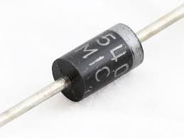

However, diodes can have more complicated behavior than these simple on–off action type operations because of their nonlinear current-voltage characteristics or deviation from Ohm’s law. Semiconductor diodes begin conducting electricity only if a certain threshold voltage or cut-in voltage is present in the forward direction and it is said to be a state in which the diode is said to be forward-biased. The voltage drop across a forward-biased diode varies only a little with the current respectively, and is a function of temperature and this effect can be used as a temperature sensor or as a voltage reference in industries.

A semiconductor diode's current–voltage or VI characteristic can be tailored by selecting the semiconductor materials and the doping or adding impurities introduced into the materials during manufacturing. These techniques are used to create special-purpose diodes that perform many different functions accordingly. For example, diodes are used to regulate voltage as termed as Zener diodes, to protect circuits from high voltage surges as avalanche diodes, to electronically tune radio and TV receivers as varactor diodes, to generate radio-frequency oscillations by tunnel diodes, Gunn diodes, IMPATT diodes, and to produce light light-emitting diodes LEDs. Tunnel, Gunn and IMPATT diodes exhibit negative resistance pattern, which is useful in microwave and switching circuits.

**Circuit Symbols**

Every diode has two terminals – connections on each end of the component – and those terminals are polarized, meaning the two terminals are distinctly different. It’s important not to mix the connections on a diode up. The positive end of a diode is called the anode, and the negative end is called the cathode. Current can flow from the anode end to the cathode, but not the other direction as a principle. If you forget which way current flows through a diode then try to remember the mnemonic ACID abbrevated as anode current in diodeor can also anode cathode is diode.

The circuit symbol of a standard diode is a triangle sliding against a line. There are a variety of diode types to use, but usually their circuit symbol will look something like this:

[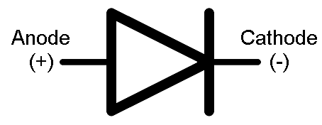](https://cdn.sparkfun.com/assets/d/6/b/f/a/5171b6bece395ff53c000000.PNG)

Terminal entering the flat type edge of the triangle represents the anode. Current flows in the direction that the triangle/arrow is pointing, but it can’t go into the other way.

[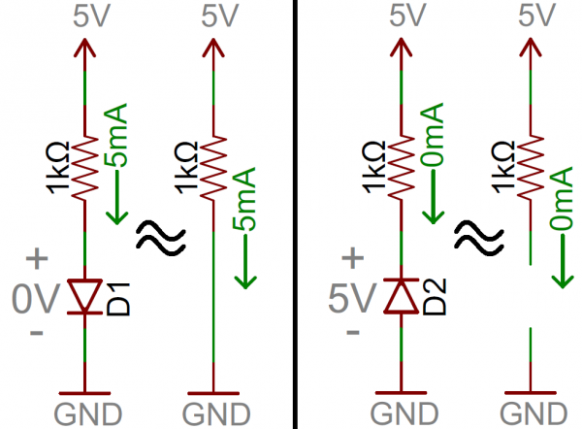](https://cdn.sparkfun.com/assets/4/d/e/a/0/5171bcf8ce395f003d000000.png)

Couple simple diode circuit examples. On the left, diode D1 is forward biased and allowing current to flow through the circuit.It looks like a short circuit. On the right, diode D2 is reverse biased mode. Current cannot flow through the circuit, and it essentially looks like an open circuit system.

Real Diode Characteristics

Ideally, diodes will resist or blocks any and all current flowing the reverse direction of it, or just act like a short-circuit if current flow is forward directional. Unfortunately, actual diode behavior isn’t quite ideal. Diodes actuay do consume some amount of energy and power when conducting forward current, and they won’t block out all reverse current. Real diodes are a bit more complicated to be studied, and they all have unique characteristics which define how they actually will operate.

**Current-Voltage Relationships**

Most important diode characteristic is its current-voltage or VI characteristics. This defines what the current running through a component is, given what voltage is measured across it. Resistors, for example, have a simple, linear VI relationship that is Ohm’s Law.The VI curve of a diode, though, is entirely non-linear in nature.

**Types of Diodes**

**Normal Diodes**

Standard signal diodes are one of the most basic, average members of the diode family in electronics. They usually have a medium high forward voltage drop and low maximum current ratings. A common example of a signal diode is the1N4148 no diode. Very general purpose, it’s got a typical forward voltage drop of 0.72V and a 300mA maximum forward current ratings respectively.

[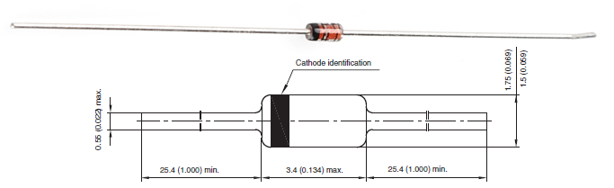](https://cdn.sparkfun.com/assets/1/f/4/b/0/51781f40ce395ff110000000.png)

Small-signal diode, the numbered 1N4148. Notice the black circle around the diode that marks which of the terminals is the cathode.

A rectifier or simple rectifying diode or power diode is a standard diode with a much higher maximum current ratings respectively. This higher current rating usually comes at the cost of a larger forward voltage disadvantage. The 1N4001 has a current rating of 1A and a forward voltage of 1.1V as the pre set specifications.

[](https://cdn.sparkfun.com/assets/b/e/b/4/1/517820f8ce395f190e000000.png)

[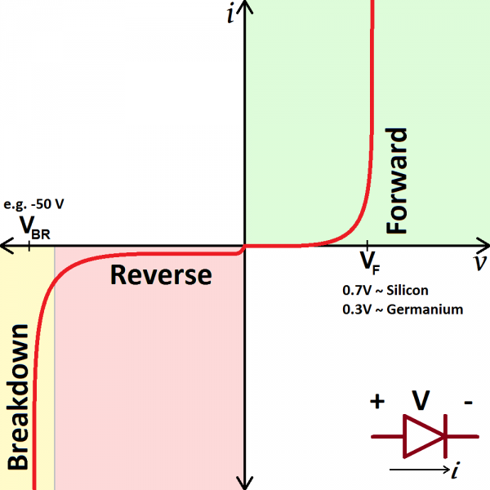](https://cdn.sparkfun.com/assets/4/4/a/5/b/5175b518ce395f2d49000000.png)

Depending on the voltage applied across a diode, diode will operate in one of three regions:

1. **Forward bias**

When the voltage across the diode is positive the diode is “on” and current can run through it. The voltage should be greater than the forward voltage (VF) in order for the current to be anything significant this is the sole condition in such case.

1. **Reverse bias**

It is the “off” mode of the diode, where the voltage is less than VF but greater than -VBR respectively. In this mode of operation current flow is mostly blocked and the diode is off state. A very small amount of current in the order of nA would flow called reverse saturation current in reverse through the diode.

1. **Breakdown**

When the voltage applied across the diode is very large lots of current will be able to flow in the reverse direction from cathode to anode it is called breakdown condition.

**Light-Emitting Diodes (LEDs)**

The flashiest member of the diode family must be the light-emitting diode (LED). These diodes quite literally light up when a positive voltage is applied.

[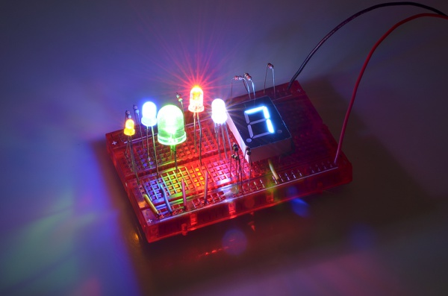](https://cdn.sparkfun.com/assets/a/f/a/b/3/51818388ce395f8102000000.jpg)

Like normal diodes, LEDs only allow current through one direction. They also have a forward voltage rating, which the voltage is required for them to light up. The VF rating of an LED is usually larger than that of a normal diode (1.2 to 3V), and it depends on the color the LED emits.

You’ll obviously most-often find LEDs in lighting applications. They’re blinky and fun! But more than that, their high-efficiency has lead to widespread use in street lights, displays, backlighting, and much more. Other LEDs emit a light that is not visible to the human eye, like infrared LEDs, which are the backbone of most remote controls. Another common use of LEDs is in optically isolating a dangerous high-voltage system from a lower-voltage circuit. Opto-isolators pair an infrared LED with a photosensor, which allows current to flow when it detects light from the LED. Below is an example circuit of an opto-isolator. Note how the schematic symbol for the diode varies from the normal diode. LED symbols add a couple arrows extending out from the symbol.

[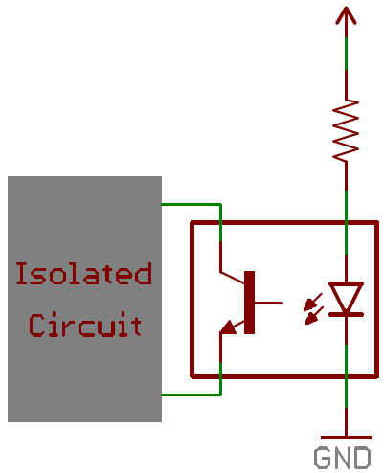](https://cdn.sparkfun.com/assets/3/5/4/2/a/5175bc8dce395f7c49000000.PNG)

**Diode Applications**

For such a simple component diodes have a huge range of uses. You’ll find a diode of some type in just about every circuit. They could be featured in anything from a small-signal digital logic to a high voltage power conversion circuit.

**Rectifiers**

A rectifier is a circuit that converts alternating current (AC) to direct current (DC). This conversion is critical for all sorts of household electronics. AC signals come out of your house’s wall outlets, but DC is what powers most computers and other microelectronics.

Current in AC circuits literally *alternates*– quickly switches between running in the positive and negative directions – but current in a DC signal only runs in one direction. So to convert from AC to DC you just need to make sure current can’t run in the negative direction.

A **half-wave rectifier** can be made out of just a single diode. If an AC signal, like a sine wave for example is sent through a diode any negative component to the signal is clipped out.

[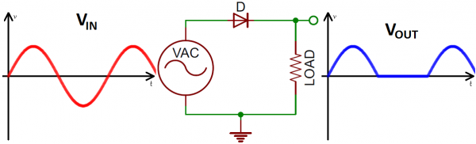](https://cdn.sparkfun.com/assets/2/9/2/f/3/5176f4bfce395f3a61000000.png)

Input wave (red) and output wave (blue) voltage waveforms, after passing through the half-wave rectifier circuit.

**A** **full-wave bridge rectifier**

 Uses four diodes to convert those negative humps in the AC signal into positive humps.

[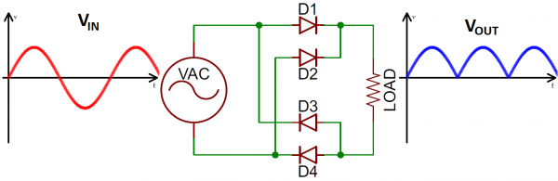](https://cdn.sparkfun.com/assets/d/2/2/3/b/5176fdc5ce395f5248000000.png)

**3.2.7 Thyristors**

It is a solid state semiconductor device of four layers of P and N-type material acts as Bi-stable switch, it conducts when gate receives current trigger and continuously conduct when the voltage across the device is not forward-biased. There are two types of thyristors in which three-lead thyristor is manufacture to control the larger current of its two leads by combining that current with smaller current of its another remaining lead which is known as Control lead. While the two-lead thyristor is used for switching on if potential difference is sufficiently large between its leads.

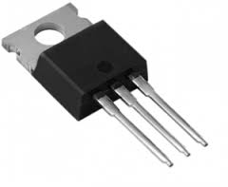

Thyristor is also known as Silicon-controlled rectifier (SCR) by some sources. It is also defined as larger set of device with layers of altering P and N type material.

It is an four-layered, three terminal semiconductor device, with each layer consisting of alternately [N-type](https://en.wikipedia.org/wiki/N-type_semiconductor) or [P-type](https://en.wikipedia.org/wiki/P-type_semiconductor) material, for example P-N-P-N. The main terminals of thyristors are labeled anode and cathode of all four layers. The control terminal, called the gate, is attached to p-type material near the cathode. (A variant called an SCS—Silicon Controlled Switch—brings all four layers out to terminals.) The operation of a thyristor can be understood in terms of a pair of tightly coupled [bipolar junction transistors](https://en.wikipedia.org/wiki/Bipolar_junction_transistor), arranged to cause a self-latching action:

[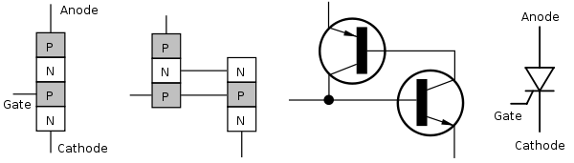](https://en.wikipedia.org/wiki/File:Thyristor.svg)

**Thyristors have three states:**

1. Reverse blocking mode which tells that Voltage is applied in the direction that would be stopped by a diode
2. Forward blocking mode which tells that Voltage is applied in the direction that would cause a diode to conduct, but the thyristor has not been triggered into conduction
3. Forward conducting mode is about the thyristor has been triggered into conduction and will still remain conducting until the forward current drops below a threshold value known as the "holding current"

**Function of the gate terminal**

The thyristor has three [p-n junctions](https://en.wikipedia.org/wiki/P-n_junction) (serially named J1, J2, J3 from the anode).

[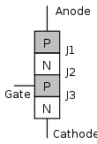](https://en.wikipedia.org/wiki/File:Thyristor_layers.svg)

**Layer diagram of thyristor**

When the anode is applied to a positive potential relative to the cathode without VAK voltage to the gate, junctions J1 and J3 are forward biased while junction J2 is reverse-biased . As J2 is reverse biased, no conduction takes place (Off state) . Now, when VAK is increased above the breakdown voltage VBO of the thyristor, avalanche breakdown takes place of J2 and the thyristor starts conducting (on state).

If a positive potential VG is applied to the gate terminal with respect to the cathode, the breakdown of the junction J2 occurs at a lower value of VAK . Through an appropriate value of VG Store the thyristor can be quickly switched to the conductive state.

Once avalanche breakdown has occurred, the thyristor is carried out , regardless of the gate voltage

(a) The current through the device (anode-cathode), the potential VAK removed or ( b ) is less than the holding current specified by the manufacturer . Therefore, a voltage pulse, as its voltage output from a UJT relaxation oscillator.

The gate pulses are with respect to the gate- trigger voltage (VGT), and the gate trigger current (IGT) characterized. Ignition varies inversely with the gate pulse width in such a way that it is apparent that there is a minimum gate charge required to trigger the thyristor.

**Switching characteristics**

[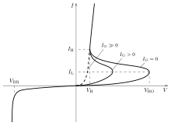](https://en.wikipedia.org/wiki/File:Thyristor_I-V_diagram.svg)

**V - I characteristics**

In a conventional thyristor, once it has been switched on by the gate terminal, the device remains latched in the on-state (i.e. does not need a continuous supply of gate current to remain in the on state), providing the anode current has exceeded the latching current (IL). As long as the anode remains positively biased, it cannot be switched off until the anode current falls below the holding current (IH).

A thyristor can be switched off if the external circuit causes the anode to become negatively biased (a method known as natural, or line, commutation). In some applications this is done by switching a second thyristor to discharge a capacitor into the cathode of the first thyristor. This method is called forced commutation.

After the current in a thyristor has extinguished, a finite time delay must elapse before the anode can again be positively biased and retain the thyristor in the off-state. This minimum delay is called the circuit commutated turn off time (tQ). Attempting to positively bias the anode within this time causes the thyristor to be self-triggered by the remaining charge carriers ([holes](https://en.wikipedia.org/wiki/Electron_hole) and [electrons](https://en.wikipedia.org/wiki/Electron)) that have not yet[recombined](https://en.wikipedia.org/wiki/Carrier_generation_and_recombination).

For applications with frequencies higher than the domestic AC mains supply (e.g. 50 Hz or 60 Hz), thyristors with lower values of tQ are required. Such fast thyristors can be made by diffusing [heavy metal](https://en.wikipedia.org/wiki/Heavy_metal_(chemistry)) [ions](https://en.wikipedia.org/wiki/Ion) such as [gold](https://en.wikipedia.org/wiki/Gold) or [platinum](https://en.wikipedia.org/wiki/Platinum) which act as charge combination centers into the silicon. Today, fast thyristors are more usually made by [electron](https://en.wikipedia.org/wiki/Electron) or[proton](https://en.wikipedia.org/wiki/Proton) [irradiation](https://en.wikipedia.org/wiki/Irradiation) of the silicon, or by [ion implantation](https://en.wikipedia.org/wiki/Ion_implantation). Irradiation is more versatile than heavy metal doping because it permits the dosage to be adjusted in fine steps, even at quite a late stage in the processing of the silicon.

In a conventional thyristor, as soon as it is turned on by the gate terminal, the device remains in the on state is locked (ie, not a continuous supply of gate current to the conducting state to remain need), the anode current providing exceeding the latching current (IL). As long as the anode remains positively biased, it can not be turned off until the anode current falls below the holding current (IH).

A thyristor can be turned off when the external circuit causes it to be negatively biased, the anode (a method as is known natural or line commutation). In some applications, this is by switching a second thyristor done a capacitor is discharged into the cathode of the first thyristor. This process is called forced commutation.

After the current is deleted in a thyristor, a finite time elapses must delay before the anode may be positively biased again, and to hold the thyristor in the OFF state. This

minimum delay is called the circuit commutated turn-off time (tQ). Trying bias positive on the anode within this time causes to be triggered, the thyristor by the remaining charge carriers (electrons and holes) itself, which does not have yet recombined.

For applications with frequencies higher than the domestic AC power (eg, 50 Hz or 60 Hz), thyristors with lower values ​​of tQ required. Such fast thyristors can be produced by diffusion of heavy metal ions such as gold or platinum, which act as charge combination centers in the silicon. Today fast thyristors are more usually produced by electron irradiation orproton of silicon or by ion implantation. Irradiation is more versatile than heavy metal doping, because it allows the dosage can be adjusted in fine steps, even at a fairly late stage in the processing of silicon.

**Basic Operating Principle of Thyristor**

Although there are various types of thyristors, but basic operating principle of thyrisrors are all more or less same. The following figure shows a conceptual view of a typical thyristor. There are three p-n junctions J1, J2 and J3. There are also three terminals anode (A), cathode (K) and gate (G), as leveled in the figure. When the anode (A) with respect to the cathode in the higher potential, the transitions are J1 and J3 is forward-biased and J2 is reverse biased and the thyristor is in the forward blocking mode. A thyristor can be considered to support such reconnected two bipolar transistors. A p-n-p-n structure of the thyristor can be represented by the p n p and n p -n transistors, as shown in the figure. Here, in this device, the collector current of a transistor is used as the base current of the other transistor. When the device is in forward blocking mode if a hole current is injected through the gate (G) terminal, the device is triggered.

When potential is applied in reverse direction, the [thyristor](http://www.electrical4u.com/thyristor-silicon-controlled-rectifier/) behaves as a reverse biased [diode](http://www.electrical4u.com/diode-working-principle-and-types-of-diode/). That means it blocks [current](http://www.electrical4u.com/electric-current-and-theory-of-electricity/) to flow in revere direction. Considering ICO to be the leakage [current](http://www.electrical4u.com/electric-current-and-theory-of-electricity/) of each transistor in cut-off condition, the anode current can be expressed in terms of gate current. 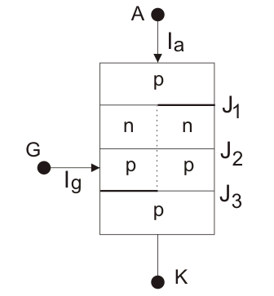Where α is the common base [current](http://www.electrical4u.com/electric-current-and-theory-of-electricity/) gain of the transistor (α = IC/IE). The anode current becomes arbitrarily large as (α1 + α2) approaches unity. As the anode-cathode voltage increases, expands the depletion region and reduces the neutral base width of n1 and p1 regions. This causes a corresponding increase in α of the two transistors. When a positive gate current of sufficient magnitude is applied to the thyristor, a significant amount of electrons is biased in the forward direction across the junction are injected, J3, n1p2n2in the base of the transistor. The resulting collector current supplied to p1n1p2 transistor base current. The combination of the positive feedback connection of the npn and pnp BJTs and the current-dependent transport base factors eventually turn on the thyristor by regenerative effect. Known to the power semiconductor components, the thyristor is the lowest forward voltage drop at high current densities. The large current flow between the anode and the cathode holding both transistors in saturation region, and gate control is lost once the thyristor latches on.

**Transient Operation of Thyristor**

A thyristor is not turned as soon as the gate current is injected; there is a minimum time delay for regenerative action required. After this time delay, the anode current starts quickly rise to state value. The rate of rise of the anode current can be limited only by external power elements. The signal gate can only turn off the thyristor but it cannot turn off the device. Of course it is turned off when the anode current flows in the reverse direction during the reverse cycle of the alternating current, tends. A thyristor has turn-off reverse recovery characteristics like a diode. Excess charge is removed when the current crosses zero determined and reached a negative value at a rate of external circuit elements.

The reverse recovery peak is reached when either junction J1 or J3 is reverse biased. The backflow begins expire, and the anode-cathode voltage quickly reaches its off-state value. Because of the finite time, which are limited to the distribution or collecting the charge plasma while turning on or off the stage, the maximum dI / dt and dV / dt, which may be imposed on the apparatus in size. Further giving device manufacturers a Conducted recovery time of the thyristor, which has for the minimum time is the thyristor remains in its reverse blocking mode before the forward voltage is applied again

**3.2.8 PIC MICROCONTROLLER**

The PIC microcontroller PIC16F877a is famous microcontroller in the industry. This control is very convenient to use the coding or programming of this control is also easier. One of the main advantages is that it as often as may be possible write-erase because it use flash memory technology. It has a total of 40 pins and there are 33 pins for input and output. PIC16F877a is used in many PIC microcontroller projects. PIC16F877A also have many applications in digital electronics circuits.

[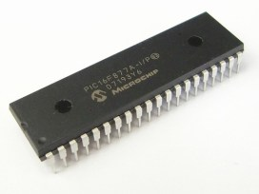](http://i2.wp.com/microcontrollerslab.com/wp-content/uploads/2015/08/PIC16F877A-microcontroller.jpg)

The PIC microcontroller PIC16F877a is famous microcontroller in the industry. This control is very convenient to use the coding or programming of this control is also easier. One of the main advantages is that it as often as may be possible write-erase because it use flash memory technology. It has a total of 40 pins and there are 33 pins for input and output. PIC16F877a is used in many PIC microcontroller projects. PIC16F877A also have many applications in digital electronics circuits.

PIC16F877A finds its applications in a large number of devices. It is located in remote sensors, security and safety equipment, building technology and used in many industrial instruments. An EEPROM is also characterized therein, which makes it possible to store a part of the information permanently as transmitter codes and receiver frequencies and some other related data. The cost of this control is low, and its handling is also easy. It’s flexible and can be used in areas where microcontrollers have never been used as in coprocessor applications and timer functions, etc.

**PIN CONFIGURATION AND DESCRIPTION of PIC16F877A**

As it has been mentioned before, there are 40 pins of this microcontroller IC. It consists of two 8 bit and one 16 bit timer. Capture and compare modules, serial ports, parallel ports and five input/output ports are also present in it.

[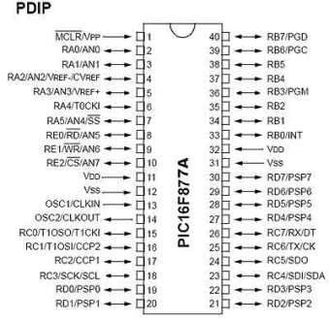](http://i1.wp.com/microcontrollerslab.com/wp-content/uploads/2015/08/PIC16F877A-Pin-configuration.jpg)

**PIN 1: MCLR**

The first pin is the master clear pin of this IC. It resets the microcontroller and is active low, meaning that it should constantly be given a voltage of 5V and if 0 V are given then the controller is reset. Resetting the controller will bring it back to the first line of the program that has been burned into the IC.

[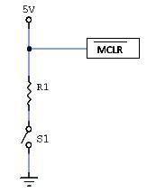](http://i2.wp.com/microcontrollerslab.com/wp-content/uploads/2015/08/PIC16F877A-reset.jpg)

A push button and a resistor is connected to the pin. The pin is already being supplied by constant 5V. When we want to reset the IC we just have to push the button which will bring the MCLR pin to 0 potential thereby resetting the controller.

**PIN 2: RA0/AN0**

PORTA consists of 6 pins, from pin 2 to pin 7, all of these are bidirectional input/output pins. Pin 2 is the first pin of this port. This pin can also be used as an analog pin AN0. It is built in [analog to digital converter](http://microcontrollerslab.com/analog-to-digital-adc-converter-working/).

**PIN 3: RA1/AN1**

This can be the analog input 1.

**PIN 4: RA2/AN2/Vref-**

It can also act as the analog input2. Or negative analog reference voltage can be given to it.

**PIN 5: RA3/AN3/Vref+**

It can act as the analog input 3. Or can act as the analog positive reference voltage.

**PIN 6: RA0/T0CKI**

To timer0 this pin can act as the clock input pin, the type of output is open drain.

**PIN 7: RA5/SS/AN4**

This can be the analog input 4. There is synchronous serial port in the controller also and this pin can be used as the slave select for that port.

**PIN 8: RE0/RD/AN5**

PORTE starts from pin 8 to pin 10 and this is also a bidirectional input output port. It can be the analog input 5 or for parallel slave port it can act as a ‘read control’ pin which will be active low.

**PIN 9: RE1/WR/AN6**

It can be the analog input 6. And for the parallel slave port it can act as the ‘write control’ which will be active low.

**PIN 10: RE2/CS/A7**

It can be the analog input 7, or for the parallel slave port it can act as the ‘control select’ which will also be active low just like read and write control pins.

**PIN 11 and 32: VDD**

These two pins are the positive supply for the input/output and logic pins. Both of them should be connected to 5V.

**PIN 12 and 31: VSS**

These pins are the ground reference for input/output and logic pins. They should be connected to 0 potential.

**PIN 13: OSC1/CLKIN**

This is the oscillator input or the external clock input pin.

**PIN 14: OSC2/CLKOUT**

This is the oscillator output pin. A crystal resonator is connected between pin 13 and 14 to provide external clock to the microcontroller. ¼ of the frequency of OSC1 is outputted by OSC2 in case of RC mode. This indicates the instruction cycle rate.

[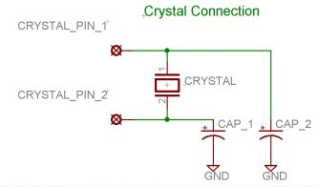](http://i0.wp.com/microcontrollerslab.com/wp-content/uploads/2015/08/crystal-interfacing-with-PIC16F877A.jpg)

**PIN 15: RC0/T1OCO/T1CKI**

PORTC consists of 8 pins. It is also a bidirectional input output port. Of them, pin 15 is the first. It can be the clock input of timer 1 or the oscillator output of timer 2.

**PIN 16: RC1/T1OSI/CCP2**

It can be the oscillator input of timer 1 or the capture 2 input/compare 2 output/ PWM 2 output.

**PIN 17: RC2/CCP1**

It can be the capture 1 input/ compare 1 output/ PWM 1 output.

**PIN 18: RC3/SCK/SCL**

It can be the output for SPI or I2C modes and can be the input/output for synchronous serial clock.

**PIN 23: RC4/SDI/SDA**

It can be the SPI data in pin. Or in I2C mode it can be data input/output pin.

**PIN 24: RC5/SDO**

It can be the data out of SPI in the SPI mode.

**PIN 25: RC6/TX/CK**

It can be the synchronous clock or USART Asynchronous transmit pin.

**PIN 26: RC7/RX/DT**

It can be the synchronous data pin or the USART receive pin.

**PIN 19,20,21,22,27,28,29,30:**

All of these pins belong to PORTD which is again a bidirectional input and output port. When the microprocessor bus is to be interfaced, it can act as the parallel slave port.

**PIN 33-40: PORT B**

All these pins belong to PORTB. Out of which RB0 can be used as the external interrupt pin and RB6 and RB7 can be used as in-circuit debugger pins.

**HOW TO PROGRAM THE INPUT AND OUTPUT PORTS of PIC16F877A**

As we have studied 5 input and output ports namely PORTA, PORTB, PORTC, PORTD and PORTE which can be digital as well as analog. We will configure them according to our requirements. But in case of analog mode, the pins or the ports can only act as inputs. There is a built in A to D converter which is used in such cases. Multiplexer circuits are also used.

But in digital mode, there is no restriction. We can configure the ports as output or as input. This is done through programming.

**3.2.9 LCD**

A liquid-crystal display (LCD) is a [flat-panel display](https://en.wikipedia.org/wiki/Flat_panel_display) or other [electronic visual display](https://en.wikipedia.org/wiki/Electronic_visual_display) that uses the light-modulating properties of [liquid crystals](https://en.wikipedia.org/wiki/Liquid_crystal). Liquid crystals do not emit light directly.

LCD (Liquid Crystal Display) screen is an electronic display module and find a wide range of applications. A 16x2 LCD display is very basic module and is very commonly used in various devices and circuits. These modules are preferred over [seven segments](http://www.engineersgarage.com/content/seven-segment-display) and other multi segment [LED](http://www.engineersgarage.com/content/led)s. The reasons being: LCDs are economical; easily programmable; have no limitation of displaying special & even [custom characters](http://www.engineersgarage.com/microcontroller/8051projects/create-custom-characters-LCD-AT89C51) (unlike in seven segments), [animations](http://www.engineersgarage.com/microcontroller/8051projects/display-custom-animations-LCD-AT89C51) and so on.

A 16x2 LCD means it can display 16 characters per line and there are 2 such lines. In this LCD each character is displayed in 5x7 pixel matrix. This LCD has two registers, namely, Command and Data.

The command register stores the command instructions given to the LCD. A command is an instruction given to LCD to do a predefined task like initializing it, clearing its screen, setting the cursor position, controlling display etc. The data register stores the data to be displayed on the LCD. The data is the ASCII value of the character to be displayed on the LCD. Click to learn more about internal structure of a [LCD](http://www.engineersgarage.com/insight/how-lcd-works).

**Pin Diagram:**

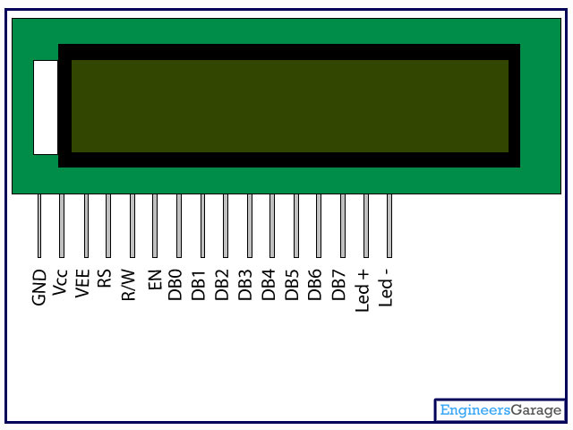

**Pin Description:**

|  |  |  |
| --- | --- | --- |
| Pin No | Function | Name |
| 1 | Ground (0V) | Ground |
| 2 | Supply voltage; 5V (4.7V – 5.3V) | Vcc |
| 3 | Contrast adjustment; through a variable resistor | VEE |
| 4 | Selects command register when low; and data register when high | Register Select |
| 5 | Low to write to the register; High to read from the register | Read/write |
| 6 | Sends data to data pins when a high to low pulse is given | Enable |
| 7 | 8-bit data pins | DB0 |
| 8 | DB1 |
| 9 | DB2 |
| 10 | DB3 |
| 11 | DB4 |
| 12 | DB5 |
| 13 | DB6 |
| 14 | DB7 |
| 15 | Backlight VCC (5V) | Led+ |
| 16 | Backlight Ground (0V) | Led- |

**3.2.10 Load**

Electrical or electronic Components which consume the Electricity are said to be as Loads.

Loads are of different types:

**Resistive Loads**

Resistive loads are loads which consume electrical energy in a sinusoidal manner. This means that the current flow is in time with and directly proportional to the voltage. It is a load that contains no inductance or capacitance, just pure resistance. Therefore; when a resistive load is energized, the current rises instantly to its steady-state value without first rising to a higher value. It includes loads such as incandescent lighting and electrical heaters.

**Inductive Loads**

An Inductive Load is a load that pulls a large amount of current (an inrush current) when first energized. After a few cycles or seconds the current "settles down" to the full-load running current. Inductive loads can cause excessive voltages to appear when switched.

Examples of Inductive Loads are motors, transformers, and wound control gear.

**Capacitive Loads**

A Capacitive Load is an AC electrical load in which the current wave reaches its peak before the voltage. Capacitive loads are loads that capacitance exceeds inductance.

Example of a Capacitive Load is the flash of the camera.

In our project we are dealing with inductive loads because they are the main cause of power factor reduction and harmonic creation. Motors and chokes are been installed in the hardware to produce harmonics and on the other hand these loads induce inductive current into the system which causes the value of power factor to get low.

**How Inductive Loads Decreases the Power Quality.**

When a voltage differential is applied across an inductor’s leads, the inductor converts electricity into an electromagnetic field. When the voltage differential is removed from the leads, the inductor will attempt to maintain the amount of electrical current flowing through it. It will discharge when the electromagnetic field collapses, or if an electrical pathway is created between the two inductor leads.

**Electric Induction Motor**

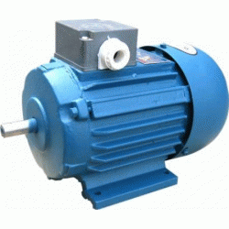

An electricInduction motor is a common example. This load is used to convert electricity into physical work. It generally requires more power to start turning the rotor initially than it requires to keep an already-turning rotor in motion, and when voltage is applied to the leads on an electric motor the motor generates a change in magnetic flux. This change induces an electromotive force that opposes the forward-turning force that would start the motor turning; this phenomenon is called a back electromotive force (EMF). After several seconds, an electric motor will have overcome the some of the impedance caused by a back EMF, and will function as designed.

**Chokes**

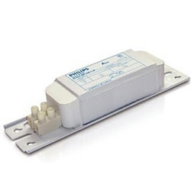

In electronics, a choke is an inductor used to block higher-frequency alternating current (AC) in an electrical circuit, while passing lower-frequency or direct current (DC). A choke usually consists of a coil of insulated wire often wound on a magnetic core, although some consist of a donut-shaped "bead" of ferrite material strung on a wire. The choke's impedance increases with frequency. Its low electrical resistance passes both AC and DC with little power loss, but it can limit the amount of AC due to its reactance.

**3.3 General Working**

The working of the hardware prototype is very simple and straightforward. Our project is a prototype which is being working on 220 V AC. This Hardware prototype is basically designed to improve and control the Power Factor (PF) and minimize the Harmonic distortion. The 220 V AC is supplied to this hardware prototype which is immediately isolated by means of an Isolator Transformer. The primary side the of Isolated Transformer is connected in series with the main WAPDA power source of 220 V AC and the secondary of this Isolated Transformer is connected to our hardware prototype. The main purpose of the Isolated Transformer in this project is that it will isolate the WAPDA supply line from our Hardware prototype without changing the voltage level. After isolating the 220 V AC is then supplied to the Hardware prototype and will then be stepped down to 12 V AC using a 220/12 V AC Transformer. This stepped down voltage is then converted into DC using a diode bridge rectifier. Ripples of DC are minimized using 680 and 470 micro Farad Capacitors. The main purpose of stepping the voltage level down from 220 V AC to 12 V DC is to provide an operating voltage to the PIC 16F877A Microcontroller. This block of the Hardware Prototype also consists of Current and Potential Transformers which are installed to measure the Current and voltage of the secondary side of the isolated Transformer at no Load condition. LEDs are also connected on this Block to show ON and OFF behavior of CT PT and the Micro Controller. Let now the load to be applied by turning on the switches connected in series with the Load. The load Installed in this Hardware Prototype is purely Inductive comprising of an Electric Induction Motor and an Electric Choke. The motor is approximately ¾ HP and the Chokes, 6 in number are of 40 Watt each. The load is approximately being maintained at 800 Watt. When the Load is turned on step by step the micro controller senses the reduction in Power Factor and the harmonic distortion. The Controller is programmed to sense the Harmonics and the increase or decrease of the Power Factor. The controller is directly connected to the Thyristor kit which will act as a switch and make the Capacitor Banks ON according to the distortions produced. The Capacitor Banks and Harmonic Filter Comprising of an RLC circuitry is connected in parallel to the Load. The thyristor Or SCR is installed on a kit. This kit works as a relay and switches the Capacitor Banks and the Harmonic Filters according to the produced amount Harmonics and reduction in the Power Factor. An LCD and (16x2) and a Personal Computer is also connected with this hardware prototype which will show the Current, Voltage, Power Factor (PF) and total harmonic distortion before and after applying the Load and clear improvement of Power factor and minimization of Harmonics can be seen.

**Chapter No 4**

**Results and Discussion**

This chapter is devoted to experimental results and their interpretation, together with the conclusions and summary of the Details provided in the above chapters. Basically the project was based and circling around the two main points: Improvement of Power Factor and Controlling of Harmonic Distortion. By controlling these two points one can improve the Power Quality of the system. Different techniques and methods were provided in above chapters to improve the Power Quality and one of them was implemented on Hardware and Software as a prototype to elaborate our ideas. Positive and effective results were obtained on the Software and Hardware as well. Some deviation between Software and Hardware results were observed during testing due to some ideal and non-ideal conditions showed by the components when tested on software and Hardware respectively. The Hardware portion is based on a 220 V prototype, which can further be implemented on higher Voltage Levels by increasing or decreasing the Ratings of the components installed on it. Moreover some other necessary protection components are to be needed to implement it on higher scales. This chapter will summarize the whole concept and will show the achievements obtained by elaborating the Results positively.

It is never economic to attempt to improve the power factor to unity, since the nearer the approach to unity the more KVAR that must be installed for a given improvement.

**Disadvantages of low power factor**

Many engineers are oblivious to the effects of low power factor. They view it only as a direct charge on their electrical bill, and only when stated as such. Low power factor is a direct cost to the utility company and must be paid for.

**Direct costs of low power factor**

Power factor may be billed as one of or combination of, the following:

1. A penalty for power factor below and a credit for power factor above a predetermined value,
2. An increasing penalty for decreasing power factor,
3. A charge on monthly KVAR Hours,
4. KVA demand: A straight charge is made for the maximum value of KVA used during the month. Included in this charge is a charge for KVAR since KVAR increase the amount of KVA.

**Indirect costs of low power factor**

Loss in efficiency of the equipment: When an installation operates with a low power factor, the amount of useful power available inside the installation at the distribution transformers is considerably reduced due to the amount of reactive energy that the transformers have to carry. The figure below indicates the available actual power of distribution equipment designed to supply 1000 KW.

**Size of capacitor bank**

Capacitors are rated in kilovars or KVAR. Common sizes are 1, 2, 3, 4, 5, 6, 7, 8, 10/12/15/20 and 25 KVAR at 415 or 440V alternating current, 3 phase, 50 Hz. Usually more than one capacitor is required give the desired degree of power factor correction. Groups of capacitors are factory assembled in various configurations. Standard capacitor ratings are designed for 50 or 60Hz operation. When operated at less than nameplate frequency of 50 or 60Hz, the actual KVAR attained will be less than rated KVAR. If the operating voltage is less than the rated voltage, a reduction in the nameplate KVAR will be realized. The following equation defines the relation:KVAR=2f CE2 X 10-3

C= 

**Table - 1**

|  |  |  |  |  |
| --- | --- | --- | --- | --- |
|  |  |  |  |  |
| **MOTOR SIZE** |  | **CORRECTION** |  | **CAPACITOR FUSING** |
| **(KW)** |  | **(KVAR)** |  | **(Amps)** |
|  |  | |  | |
| **3.0** |  | **1.5** |  | **4** |
|  |  | |  | |
| **4.0** |  | **2.0** |  | **4** |
|  |  | |  | |
| **5.5** |  | **2.5** |  | **6** |
|  |  | |  | |
| **7.5** |  | **3.0** |  | **6** |
|  |  | |  | |
| **11** |  | **5.0** |  | **10** |
|  |  | |  | |
| **15** |  | **6.25** |  | **16** |
|  |  | |  | |
| **18.5** |  | **8.0** |  | **16** |
|  |  | |  | |
| **22** |  | **10.0** |  | **20** |
|  |  | |  | |
| **30** |  | **12.5** |  | **25** |
|  |  | |  | |
| **37** |  | **15.0** |  | **32** |
|  |  | |  | |
| **45** |  | **15.0** |  | **32** |
|  |  | |  | |
| **55** |  | **20.0** |  | **40** |
|  |  | |  | |
| **75** |  | **20.0** |  | **40** |
|  |  | |  | |
| **90** |  | **25.0** |  | **50** |
|  |  | |  | |
| **110** |  | **25.0** |  | **50** |
|  |  | |  | |
| **132** |  | **30.0** |  | **63** |
|  |  | |  | |
| **150** |  | **35.0** |  | **80** |
|  |  | |  | |
| **185** |  | **40.0** |  | **80** |
|  |  | |  | |
| **220** |  | **45.0** |  | **100** |
|  |  | |  | |
| **250** |  | **50.0** |  | **100** |
|  |  |  |  |  |

**Important Considerations for Static Power Factor Correction**

As a large proportion of the inductive or lagging current on the supply is due to the magnetizing current of induction motors, it is easy to correct each individual motor by connecting the correction capacitors to the motor starters. With static correction, it is important that the capacitive current is less than the inductive magnetizing current of the induction motor. In many installations employing static power factor correction, the correction capacitors are connected directly in parallel with the motor windings. When the motor is ‘Off Line’, the capacitors are also ‘Off Line’. When the motor is connected to the supply, the capacitors are also connected providing correction at all times that the motor is connected to the supply. This removes the requirement for any expensive power factor monitoring and control equipment. In this situation, the capacitors remain connected to the motor terminals as the motor slows down.

**Providing Static Correction**

Static correction is commonly applied by using one contactor to control both the motor and the capacitors. It is better practice to use two contactors, one for the motor and one for the capacitors. Where one contactor is employed, it should be up sized for the capacitive load. The use of a second contactor eliminates the problems of resonance between the motor and the capacitors.

**Harmonic Distortion and Power Factor Correction**

The rapid increase of semiconductor technology in electrical systems has led to a phenomenon known as ‘Harmonics’. Solid-state electronic devices and other non-linear electronic loads that alter or control electrical power produce harmonics. Harmonics is referred to as the frequencies that are integer multiples of the fundamental line frequency of 60Hz. These non-linear loads include: adjustable speed drives, programmable controllers, induction furnaces, computers, and uninterruptible power supplies.

**Linear loads**

Linear loads occur when the impedance is constant; then the current is proportional to the voltage -- a straight-line graph, as shown in Figure below. Simple loads, composed of one of the elements do not produce harmonics

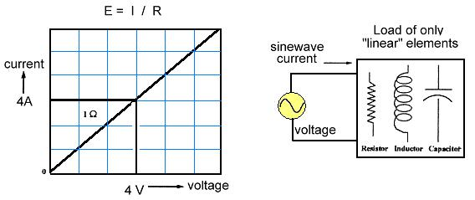

**Non-linear loads**

Non-linear loads occur when the impedance is not constant; then the current is not proportional to the voltage -- as shown in Figure below. Combinations of the components normally create non-linear loads and harmonics.

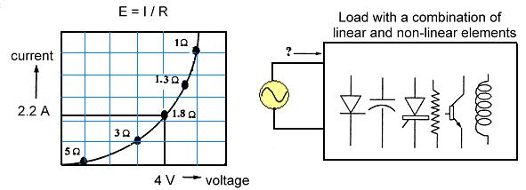

**The Cause:**

The non-linear loads (electronic systems) dramatically increase harmonic noise on the line side of the power distribution plant, which impacts the whole electrical distribution system. Typical examples of non-linear loads (harmonic sources) are:

* Electronic Switching Power Converters
* Computers
* Uninterruptible power supplies (UPS)
* Solid-state rectifiers
* Electronic process control equipment, PLC’s, etc

**Arcing Devices**

* Discharge lighting, e.g. Fluorescent, Sodium and Mercury vapor
* Arc furnaces
* Welding equipment
* Electrical traction system

**Ferromagnetic Devices**

* Transformers operating near saturation level
* Magnetic ballasts (Saturated Iron core)
* Induction heating equipment
* Chokes

**Appliances**

* TV sets, air conditioners, washing machines, microwave ovens & vacuum cleaners
* Fax machines, photocopiers, printers

**The Effect:**

Harmonics have detrimental effect on the electrical power system in a facility. Overheated neutrals, hot circuit breakers, unexpected breaker tripping, dangerously hot transformers, unexplainable equipment malfunctions, spurious system lockup, and more are now common problems in many facilities. These problems can cause financial losses through added maintenance cost, staff downtime and interrupted production.

**Signs of Harmonic Distortion Problems**

* Overheating of motors and transformers
* Frequent tripping of circuit breakers
* Frequent fuse blowing
* Capacitor failures
* Overloading of transformer neutral
* Failure or malfunctioning of computers, motor drives, lighting circuits and other sensitive loads.

If any of these conditions exist in your facility an analysis of your system will pinpoint the problem.

**Harmonics and Power Factor Capacitors**

With the non-linear loads it is very difficult to correct for poor power factor without increasing existing harmonic distortions thereby we trade one problem for another. The simple answer is to treat both problems at once. The harmonics lead to a higher capacitor current, because the higher frequencies are attracted to the capacitors. The impedance of the capacitor decreases as the frequencies increases. If the frequency of such a resonating circuit is close enough to harmonic frequencies, the resulting circuit amplifies the oscillations and leads to immense over currents and over voltages above the specified limits.

Capacitors do not generate harmonics but under certain conditions they can amplify existing harmonics of the systems. Important precautions must be undertaken when selecting the capacitors. If capacitor is installed in a circuit with harmonics normally it should be equipped with 6% series reactor respectively. For a circuit with significantly 5th harmonic, it should be equipped with 8% series reactor accordingly. For the circuit with 3rd harmonic like arc furnaces, it should be equipped with 13% series reactors. For the capacitor installed as non-fixed used it should be equipped with 6% series reactors. If the capacitor is equipped with reactors its rated voltage should be increased 15% - 20% to insure safety and extend lifetime of capacitor.

For the minimizing occurrence of harmonic resonance, the resonant harmonic of the system including the capacitor should be estimated.

In **three-phase systems**, low voltage systems, harmonic values of 5, 7, 11, 13, 17, 19 etc should be avoided as they correspond to the characteristic harmonics of non-linear loads respectively. This includes all of the odd harmonics, except for the multiples of three.

Examples of such devices are variable speed and variable frequency AC drives, DC drives, three phase power controlled furnaces and many other types of industrial equipment.

In **single-phase**, low-voltage systems, generally exhibit the following harmonics like 3, 5, 7, 9, 11, 13 etc. This includes all of the odd harmonics. Examples of such devices are those usually powered by switch mode power supplies such as personal computers, fluorescent lighting, and a myriad of other equipment found in the modern offices. It also includes equipment found in hospitals, TV and radio stations, and control rooms of large processing plants. The harmonics from these devices are generally richest at the third harmonic and continually decrease as the harmonic number increases.

**Options to Reduce Harmonics**

Harmonic levels or orders that exceed the recommended values set forth by IEEE 519 1992 should be removed through harmonic filtering. Failure to address these harmonic issues may lead to problems on the electrical distribution systems. Active Harmonic Power Correction Filters is a solution to the problems. By truly canceling the harmonic component the true fundamental becomes the only component that is reflected back to the line.

Once identified the resonant harmonics can be avoided in several ways as we will discuss as under

**1.** **Change the applied KVAR to avoid unwanted harmonics**

Although this is the least expensive way to avoid resonant harmonics, it is not always successful because typically some portion of the applied KVAR is switched on and off as load conditions require. The calculation of system harmonics should be repeated several times for each level of compensation. Adjusting the size of the capacitor may be important to avoid the harmonic values.

**2. Add harmonic filter**

In order to filter harmonics at a specific site or situation the tuned harmonic filters can be applied. A capacitor is connected in series with an inductor such that the resonant frequency of the filter equals the harmonic to be eliminated. Tuned filters should never be applied without a detailed analysis of the system. The currents expected to flow in the filter are difficult to predict and are a complex function of the system and load characteristics.

**3. Add blocking inductor**

Inductors added to the lines feeding the capacitor can be sized to block higher than 4th harmonic currents in the systems. This specific method protects the capacitor from the harmonics but does not eliminate the harmonics of the main concern from the system. A system study is required to determine correct ratings for the capacitor and inductors.

**Harmonic Limits in Electric Power Systems (IEEE 519 1992)**

The harmonic voltage limitations set forth by IEEE 519 1992 are as follows

1. Maximum Individual Frequency Voltage Harmonic that is 3%
2. Total Harmonic Distortion of the Voltage that is 5%

Harmonic limitations have been established by IEEE 519-1992 for the following reasons

* To limit the damage to power factor correction capacitors and harmonic filter systems caused by excessive harmonics
* To prevent series or parallel resonance in the electrical system
* To keep the level of harmonics at the PCC (Point of Common Coupling) from being excessive and distorting the system voltage and damaging other equipment on the system.The PCC is defined as the electrical connecting point or interface between the utility distribution system and the customer's electrical distribution system.

**Benefits of Power Factor Correction**

**Benefit 1 - Reduce Utility Power Bills**

In areas where a KVA demand clause or some other form of low power factor penalty is incorporated in the electric utility's power rate structure, removing system KVAR improves the power factor, reduce power bills by reducing the KVA. Most utility bills are influenced by KVAR usage.

**Benefit 2 – Increase System Capacity**

The power factor improvement releases system capacity and permits additional loads (motors, lighting, etc.) to be added without overloading the system. In a typical system with a 0.80 PF, only 800 KW of productive power is available out of 1000 KVA installed. By correcting the system to unity (1.0 PF), the KW = KVA. Now the corrected system will support 1000 KW, versus the 800 KW at the .80 PF uncorrected condition; an increase of 200 KW of productive power. This is achieved by adding capacitors which furnish the necessary magnetizing current for induction motors and transformers. Capacitors reduce the current drawn from the power supply; less current means lesser load on transformer

Then feed circuits. Power factor correction through devices such as capacitors can avoid an investment in more expensive transformers, switchgear and cable, otherwise required to serve additional load. The figure below shows the empirical relationship of system capacity vs. power factor. From the figure one can see that improving power factor from .8 to .9 or .8 to .95 shall release approximately 12% or 20% system capacity respectively.

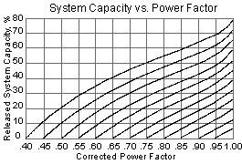

**Benefit 3 - Improve System Operating Characteristics (Gain Voltage)**

A good power factor (0.95) provides a stiffer voltage, typically a 1-2% voltage rise can be expected when power factor is brought to -0.95 or +0.95. Excessive voltage drops can make your motors sluggish, and cause them to overheat. Low voltage also interferes with lighting, the proper application of motor controls and electrical and electronic instruments. Motor performance is improved and so is production.

**Benefit 4 - Improve System Operating Characteristics**

Improving power factor at the load points shall relieve the system of transmitting reactive current. Less current shall mean lower losses in the distribution system of the facility since losses are proportional to the square of the current (I2R). Therefore, fewer kilowatt-hours need to be purchased from the utility.

**Analysis of the project by Oscilloscope**

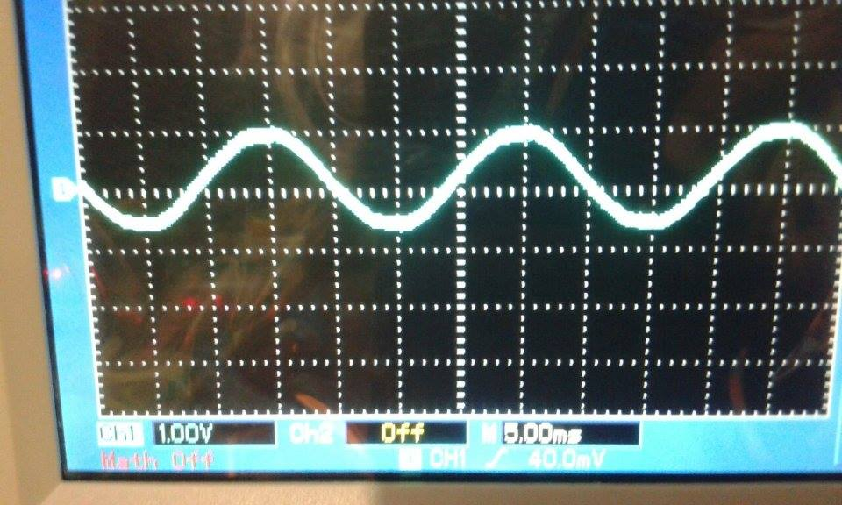

**Sinosoidal wave of our system-before introducing harmonics**

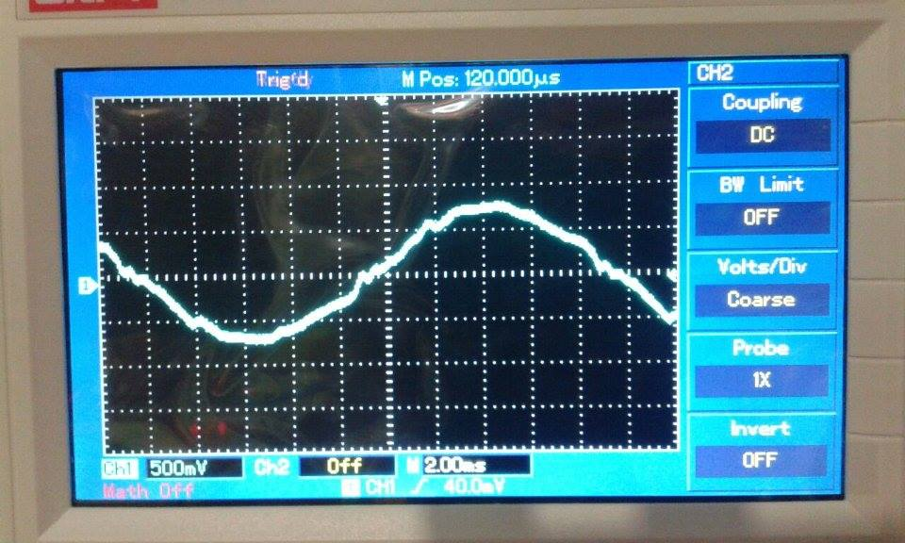

**Harmonics formation clearly visible**

**Conclusions**

Depending on your utility and geographic area, a power factor less than 90% will be penalized, and although there are no penalties paid for the level of harmonics, their presence in the system can be far more costly than the Power Factor penalties. System harmonics should be considered when applying power factor correction capacitors.

Active Harmonic Filters with power correction can:

* Reduce energy costs
* Increase personnel performance and productivity
* Create energy savings from 5% to 20%
* Avoid utility penalties up to an additional 20%
* Create an economic payback in 1.5 to 3.0 year.