Experiment 6
To check the operation of 2 to 4-line decoder
Objective
In this lab students will
- Check the operation of 2 to 4-line decoder using IC74LS139.
- Implementation of half adder with 2 to 4-line decoder using IC LS74139.
Components
- IC74LS139×1
- IC74LS00×1
- AM2000 TRAINER
- Multimeter
- Cutter
- Single core wire
- Pair of Pliers
Theory
Binary Decoder
Binary Decoder is another combinational logic circuit constructed from individual logic gates and is the exact opposite to that of an Encoder. The name “Decoder” means to translate or decode coded information from one format into another, so a binary decoder transforms “n” binary input signals into an equivalent code using 2^{n} outputs. Binary Decoders are another type of digital logic device that has inputs of 2-bit, 3-bit or 4-bit codes depending upon the number of data input lines, so a decoder that has a set of two or more bits will be defined as having an n-bit code, and therefore it will be possible to represent 2^{n} possible values. Thus, a decoder generally decodes a binary value into a non-binary one by setting exactly one of its n outputs to logic “1”.
If a binary decoder receives n inputs (usually grouped as a single Binary or Boolean number) it activates one and only one of its 2^{n} outputs based on that input with all other outputs deactivated.
A 2-to-4 Binary Decoders
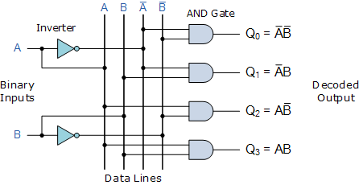
Truth Table
x | y | E | d₀ |  | d₁ | d₂ | d₃
0 | 0 | 1 | 1 | 0 |  | 0 | 0
0 | 1 | 1 | 0 | 1 |  | 0 | 0
1 | 0 | 1 | 0 | 0 |  | 1 | 0
1 | 1 | 1 | 0 | 0 |  | 0 | 1

This simple example above of a 2-to-4 line binary decoder consists of an array of four AND gates. The 2 binary inputs labelled A and B are decoded into one of 4 outputs, hence the description of 2-to-4 binary decoder. Each output represents one of the min-terms of the 2 input variables, (each output = a min-term). The binary inputs A and B determine which output line from Q0 to Q3 is “HIGH” at logic level “1” while the remaining outputs are held “LOW” at logic “0” so only one output can be active (HIGH) at any one time. Therefore, whichever output line is “HIGH” identifies the binary code present at the input, in other words it “de-codes” the binary input.
Procedure:
- Connect the AM2000 trainer to the 220V AC power supply
- Turn on the trainer and verify the voltage of the power supply using the multimeter. It should be +5V exactly.
- Install IC74LS139 on the trainer’s board.
- Wire the circuit according to the diagram by consulting gate IC’s diagram.
- Use any of the two logic switches from S2 to S9 for inputs A and B respectively.
- For output indication use any of the LED’s from L0 to L15.
- Supply the +5v and GND to the pins 14 and 7 of the IC respectively.
- Test all the possible combinations of inputs and verify the output according to the truth tables of half adder and full adder.
- Make truth table according to the results.
In case of trouble:
- Check the power supply.
- Check the Vcc and GND at pins 14 and 7 respectively.
- Check all the wire connections.
- Check the circuit wiring and remove the breaks.
- Check the IC using truth table.
Pin configuration of IC 74LS139 diagram

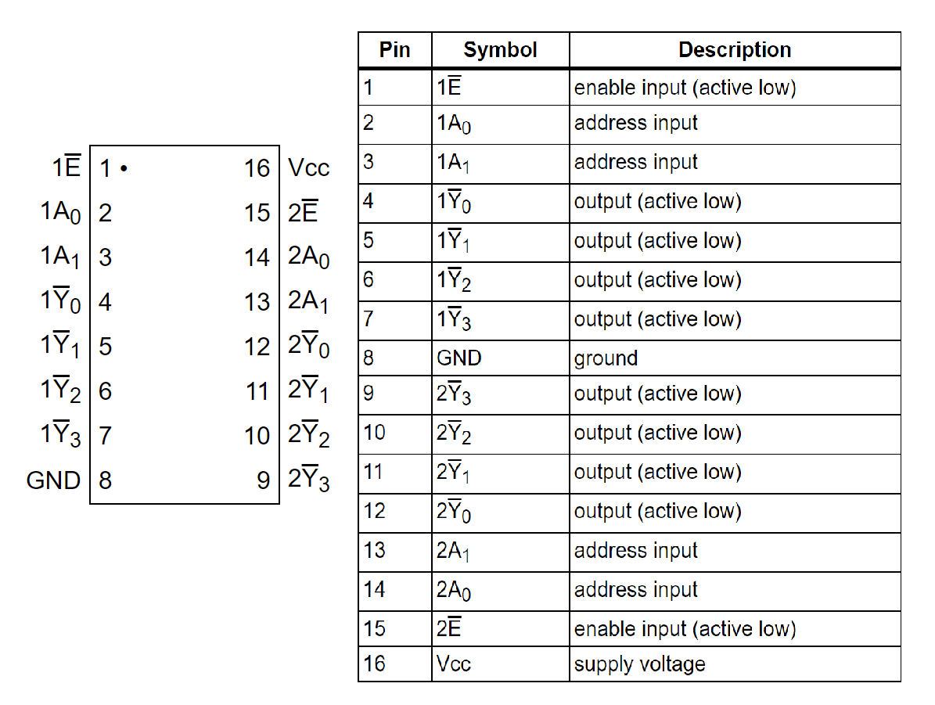
Block Diagram of Half Adder with Truth Table of 2X4 Decoder

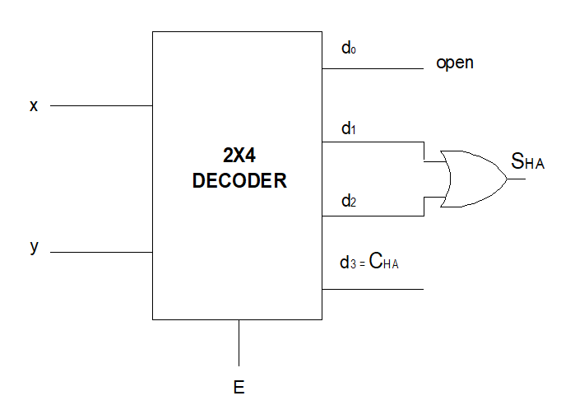
Exercise
Determine the relation between 2 to 4-line decoder and half adder circuit.
__________________________________________________________________________________________________________________________________________________________________________________________________________________________________________________________________________________________________________________________________________________________________________________________________________________________________________________________________________________________________________________________________________________________________
Design the circuit for full adder using 2 to 4-line decoder.

Conclusion
______________________________________________________________________________________________________________________________________________________________________________________________________________________________________________________________________________________________________________________________________________________________________________________________________

