Experiment 7
To design and analyze the operation of 1 to 2-line multiplexer
Objective
In this lab students will
- Analyze the operation of 1 to 2-line multiplexer using IC74LS157 or IC74LS158.
- Design a combinational circuit and implement it with the multiplexer.
Components
- IC74LS157×1 or
- IC74LS158×1
- AM2000 TRAINER
- Multimeter
- Cutter
- Single core wire
- Pair of Pliers
Theory:
Multiplexer is a device that has multiple inputs and a single line output. The select lines determine which input is connected to the output, and also to increase the amount of data that can be sent over a network within certain time. It is also called a data selector. For n select lines, we have 2^{n} input lines.
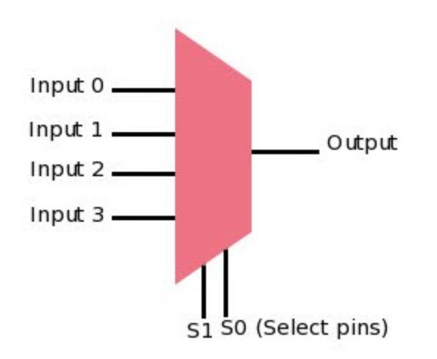

Multiplexer Types
Multiplexers are classified into four types:
- 2-1 multiplexer (1select line)
- 4-1 multiplexer (2 select lines)
- 8-1 multiplexer (3 select lines)
- 16-1 multiplexer (4 select lines)

IC diagram of 74LS157

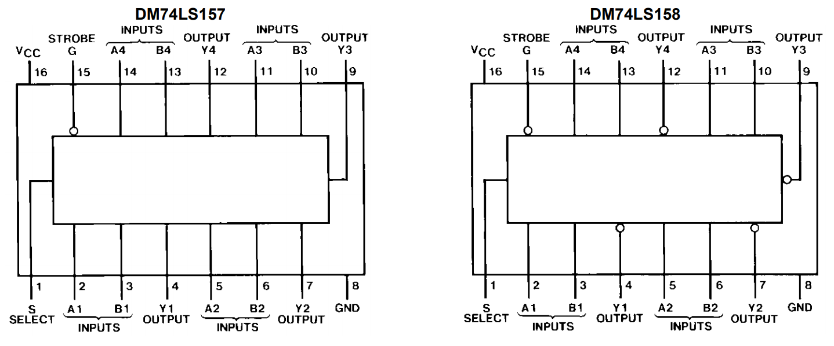

Truth Table
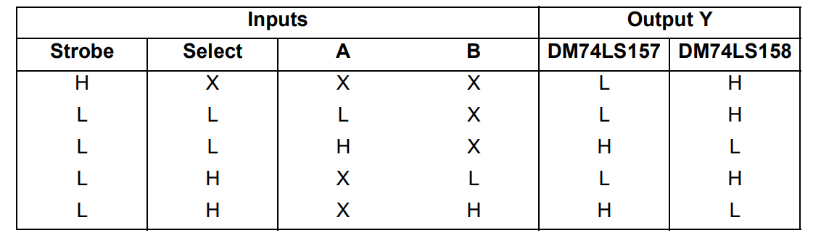
Procedure:
- Connect the AM2000 trainer to the 220V AC power supply
- Turn on the trainer and verify the voltage of the power supply using the multimeter. It should be +5V exactly.
- Install IC74LS157 or IC74LS158 on the trainer’s board.
- Wire the circuit according to the diagram by consulting gate IC’s diagram.
- Use any of the two logic switches from S2 to S9 for inputs A and B respectively.
- For output indication use any of the LED’s from L0 to L15.
- Supply the +5v and GND to the pins 14 and 7 of the IC respectively.
- Test all the possible combinations of inputs and verify the output according to the truth tables of 2 to 1-line multiplexer.
- Make truth table according to the results.
In case of trouble:
- Check the power supply.
- Check the Vcc and GND at pins 14 and 7 respectively.
- Check all the wire connections.
- Check the circuit wiring and remove the breaks.
- Check the IC using truth table.
Truth Table [5]
Input |  |  |  | Output
Strobe | Select | 1A | 1B | 1Y
Exercise
Design and analyze the 3 input XOR gate using 2 to 1 line multiplexers. [5]
______________________________________________________________________________________________________________________________________________________________________________________________________________________________________________________________________________________________________________________________________________________________________________________________________________________________________________________________________________________________________________________________________________________________________________________________________________________________________________________________________________________________________________________________

Implement the following Boolean function with 4 to 1-line multiplexer. [5]
$$F\left(A,B,C\right)=\sum{(1,2,5,6)}$$
______________________________________________________________________________________________________________________________________________________________________________________________________________________________________________________________________________________________________________________________________________________________________________________________________________________________________________________________________________________________________________________________________________________________________________________________________________________________________________________________________________________________________________________________
________________________________________________________________________________________________________________________________________________________________________________________________________________________________________________________________________________________________________________________________________________________________________________________________________________________________________________________________________________________________________________________________________________________________________________________________________________________________________________

Read the data sheet of IC74LS158 and mention the role of strobe input. [3]
________________________________________________________________________________________________________________________________________________________________________________________________________________________________________________________________________________________________________________________________________________________________________________________________________________________________________________________________________________________________________________________________________________________________________________________________________________________________________________

What are the applications of multiplexers? [3]
____________________________________________________________________________________________________________________________________________________________________________________________________________________________________________________________________________________________________________________________________________________________________________________________________________________________________________________________________________________
Conclusion [5]
____________________________________________________________________________________________________________________________________________________________________________________________________________________________________________________________________________________________________________________________________________________________________________________________________________________________________________________________________________________

