Experiment 5
To design half adder, full adder, half subtractor and full subtractor circuits
Objective
In this lab students will learn
- How to design half adder, full adder, circuit using XOR and AND gates?
- How to design half subtractor and full subtractor circuit using XOR, AND and OR gates?
Components
- IC74LS86×1
- IC74LS08×1
- IC74LS32×1
- AM2000 TRAINER
- Multimeter
- Cutter
- Single core wire
- Pair of Pliers

Theory:

Half Adder and Full Adder Circuit
An adder is a digital circuit that performs addition of numbers. The half adder adds two binary digits called as augend and addend and produces two outputs as sum and carry; XOR is applied to both inputs to produce sum and AND gate is applied to both inputs to produce carry. The full adder adds 3 one bit numbers, where two can be referred to as operands and one can be referred to as bit carried in. And produces 2-bit output, and these can be referred to as output carry and sum.
Half Adder:
By using half adder, you can design simple addition with the help of logic gates.

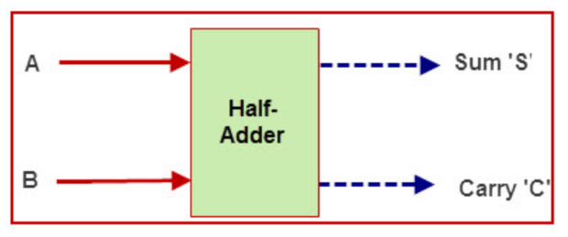

Full Adder:
The difference between a half-adder and a full-adder is that the full-adder has three inputs and two outputs, whereas half adder has only two inputs and two outputs. The first two inputs are A and B and the third input is an input carry as C-IN.
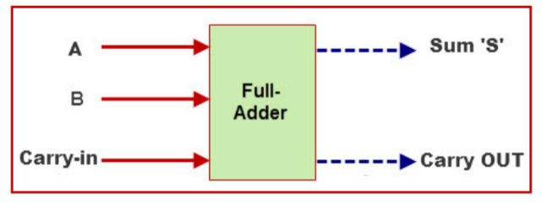
Full adder circuit can be designed using two half adders as shown in the figure below.
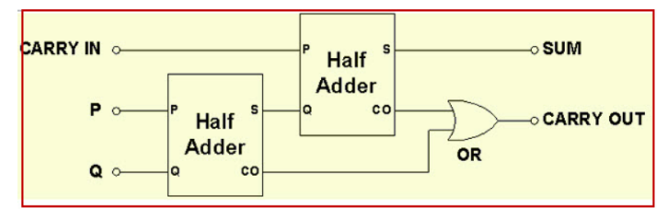
Half subtractor:
The half-subtractor is a combinational circuit which is used to perform subtraction of two bits. It has two inputs, X (minuend) and Y (subtrahend) and two outputs D (difference) and B (borrow). The logic symbol is shown below.
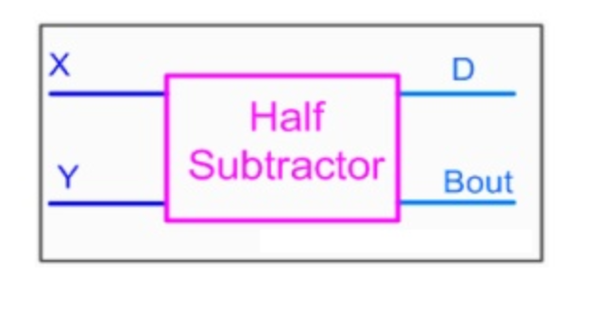

Full Subtractor
A full subtractor is a combinational circuit that performs subtraction involving three bits, namely minuend, subtrahend, and borrow-in. The logic symbol is shown below.

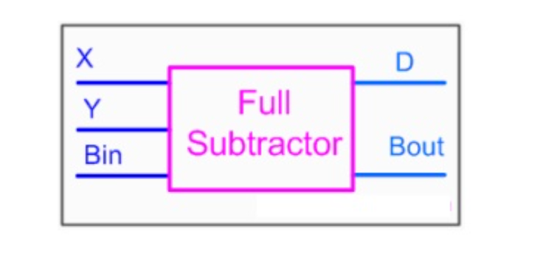
Procedure:
- Connect the AM2000 trainer to the 220V AC power supply
- Turn on the trainer and verify the voltage of the power supply using the multimeter. It should be +5V exactly.
- Install IC74LS02 and IC74LS04 on the trainer’s board.
- Wire the circuit according to the diagram by consulting gate IC’s diagram from previous manuals.
- Use any of the two logic switches from S2 to S9 for inputs A and B respectively.
- For output sum and carry indication use any two of the LED’s from L0 to L15.
- Supply the +5v and GND to the pins 14 and 7 of the IC respectively.
- Test all the possible combinations of inputs and verify the output according to the truth tables of half adder, full adder, half subtractor and full subtractor.
- Make truth table according to the results.
- This experiment can also be implemented using NAND gates only by replacing XOR gate by its NAND gate equivalent circuit.
In case of trouble:
- Check the power supply.
- Check the Vcc and GND at pins 14 and 7 respectively.
- Check all the wire connections.
- Check the circuit wiring and remove the breaks.
- Check the IC using truth table.

Truth Table: [5]
Half Adder
A | B | Sum | Carry

Full Adder
A | B | C-IN | Sum | Carry-out

Half Subtractor [5]
A | B | Difference | Borrow

Full Subtractor

A | B | B-IN | Difference | Borrow

Exercise:
1-Draw the possible equivalent logic diagrams of half Adder circuit and derive its expression. [5]

2-Draw the possible equivalent logic diagrams of full Adder circuit and derive its expression. [5]

Conclusion: [3]
__________________________________________________________________________________________________________________________________________________________________________________________________________________________________________________________________________________________________________________________________________________________________________________________________________________________________________________________________________________________________________________________________________________________________
Open-Ended Lab (5)
The Code converter is used to convert one type of binary code to another. There are different types of binary codes like BCD code, gray code, excess-3 code, etc. Different codes are used for different types of digital applications. To get the required code from any one type of code, the simple code conversion process is done with the help of combinational circuits.
Design a BCD to Excess-3 code converter circuit, implement it in Lab and show all steps in detail.

