Experiment 1
Verify the truth table of AND, OR, and NOT gate
Objective
In this lab students will verify
- The truth table of AND gate
- The truth table of OR gate
- The truth table of NOT gate
Components
- IC74LS08×1
- IC74LS32×1
- IC74LS04×1
- AM2000 TRAINER
- Multimeter
- Cutter
- Single core wire
- Pair of Pliers
Task 1:
To check the operation of AND gate according to the AND’s truth table using 74LS08 IC.
AND gate
The AND gate is an electronic circuit that gives a high output (1) only if all its inputs are high. A dot (.) is used to show the AND operation i.e. A.B. Bear in mind that this dot is sometimes omitted i.e. AB

Procedure:
- Connect the AM2000 trainer to the 220V AC power supply
- Turn on the trainer and verify the voltage of the power supply usin the multimeter. It should be +5V exactly.
- Install IC74LS08 on the trainer’s board.
- Wire the circuit according to the diagram by consulting AND gate IC’s diagram shown below.
- Use any of the two logic switches from S2 to S9 for inputs A and B respectively.
- For output indication use any of the LED’s from L0 to L15.
- Supply the +5v and GND to the pins 14 and 7 of the IC respectively.
- Test all the possible combinations of inputs and verify the output according to the truth table of AND gate.
- Make truth table according to the results.
- Similarly replace the IC’s and check their gates.
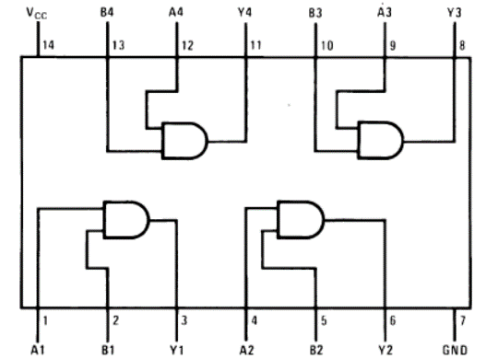
Figure 1AND Gate IC 74LS08
In case of trouble:
- Check the power supply.
- Check the Vcc and GND at pins 14 and 7 respectively.
- Check all the wire connections.
- Check the circuit wiring and remove the breaks.
- Check the IC using truth table.

Draw AND gate symbol (1)

Truth Table (2)
Input (X) | Input (Y) | Output

Task 2:
To check the operation of OR gate according to the OR’s truth table using 74LS32 IC.
OR gate
The OR gate is an electronic circuit that gives a high output (1) if one or more of its inputs are high. A plus (+) is used to show the OR operation.

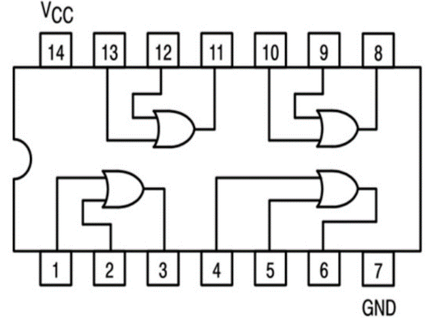
Figure 2 OR gate IC 74LS32
Draw OR gate symbol (1)

Truth Table (2)
Input (X) | Input (Y) | Output

Task 3:
To check the operation of NOT gate according to the NOT’s truth table using 74LS04 IC.
NOT gate
The NOT gate is an electronic circuit that produces an inverted version of the input at its output. It is also known as an inverter. If the input variable is A, the inverted output is known as NOT A. This is also shown as A', or A with a bar over the top.
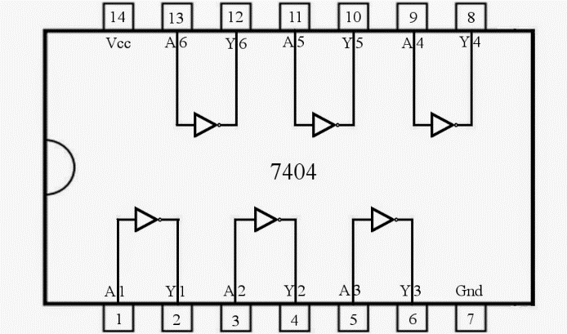
Figure 3 NOT gate IC 74LS04
Draw NOT gate symbol (1)

Truth Table (2)
Input (X) | Input (y) | Output

Conclusion (2)
______________________________________________________________________________________________________________________________________________________________________________________________________________________________________________________________________________________________________________________________________________________________________________________________________

