Lab-6
Serialization of data and BCD and ASCII conversion in PIC
Objective:
In this lab students will learn
- How to implement of serialization of data in PIC using rotate instructions.
- How to perform conversion between BCD and ASCII?
Theory
There are four types of rotate instructions in PIC microcontroller that are: RRCF, RRNCF, RLCF, RLNCF. This will allow the contents of file registers to rotate right or left. Two types of rotations are possible: first is without carry and the second is through carry flag of status register. Each of these instructions is shown below:
RRNCF
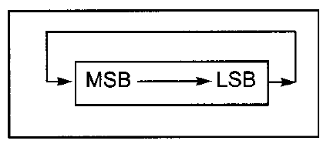
RLNCF
RRCF
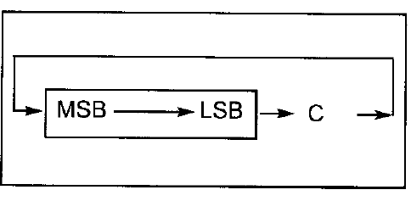
RLCF
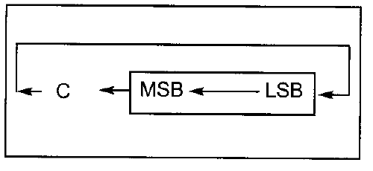
Lab Exercise
Run all questions on MPLAB and show the contents of the relevant registers.
Find the contents of WREG register after each of the following are executed. [4]
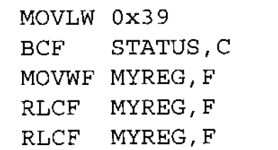
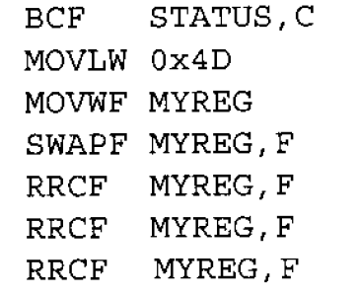
______________________________________________________________________________________________________________________________________________________________________________________________________________________________________________________________________________________________________________________________________________________________________________________________________________________________________________________________________________________________________________________________________________________________________________________________________________________________________________________________________________________________________________________________
Write a program to find the number of zeros in a byte of data. [4]
______________________________________________________________________________________________________________________________________________________________________________________________________________________________________________________________________________________________________________________________________________________________________________________________________________________________________________________________________________________________________________________________________________________________________________________________________________________________________________________________________________________________________________________________
[5]
____________________________________________________________________________________________________________________________________________________________________________________________________________________________________________________________________________________________________________________________________________________________________________________________________________________________________________________________________________________________________________________________________________________________________________________________________________________________________________________________________________________________________________________________________________________________________________________________________________________________________________________________________________________________________________________________________________________________________________________________________________________________________________________________________________________________________________________________________________________________________________________________________________________________________________________________________________________________________________________________________________________________________________________________________________________________________________________________
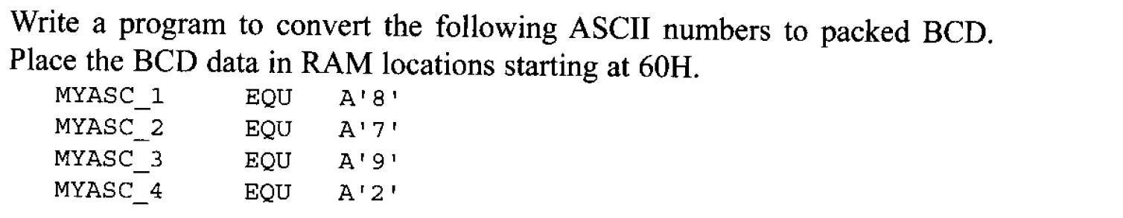[5]
________________________________________________________________________________________________________________________________________________________________________________________________________________________________________________________________________________________________________________________________________________________________________________________________________________________________________________________________________________________________________________________________________________________________________________________________________________________________________________________________________________________________________________________________________________________________________________________________________________________________________________________________________________________________________________________________________________________________________________________________________________________________________________________________________________________________________________________________________________________________________________________________________________________________________________________________________________________________________________________________________________________________________________________________________________________________________________________________________________________________________________________________________________________________________________________________________________________________________________________________________________________________________________________________________________________________________________________________________________________________________________________________________________________________________________________________________________________________________________________________________________________________________________________________________________________________________________________________________________________________________________________________________________________________________________________________________________________________________________________________________________________________________________________________________________________________________________________________________________________________________________________________________________________________________________________________________________________________________________________________________________________________________________________________________________________________________________________________________________________________________________________________________________________________________________________
Conclusion [2]
____________________________________________________________________________________________________________________________________________________________________________________________________________________________________________________________________________________________________________________________________________________________________________________________________________________________________________________________________________________

