**Assignment 1**

**CLO1-Programming Fundamentals**

**Instructions:**

* **This is an individual task.**
* **Only hand written submission will be accepted. Attach software simulations where needed.**
* **No late submission will be accepted.**

1. Write a program that prints the following shapes with asterisks.

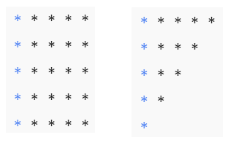

1. Write a program that reads in two integers and determines and prints whether the first is a multiple of the second. [*Hint:* Use the remainder operator.]
2. Write a program that inputs one five-digit number, separates the number into its individual digits and prints the digits separated from one another by three spaces each. [*Hint:* Use combinations of integer division and the remainder operation.] For example, if the user types in 42139, the program should print



1. Write a program that calculates the squares and cubes of the numbers from 0 to 10 and uses tabs to print

the following table of values:

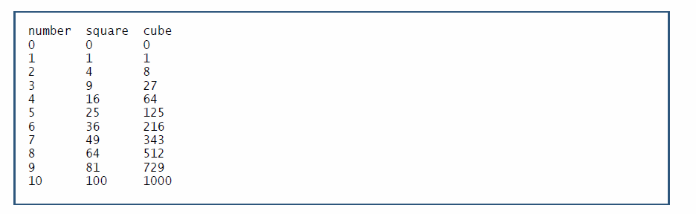

1. The process of finding the largest number (i.e., the maximum of a group of numbers) is used frequently in computer applications. For example, a program that determines the winner of a sales contest would input the number of units sold by each salesperson. The salesperson who sells the most units wins the contest. Write a pseudocode program and then a program that inputs a series of 10 non-negative numbers and determines and prints the largest of the numbers. [*Hint:* Your program should use three variables as shown below.]

counter: A counter to count to 10 (i.e., to keep track of how many numbers have been input and to determine when all 10 numbers have been processed)

number: The current number input to the program

largest: The largest number found so far

1. Write a program that repeatedly asks the user to enter two money amounts expressed in old-style British currency: pounds, shillings, and pence. The program should then add the two amounts and display the answer, again in pounds, shillings, and pence. Use a do loop that asks the user whether the program should be terminated. Typical interaction might be

Enter first amount: £5.10.6

Enter second amount: £3.2.6

Total is £8.13.0

Do you wish to continue (y/n)?

To add the two amounts, you’ll need to carry 1 shilling when the pence value is greater

than 11, and carry 1 pound when there are more than 19 shillings.

1. Find all prime numbers between 1 and 100 using nested loops.
2. Explain the dangling if-else problem with an example.
3. Write a **C++ program to check if a given number is a palindrome** (same forward and backward) **without using functions**:

Example:

12321 (palindrome number).

1. Wite a **C++ program to calculate** ex **using the Maclaurin series expansion** of first 10 terms.

