# **Lab-5**

**Arithmetic Instructions of PIC Microcontroller**

**Objective:**

In this lab students will learn

* How to manipulate arithmetic instructions for different applications?
* How to perform the addition of packed BCD numbers?
* How the division of numbers is performed in PIC microcontroller?

**Theory**

Different types of arithmetic instructions available in PIC are given as:

**Addition**

* ADDLW
* ADDWF
* ADDWFC

**Subtraction**

* SUBLW
* SUBWF
* SUBWFB
* SUBFWB

**Multiplication**

MULLW

**Lab Exercise**

**Find C, Z and DC flags for each of the following: [4]**

**(a)**

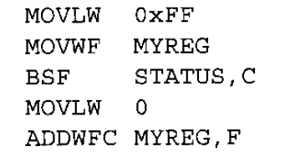

**(b)**

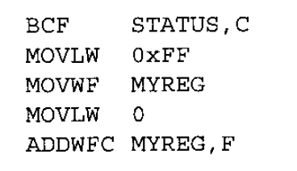

**________________________________________________________________________________________________________________________________________________________________________________________________________________________________________________________________________________________________________________________________________________________________________________________________________________________________________________________________________________________________________________________________________________________________________________________________________________________________________________________________________________________________________________________________________________________________________________________________________________________________________________________________________________________________________________________________________________________________________**

**Assume that 4 BCD data items are placed in memory locations starting at 50H. Write a program to find the sum of all terms and the result must be in BCD. Show the updated memory locations on MPLAB. [5]**

**________________________________________________________________________________________________________________________________________________________________________________________________________________________________________________________________________________________________________________________________________________________________________________________________________________________________________________________________________________________________________________________________________________________________________________________________________________________________________________________________________________________________________________________________________________________________________________________________________________________________________________________________________________________________________________________________________________________________________**

**Write a program to subtract 34-29. [3]**

**____________________________________________________________________________________________________________________________________________________________________________________________________________________________________________________________________________________________________________________________________________________________________________________________________________________________________________________________________________________________________________________________________________________________________________________________________________________________________________________________________________________________________________________________________________________________________________________________________________**

**Assume that the file register location 0X20 has the value F3H. Write a program to convert it into decimal. Save the digits in the location 0x40, 0x41, 0x42 where the least significant digit is in 0x20. Show the updated memory locations on MPLAB software. [5]**

**________________________________________________________________________________________________________________________________________________________________________________________________________________________________________________________________________________________________________________________________________________________________________________________________________________________________________________________________________________________________________________________________________________________________________________________________________________________________________________________________________________________________________________________________________________________________________________________________________________________________________________________________________________________________________________________________________________________________________________________________________________________________________________________________________________________________________________________________________________________________________________________________________________________________________________________________________________________________________________________________________________________________________________________________________________________________________________________________________________________________________________________________________________________________________________________________________________________________________________________________________________________________________________________________________________________________________________________________________________________________________________________________________________________________________________________________________________**

**Show how to perform 778/3 on PIC microcontroller? [5]**

**________________________________________________________________________________________________________________________________________________________________________________________________________________________________________________________________________________________________________________________________________________________________________________________________________________________________________________________________________________________________________________________________________________________________________________________________________________________________________________________________________________________________________________________________________________________________________________________________________________________________________________________________________________________________________________________________________________________________________**

**Conclusion [3]**

**____________________________________________________________________________________________________________________________________________________________________________________________________________________________________________________________________________________________________________________________________________________________________________________________________________________________________________________________________________________**