# **Lab-8**

**PIC microcontroller Timer Programming using assembly language**

**Objective:**

In this lab students will learn

* How many timers are there in PIC18f4550
* How timers are used for introducing delays.

**Theory**

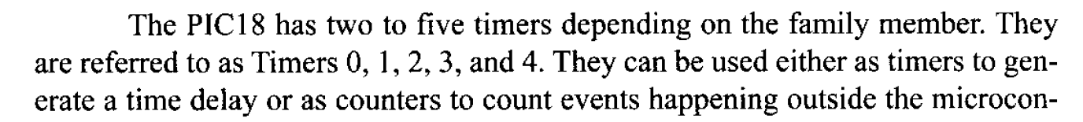 

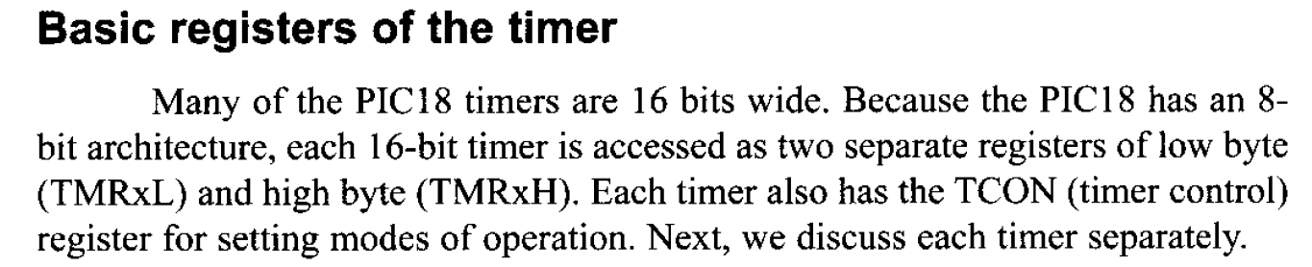

**Timer0 register and programming**

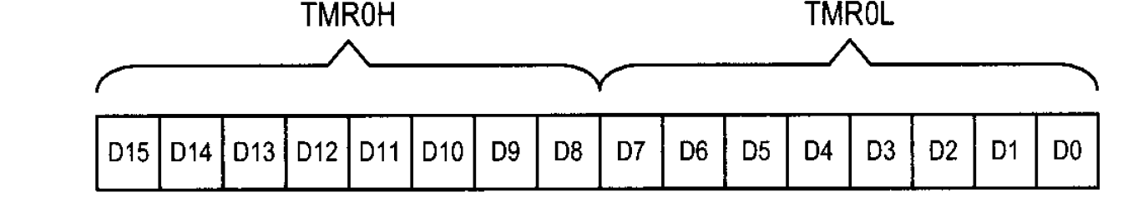

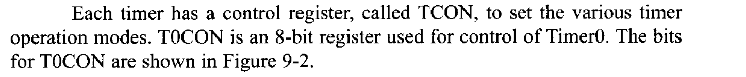

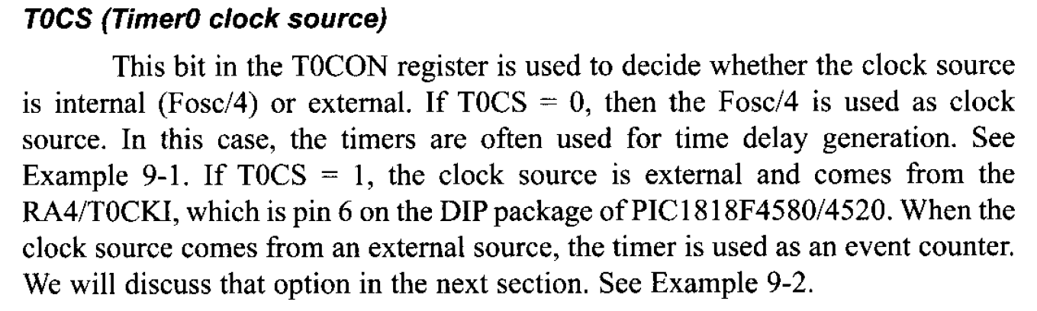

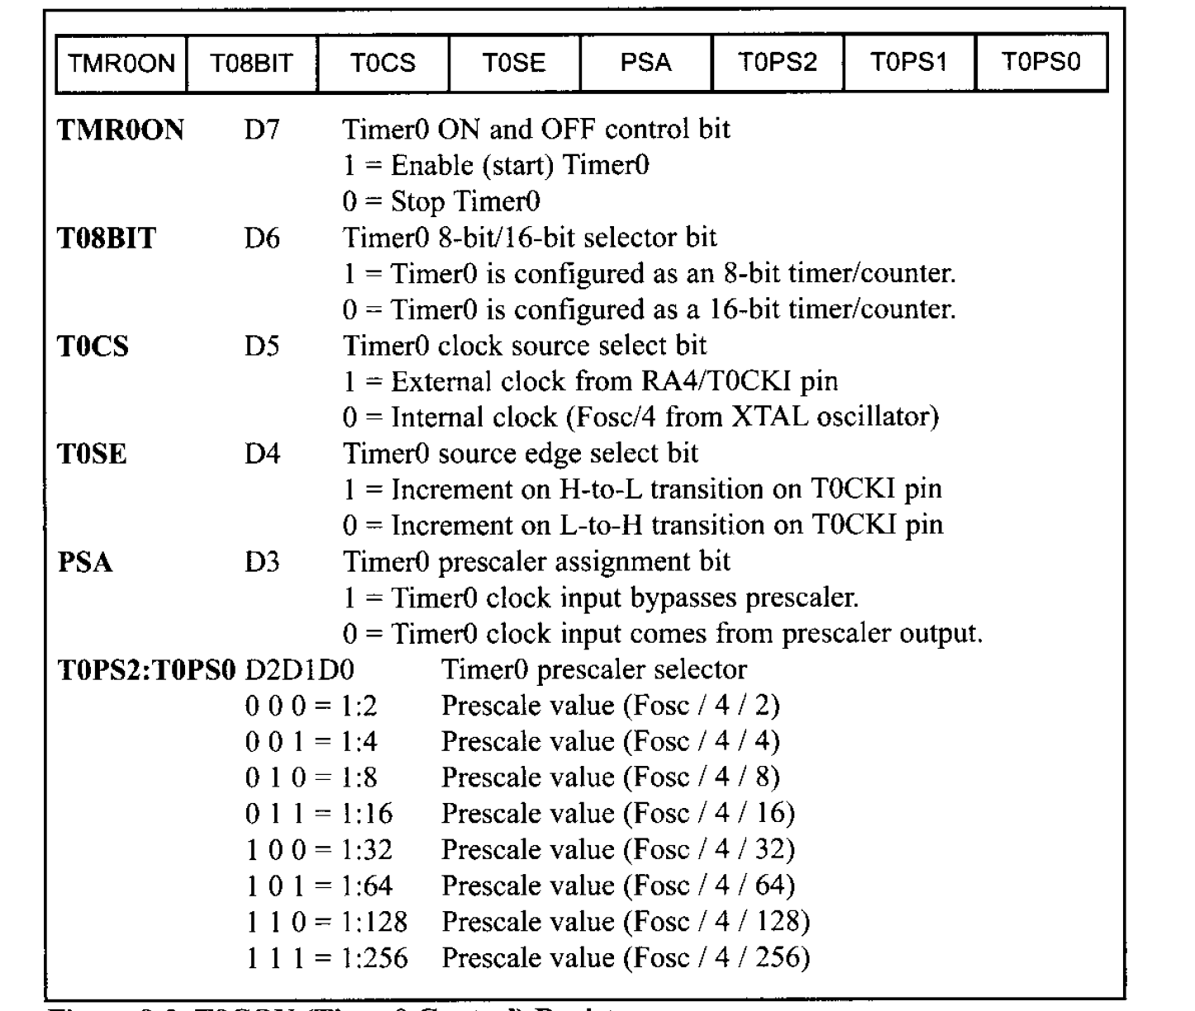

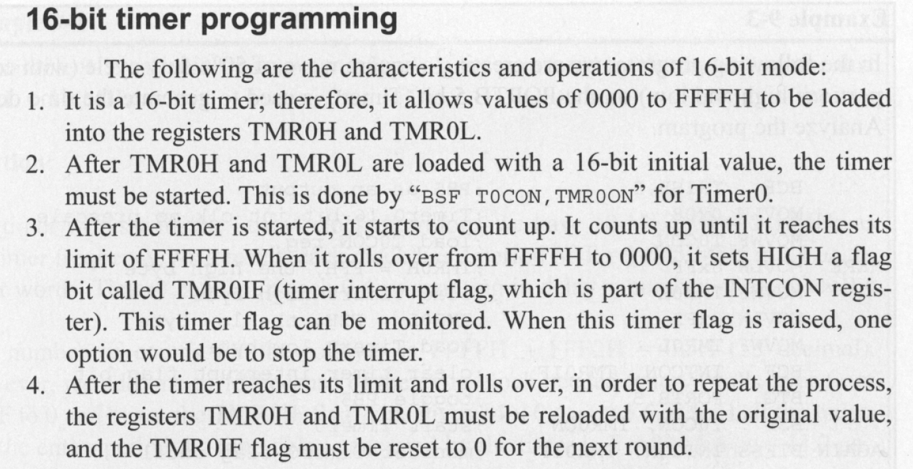

**Lab Exercise**

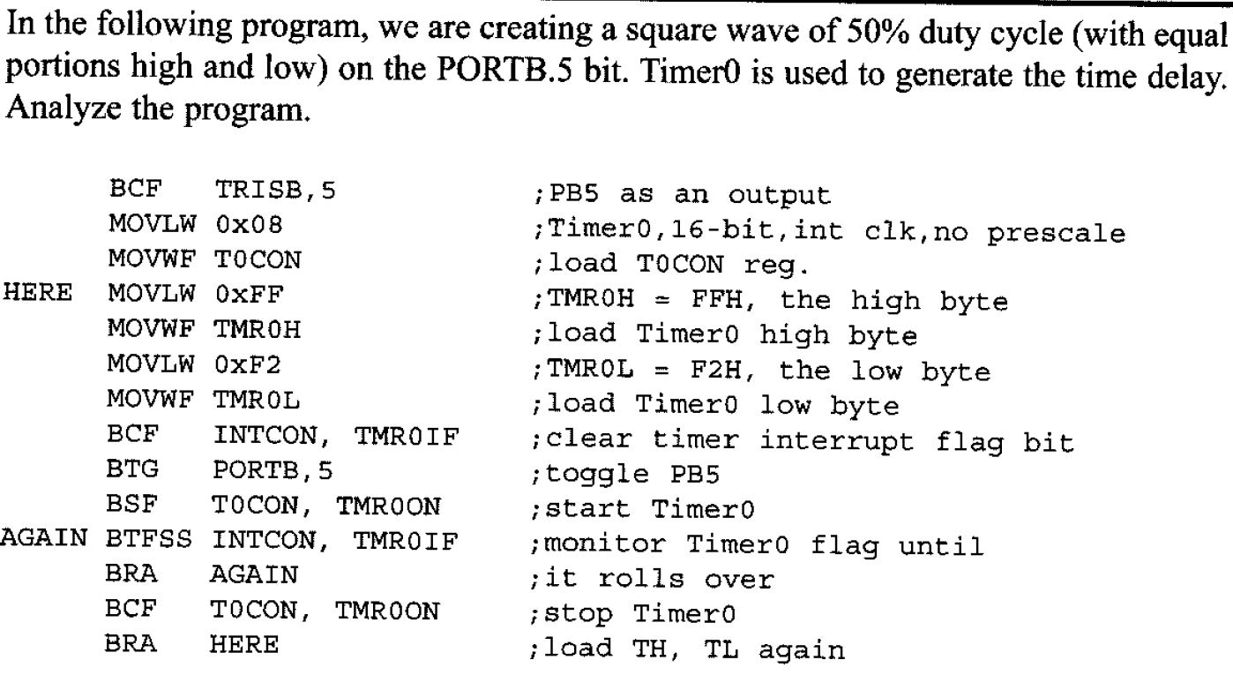

**Also calculate the delay introduced. [2]**

**________________________________________________________________________________________________________________________________________________________________________________________________________________________________________________________________________________________________________________________________________________________________________________________________________________________________________________________________________________________________________________________________________________________________________________________________________________________________________________________________________________________________________________________________________________________________________________________________________________________________________________________________________________________________________________________________________________________________________________________________________________________________________________________________________________________________________________________________________________________________________________________________________________________________________________________________________________________________**

**Write down the steps for programming the timer in 16 bit mode. [2]**

**___________________________________________________________________________________________________________________________________________________________________________________________________________________________________________________________________________________________________________________________________________________________________________________________________________________________________________________________________________________________________________________________________________________________________________________________________________________________________________________________________________________________________________________________________________________________________________________________________________________________________________________________________________________________________________________________________________________________________________________________________________________________________________________________________________________________________________________________________________________________________________________________________________________________________________________________________________________________________________________________________________________________________________________________________________________________________________________________________________________________________________________________________________________________________________________________________________________________________________________________________________________________________________________________________________________________________________________________________________________________________________________________________**

**Calculate the frequency of square waveform generated at pin PORTB.5. Show Simulations on Proteus. [2]**

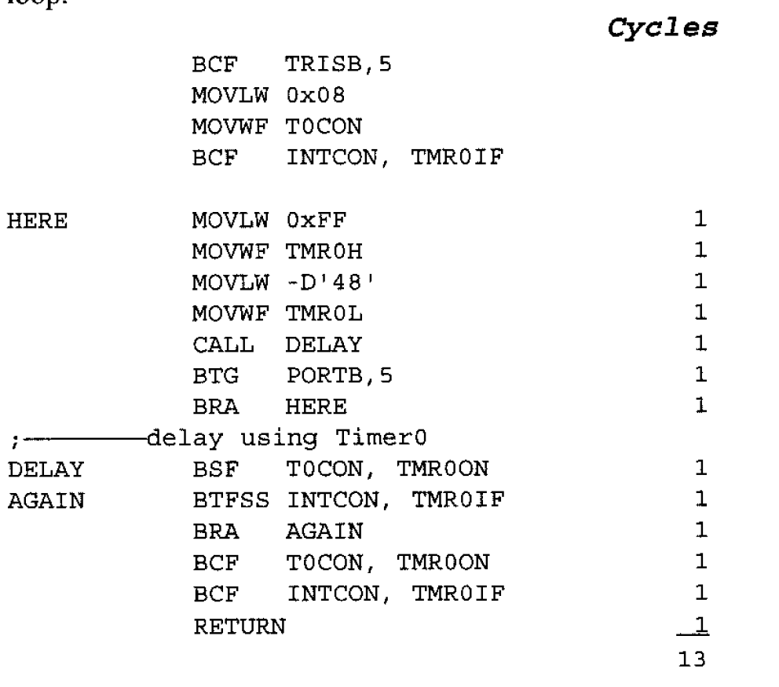

**____________________________________________________________________________________________________________________________________________________________________________________________________________________________________________________________________________________________________________________________________________________________________________________________________________________________________________________________________________________**

**Write a program to generate a square waveform with a period of 20msec on pin PORTB.3. Show Simulations on Proteus and verify your calculations. [2]**

**____________________________________________________________________________________________________________________________________________________________________________________________________________________________________________________________________________________________________________________________________________________________________________________________________________________________________________________________________________________________________________________________________________________________________________________________________________________________________________________________________________________________________________________________________________________________________________________________________________________________________________________________________________________________________________________________________________________________________________________________________________________________________________________________________________________________________________________________________________________________________________________________________________________________________________________________________________________________________________________________________________________________________________________________________________________________________________________________**

**Generate a square waveform of 3KHz frequency on pin PORTB.3. Show Simulations on Proteus and verify your calculations. [2]**

**________________________________________________________________________________________________________________________________________________________________________________________________________________________________________________________________________________________________________________________________________________________________________________________________________________________________________________________________________________________________________________________________________________________________________________________________________________________________________________________________________________________________________________________________________________________________________________________________________________________________________________________________________________________________________________________________________________________________________**

**What is the minimum frequency that you can generate using 16-bit timer mode? [2]**

**________________________________________________________________________________________________________________________________________________________________________________________________________________________________________________________________________________________________________________________________________________________________________________________________________________________________________________________________________________________________________________________________________________________________________________________________________________________________________________________________________________________________________________________________________________________________________________________________________________________________________________________________________________________________________________________________________________________________________**

**Conclusion [3]**

**__________________________________________________________________________________________________________________________________________________________________________________________________________________________________________________________________________________________________________________________________________________________________________________________________________________________________________________________________________________________________________________________________________________________________**