**Electromagnetic Field Theory**

**(Course Code: EE-2201)**

**Course Coordinator:**

Engr. Asma Mushtaq [asmamushtaq@gcu.edu.pk](mailto:asmamushtaq@gcu.edu.pk)

Lecture Timings:

**Monday**:08:00 am to 09:30 am

**Wednesday:** 08:00 am to 09:30 am

**Contact Hours: Credit Hours:**

Theory = 48 Theory = **3.0**

Practical = 0 Practical = **0**

Total = 48 Total = **3.0**

|  |  |  |  |
| --- | --- | --- | --- |
| **CLO** | **Outcome Statement** | **Level** | **PLO** |
| 1 | ***Explain*** orthonormal and non-orthonormal coordinate systems and operations. | 2 | 1 |
| 2 | ***Apply*** electrostatics and magneto-statics in different scenarios. | 3 | 1 |
| 3 | ***Explain*** time dependent fields, coupled electric and magnetic field intensities and electromagnetic model. | 2 | 1 |

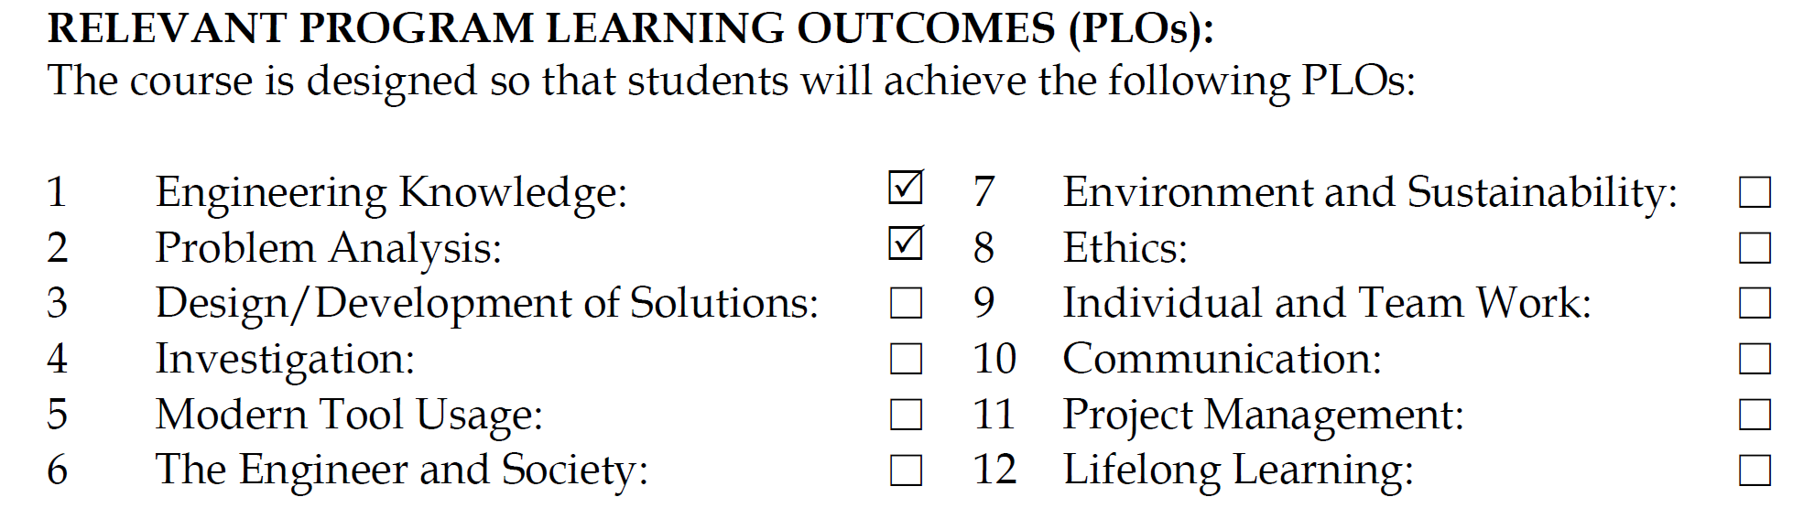

**Course outline:**

Vector algebra, coordinate systems and transformations, Vector calculus, electrostatic fields in materials, electrostatic boundary value problems, resistance and capacitance calculation. Magneto-static fields, magneto-static fields and materials, inductance calculation. Faraday's Law, displacement current and Maxwell's equation.

**Teaching Methodology**

* Lecturing
* Written Assignments

**Assessment (Theory)**

* Assignments 10%
* Quizzes 10%
* Mid Term 20%
* Presentation 10%
* Final 50%

**Recommended books:**

1. William Hayt and John A. Buck, “Engineering Electromagnetics”, McGrawHill, ISBN: 0073104639, Latest Edition.
2. David K. Cheng, "Fundamentals of Engineering Electromagnetics", Addison Wesley.

**Reference:**

1. Electromagnetics for engineers by Fawwaz T. Ulaby Pearson Education, Low Price edition.

**Lecture Break-up plan**

|  |  |
| --- | --- |
| **Lecture** | **Tentative Course Schedule** |
| 1 | Introduction to Electromagnetics (EM power spectrum), Introduction to vectors, Fields (scalar & vector) |
| 2 | Rectangular Coordinate Systems Vectors multiplication (dot and cross) and its significance in real life |
| 3 | Circular cylindrical |
| 4 | spherical coordinate systems |
| 5 | End problems Session |
| 6 | Electrostatics: Coulomb’s Law, Faraday’s Law |
| 7,8 | Field due to continuous volume charge distribution, Field of line charge, Field of sheet of charge |
| 9,10 | Electric Flux Density, Gauss’s Law and its applications (symmetrical charge distribution) |
| 11 | Divergence Theorem and Maxwell’s First Equation |
| 12 | Energy expended in moving a point charge in an electric field |
| 13,14 | Line integral, potential difference and electric potential |
| 15 | Potential Gradient and Dipole |
| 16 | Energy Density in an electrostatic field references. |
| 17-19 | Types of materials and their parameters, conductor properties and their boundary conditions. |
| 20 | The method of images. |
| 21-22 | Derivation of Poisson’s and Laplace’s Equations, Solution of Poisson’s and Laplace’s equations. |
| 23 | Introduction to magnetostatics, Biot- Savart Law, |
| 24 | Curl of a vector field and Stoke’s Theorem. |
| 25 | Magnetic flux and magnetic flux density |
| 26-27 | Calculation of inductance and capacitance of an inductor. |
| 28 | Maxwell’s magnetostatic equations |
| 29 | Magnetic Boundary conditions. |
| 30 | Faraday’s law |
| 31 | Stationary loop in time varying magnetic field |
| 32 | Moving Conductor in static magnetic field |

|  |  |
| --- | --- |
| **Evaluation criterion** | * **Quizzes & Class Participation:50%** * **Final: 50 %** |